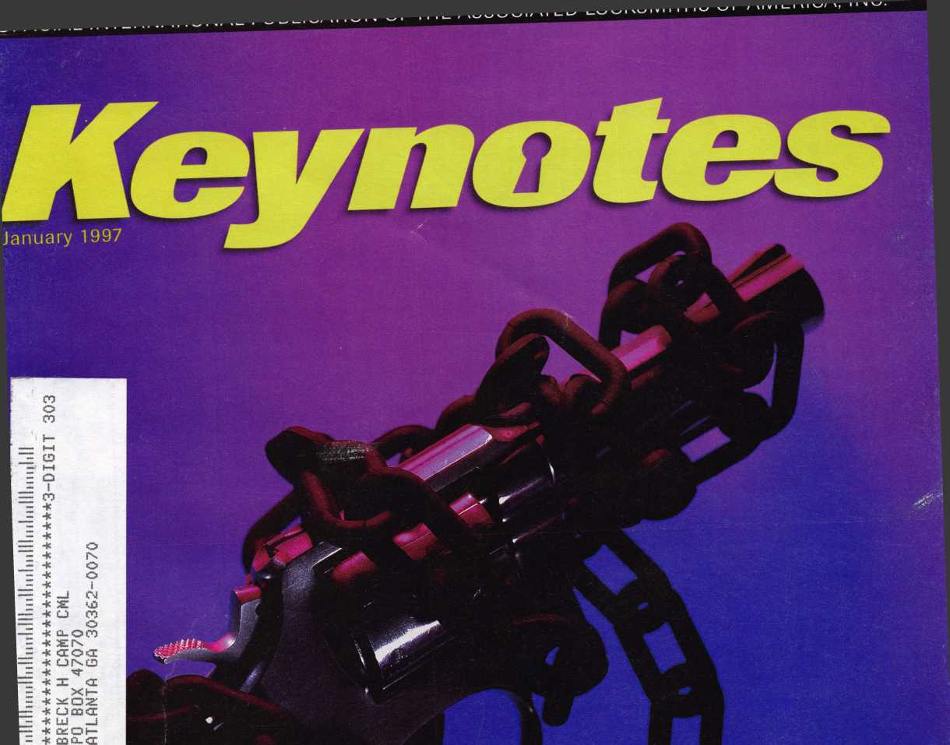

**Unchained**

Melody

***A new product that hits the right note***

**flISO„ *The wave in boet hnniware* • *Success:^ i,* to *training* • *• »^Cn/**

I18111

\ Convention and Trade Show

10 The Galt House

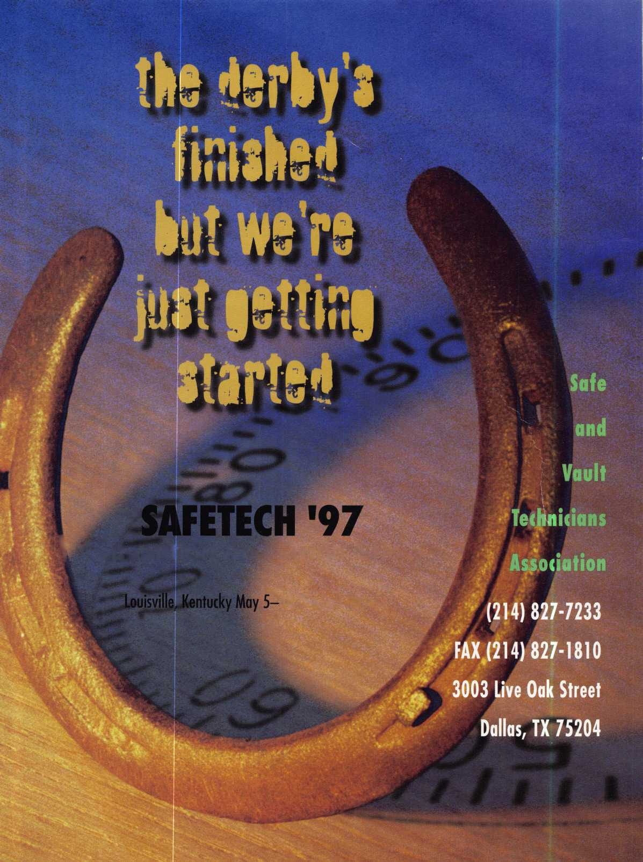

pMI

**ALOA ’97** AND SECURITY **EXPO**

**AUGUST 2,1997 CONVENTION CENTER HOTEL**

**RENO, NEVADA**

WITH QUESTIONS OR COMMENTS CONTACT:

ASSOCIATED LOCKSMITHS OF AMERICA, INC 3003 LIVE OAK ST.

DALLAS, TEXAS 75204

214-827-1701

800-532-2562

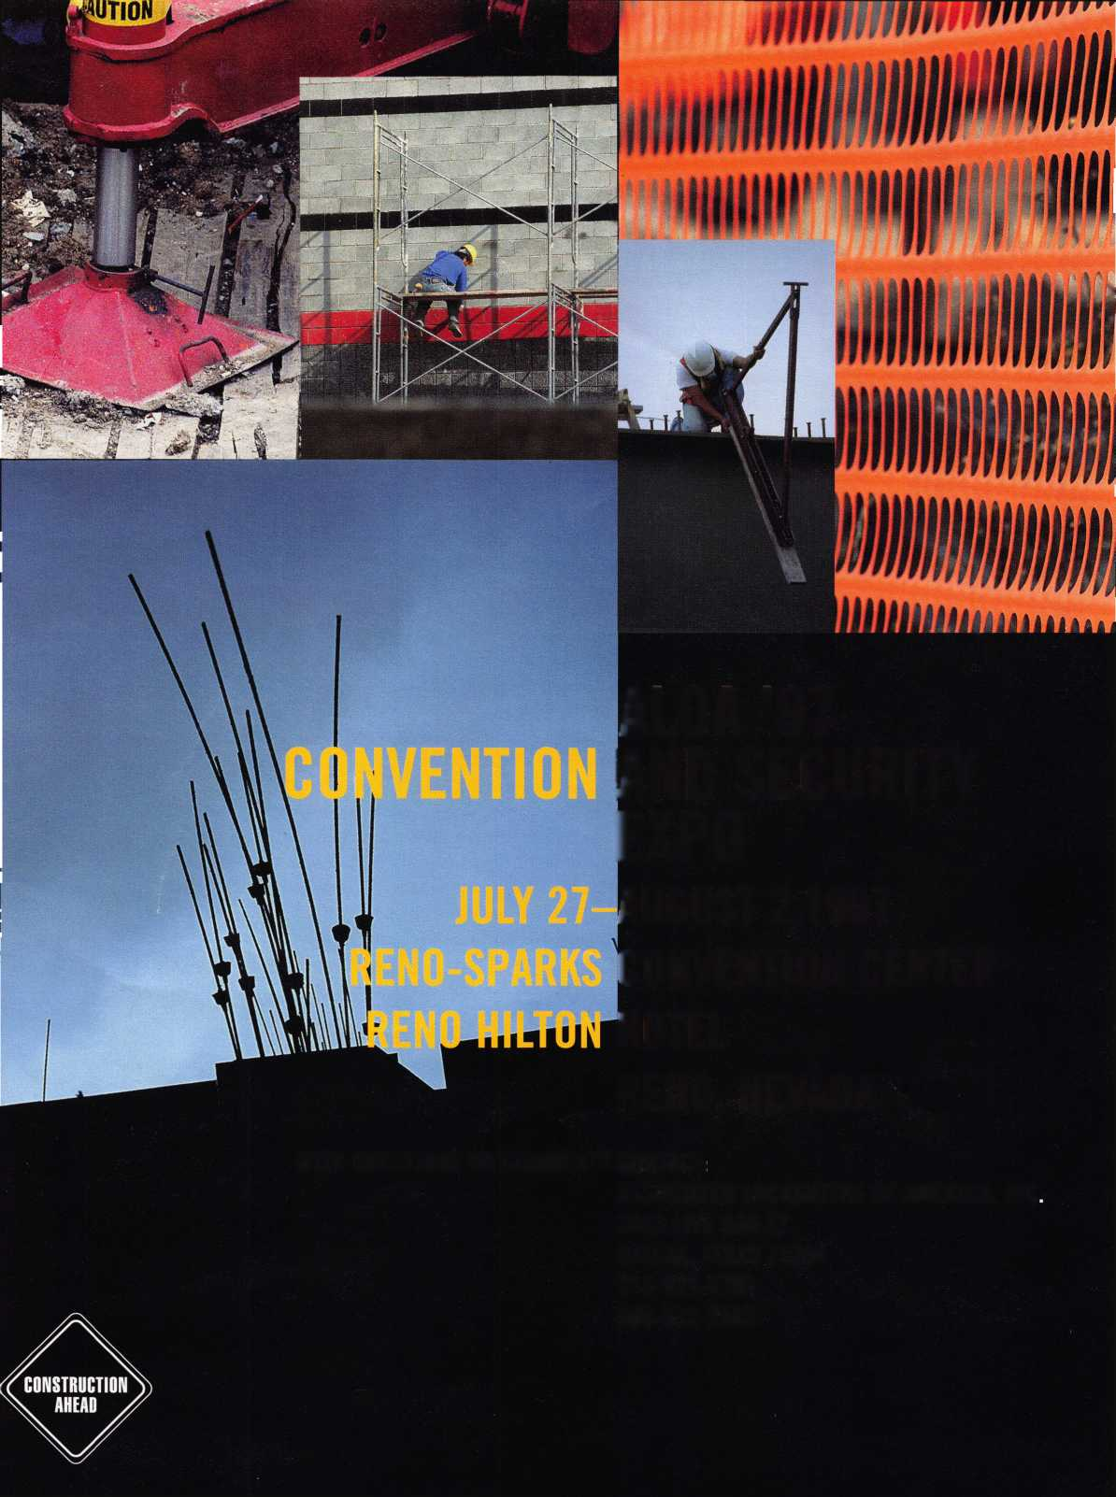

avid Lowell

1 would like to share one vision of ALOA in the year 2000 ...”

The beginning of the year is always an exciting time for me. I look forward to carrying

ut all sorts of New Years’ resolutions while trying not to make the same mistakes that I

ade the previous year. This new year is especially exciting for me because of the results of

ur fall board meeting. In this issue you will find the reports from the various committees

hat met and planned for 1997.

When I became president, I appointed a Strategic Planning Committee whose goal was to

brmulate a plan for the future of our association. In that strategic planning process, each

Lember of the committee was asked to submit a vision statement of the future of ALOA.

ince this is the new year, I would like to share one of those vision statements with you.

In the year 2000, ALOA will have grown to a membership of 20,000 locksmiths. There  
ill be several new categories of membership including institutional, electronic security, safe

nd vault, corporate and government.

Locksmithing will be officially recognized in all 50 states as a registered trade. In coopera-

tion with the state agencies, ALOA through PRP and ACE will be authorizing and adminis-  
tering certification programs, and conducting onsite training programs to assist with compli-  
ance with the various certification and licensing programs.

Most security hardware manufacturers’ products will have the ALOA Seal of Approval on  
them after being submitted to the ALOA testing facilities for inspection and verification of  
compliance to industry standards.

The ALOA 2000 Security Expo in Las Vegas will have 10,000 attendees from all of the  
related lock, safe and electronic security industries. These attendees will be treated to the  
largest display of security related items ever assembled in one place.

The ALOA Scholarship Fund will consist of $1,000,000.00. Funds will be available for  
100 fully paid scholarships at ALOA educational conferences that will be held in six sites  
each year, including the annual convention.

All ALOA members will have the opportunity to vote on bylaws changes and officer elec-  
tions by picking up the phone and keying in their choices by touch tone. The vice presidents  
will be elected by the members from their region only.

ALOA members will be recognized by consumers, manufacturers and government agen-  
cies as the source of choice for all of their physical security needs.

As a membership benefit, ALOA members will be able to purchase inventory at a dis-  
count that is not available to non-ALOA members. In addition, there will be manufacturers’  
rebate programs exclusively for ALOA members whole value will far offset the membership  
dues.

All of these visions are achievable with your input and support. I look forward to working  
together with all of you this year towards making them a reality.

-David Lowell, CML, CMS

Keynotes

January 199"7



Editor

Editor

t Director ^.rtising Sales

Contributing Authors



Publications Committee

ALOA Professional Staff

Staff Administrator Office Manager Receptionist Comptroller Financial Assistant Meetings & Education Manager Meetings & Education Assistant Administrative Assistant Membership Coordinator Mailroom Assistant

Anne McDonald Davis, ABC

Laurie Kline

Derek Holiman

Mary Sadler

Anelia M. Banda

Jerome V. Andrews, CML

Charles Cameron,CML

Paul Chandler, CRL

Claire Cohen, CML

Don Coleman, CPL, CPP

Bob De Weese, CPL

Ray D’Adamo, CML

Sal Dulcamaro, CML

Joe Esposito, CML

James Glazier, CML

Jon Griswold, CML

A.J. Hoffman, CML

Ken Holmlund, CRL

Tom Hood, CML

Richard A. Lacy, CPL

Barry Leas, CRL

Ray Lusk, CML

Mark Ohno

David Parrott

Henry H. Printz,CML

Randy Simpson, CML

Robert Stafford, CPL

Dave Thielen

James Watt, CML, CPS

John D. Cannon, CML, Chairman

Jerome Andrews, CML

A.J. Hoffman, CML

Tony Ramunno, CML, CPS

Donald E. Rule', CML

James Watt, CML, CPS

Evelyn Wersonick, CML, CPS (Trustee)

Charles W. Gibson, Jr.

Mary May

Margo E. Vela

Kathy J. Romo

Debra Bradshaw

Carmen D. Murphey, CMP

Jessica Vasquez

Janelle Vergara

Brandon Durrett

Jesse Morales Jr.

Executive

Complete address and phone number listings for the ALOA Board and Keynotes authors are available in your membership directory or by contacting the ALOA office at (214)827-1701.



ssion Statement: The Associated Locksmiths of America. Inc. is dedicated to enhancing the professionalism, education and ethics among locksmiths and se in related sectors of the physical security industry. With approximately 10,000 members in the United States, Canada and the freeworld, ALOA is poised to d members obtain the knowledge, the strength, and the confidence to perform their role in the physical security field with pride and dignity. But it is only )ugh active involvement and participation that ALOA can fully achieve its potential-and can help members to achieve theirs.

licies: Keynotes" is the official publication of the Associated Locksmiths of America, Inc. (ALOA). Keynotes" acts as a moderator without approving, disap- ving, or guaranteeing the validity or accuracy of any data, claim, or opinion appearing under a byline or obtained or quoted from an acknowledged source.

: opinions expressed by the authors do not necessarily reflect the official views of ALOA. Also, appearance of advertisements and new products or service irmation does not constitute an endorsement of products or services featured by the Association. The Association does not accept responsibility for the inac- acy of any data, claim, or opinion appearing in this publication, due to typographical errors on the part of the authors, Association staff or its agents, itor’s Note: This publication is designed to provide accurate and authoritative information in regard to the subject matter covered. It is provided and dis- linated with the understanding that the publisher is not engaged in rendering legal or other professional services. If legal advice and other expert assistance squired, the services of a competent professional should be sought.

ithors’ Payment: Effective Nov. 1, 1995, payment will be made for original articles submitted exclusively to Keynotes" magazine at a rate of: technical arti- 5—$75 per page, double-spaced with standard one-inch margins: and business/human interest articles—$50 per page, double-spaced with standard one- ■i margins. (If only a portion of an eligible article is published, payment will be made for that portion only.) Authors will be paid $10 for each photograph, irt, exhibit or illustration that is utilized for their article. Maximum payment for both copy and photos is $350 for technical articles and $150 for ;iness/human interest articles.

ment will not be offered for articles submitted by ALOA employees or members of the ALOA Board of Directors (unless material is of a technical nature), nor articles submitted by a company that promote that company’s products or services. ALOA reserves the right not to pay for articles submitted by an individ- (s) that promote a particular company’s products or services.

sclaimer: The Associated Locksmiths of America, Inc., (ALOA), reserves the right to refuse any article for any reason. Additionally, ALOA reserves the right sdit, amend or modify any article submitted for publication in order to preserve technical accuracy, clarity, fairness or grammatical correctness. ALOA will ke the best efforts to notify the author of any changes. The extent of ALOA’s liability for any article or information contained therein will be a notice of correc- ) or retraction in the next possible issue.

motes" (ISSN 0277 0792) is published monthly except for the combined July/August issue by The Associated Locksmiths of America, Inc., 3003 Live Oak St., las, TX 75204-6186. Telephone: (214) 827-1701; FAX (214) 827-1810: e-mail [aloa@anet-dfw.com](mailto:aloa@anet-dfw.com). Subscription rates for members-$15.00 per year. Second ss postage paid at Dallas, Texas. POSTMASTER: Send address changes to: Keynotes, 3003 Live Oak St., Dallas, TX 75204-6186. © Copyright 1997, All rights erved. No part of the contents may be reproduced or reprinted in any form without prior written permission of the publisher.

Board

President

David M. Lowell, CML, CMS (602) 263-7716 Regional Vice Presidents Southeast

Dallas C. Brooks

Chairman: Finance Committee

(334) 826-8990

North Central

David A. Paulsrud, Sr., CML

Chairman: ALOA Scholarship Foundation, Inc.

(612) 533-6164

South Central

Carl King, CML

Chairman: Bylaws Committee

Curator: ALOA Museum

(713) 465-2500

Southwest

John I. Shandy, CML

Chairman: Membership Committee

(303) 443-9740

Northeast

John D. Cannon, CML

Chairman: Publications Committee

(703) 960-6413

Northwest

James M. Watt. CML, CPS Chairman: PRP Committee (406) 549-7667

Secretary

Ricardo Ohmit, CML (217) 384-6006

Trustees:

Breck H. Camp, CML, Chairman (770) 455-6244 Henry H. Printz, CML (201) 538-2737

Evelyn V. Wersonick, CML, CPS

(505) 247-9413

Leonard J. Passarello, CPL

(416) 752-7210

Edwin Toepfer, RL

(416) 225-5589

Directors

Dana L. Barnum, CML

Chairman: Chapters Committee

(610) 565-9900

James H. Glazier, CML

Chairman: Education Committee

(301) 831-5454

John J. Greenan, CPL, CPS

Chairman: Legislative Committee

(312) 486-2030

Barry K. Leas, CRL

(610) 272-9292

Raymond C. Lusk, CML

Chairman: Convention Committee

(509) 624-3152

Jeffrey S. Nunberg, CML

(305) 324-8800

Anthony J. Ramunno, CML, CPS Chairman: Library/Museum Committee (330) 782-6204 Randy L. Simpson, CML Chairman: Public Relations Committee

1. 780-7026 Robert H. Stafford, CPL Chairman: Grievance Committee (860) 768-7917

William T. Straub, CML

1. 779-0383 Bruce J. Tarbet, CML (601) 924-4184

Chairmen of International Affairs

Laurence P. Mills Australia (129) 958-0445 Hans Mejlshede, CML Europe

Members-at-Large

Jerome V. Andrews, CML"'

(860) 621-3601

Steven G. Engel, CML, CPP k

Chairman: Strategic Planning Committee

(414) 731-5400

A.J. Hoffman, CML

(714) 474-8877

J. Thomas Hood, CML

(610) 539-9555

Donald E. Rule', CML

(601) 324-2658

January 1997

Keynotes

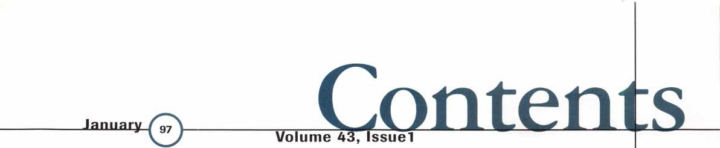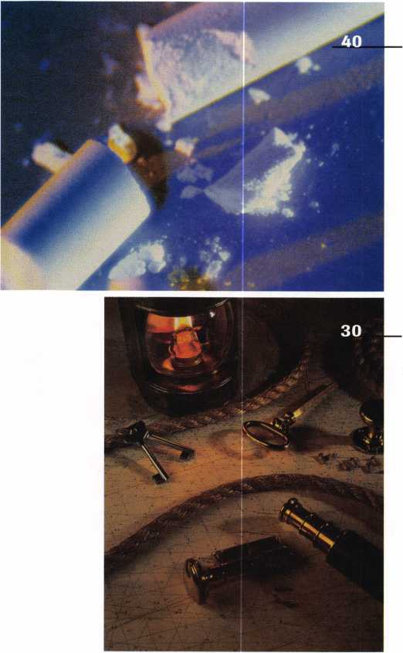

A Word With David Lowell, CML, CMS

Legislative Comment

Who are you? By John Greenan, CPL, CPS

52

PRP Report

A link with licensing standards By James Watt, CML,

CMS

56

Focus on Education

CCTV smarts in demand. By James Glazier, CML

59

Chapter News

’97 programs approved. By Dana Barnum, CML

o

**o**

c

**2**

**3**

C/5

6 (D

Some point-counterpoint

TO

Upcoming Events

July 27-Aug. 2-

Mail Box'53

2 3 2

main event |CD

11

Applicants for Membership

Scheduled for clearance by Feb. 1

12

Industry News

Big change from Medeco\

14

Security Marketplace

Expanded coverage continues

53

Trade Tips

Caddies and tubulars By Tony Ramunno, CML, CPS

55

ALOA Extra

Some fond farewells

60

Back Page

43

Buyers’ Guide

For your shopping pleasure

44|

Associate Membersl

Manufacturers!distributors back ALOA I

49

Classifieds

Buy it, hire 'em, get sold

55

Ad Index

Index to Advertisers for this issue

3

*(A*



Keynotes

January 1997



**2**

**CO**

**0**

**20**

Down to the Wire

Time’s up. Take a deep breath, sip a cool drink of water, start the PRP evaluation.

By Claire Cohen, CML

**22**

The ABCs Of CCTV “H” is for Housing

Indoors, outdoors, hidden or aesthetic—there’s alot to con­sider before mounting that equipment.

By Paul Chandler, CRL

**35** Cover

Unchained Melody

24

Motorcycle Locksmithing, Part 2 The Yamaha

Oh come on now—it doesn’t have to be that hard. Break

Our latest two-wheel installment is a documentation and

those chains! With a little help from Saf-T-Lock and Keynotes author Sal Dulcamara, CML, you’ll show your customers that securing a handgun’s as easy as pushing a button.

By Sal Dulcamara, CML

28

ASSA’s New Mogul Cylinder for Detention Locks

chronology of the Yamaha motorcycle in the United States, dating from the late 1960s.

By Ray D’Adamo, CML and Tina D’Adamo, CRL

40

Employee Training

Tired of running ads for qualified workers and not finding what you want? Try growing your own—it’s easier than

The internal construction is quite similar to most any ASSA high security cylinder, with its twin locking action.

By Sal Dulcamara, CML

30

tomatoes.

By Richard Dyer, CRL

42

ALOA ’97 Security Expo

Seaworthy

Boat Locksmithing and Marine Hardware

Tell me again why you have to take your shoes off. And what’s the thing about brass screws? And, for pete’s sake, why do you have to leave your tool box on the pier?

By Ray Iglesias, CPL

Everything old is new again at the annual ALOA convention  
and trade show. Stay tuned to learn what we’re keeping of  
the best and the best we’re adding to that.

By Charles W. Gibson, Jr.

34

Isn’t That Special!?

Hey, that’s what I need! A rubber coated, tempered steel, single pin, interchangeable, shackle protected, bolt cutter resistant, unique one-of-a-kind thing-a-majig. Yeah.

January 1997

Keynotes

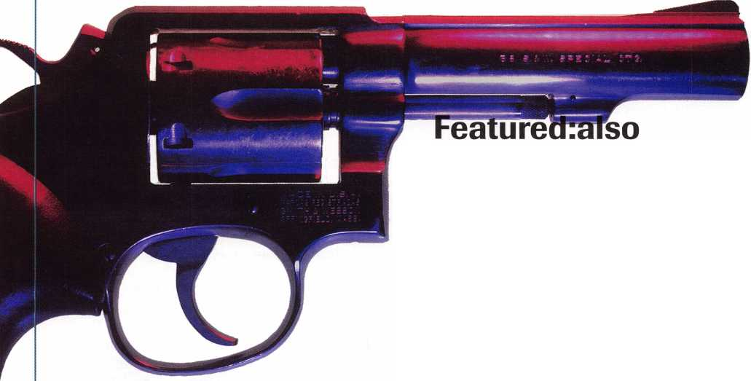

Keynotes

Mail Box



Dept]

**If you have an opinion to offer on the letter(s) printed in Keynotes each month, let us know! Submissions to the “Keynotes Mail Box” department are printed on a space-available basis. Write to: Keynotes Mail Box;**

**Associated Locksmiths of America, Inc.; 3003 Live Oak Street; Dallas TX 75204; or FAX (214) 827-1810.**

Regarding “New Bees”

This letter was sent to Bob DeWeese care of Keynotes.

Dear Bob,

Regarding your article to “new bees” in Keynotes November issue, “So You Wanna Do Cars?”—I feel your reference to making $98.00 dollars on the deadbolt install and $94.00 on a GM key misleading if not mis­taken. Profit is not net—your gross net may be invoice less your parts cost, but net must account for all cost involved. Truck, tools, insurance, advertising, license, bonds,

ALOA membership, school, fuel, oil, tele­phone, accounting and all indirect costs must be considered. These are as necessary in providing our service as the $43 key blank or $18.63 dead bolt, and result in a profit margin of 3-15% or 2.94-$ 14.70 respectfully on a $98 job. One of our responsibilities, as veterans in our beloved trade, is to convey true cost to our friends and apprentices—wouldn’t you agree? Thank you for your input and professional­ism over the years.

David R. VadBunker President**,** GCLA

Response from Bob DeWeese, CPL

When referring to my cost for the jobs, I was referring to immediate out-of-pocket expenses only. While it is true that all of the normal business expenses that you’ve men­tioned (plus a few more) cut deeply into the true net profit for the jobs, it would be diffi­cult to come up with an exact figure, espe­cially since everyone’s business expenses are different. However, in taking those addi­tional expenses into account, the differences in the profit on the two jobs would still be the same assuming that you subtracted the same proportional amount from each job to cover business expenses, since both jobs came to a total of $95 each. Maybe I simpli­fied too much. I just assumed that most would figure that out on their own. And we all know what happens when we “assume.”

Just as an example—at the end of last year, my net profit was a little more than 55% of what my business grossed. Keep in

6 | KeynotesJanuary 1997

mind that I am a mobile business. I have no shop to maintain and I have no other employees—both of which add considerably to one’s expenses.

Blank Stares

Dear Editor,

I am writing concerning Curtis Automo­bile keyblanks. For many years, we have used their keyblanks. They have had better blanks than anyone in the industry; howev­er, the last few months we have had some problems with the blanks we have ordered. For instance, several of the blanks will not fit on Va inch hooks (i.e., Y-154, HD-90, B- 86). If I am not mistaken, almost every locksmith in the country uses Va inch hooks on their peg board. Another problem is that one particular blank will barely fit on a decent keyring. If one is able to get it on the ring, it will not rotate around the ring. The blank that I am referring to is General Motors B-86. The head of this blank was cut to half the size of the original.

I have contacted Curtis Industries with my concerns. There has been no one there that has either been concerned or helpful. We have talked to sales and engineering. Maybe we just haven’t talked to the right person yet. I am hoping that maybe you can help us with our dilemma. We would like to keep purchasing Curtis’ blanks, but if they are going to continue to make unfavor­able changes, we will also have to make some changes. We are in the business to make our customers happy. Curtis should also be worrying about making their cus­tomers happy instead of saving money. Sincerely,

Robert L Glenn Glenn's Lock & Key, Inc.

Response to R. Glenn

Dear Editor,

Thank you for forwarding Mr. Glenn’s letter. I had already received a copy myself and had called him personally some weeks ago. We discussed the key ring holes, and he makes a very good point about its size. We are currently looking into the matter.

I’m not sure to whom Mr. Glenn spoke when he called, but I welcome any opportu­nity to talk with customers—in fact, any locksmith. It is important to me and to Curtis that we keep a sensitive ear to the locksmith’s needs. Curtis’ Locksmith Divi­sion is kicking off its third year, and the feedback we’re getting from our customers suggests we are doing things right.

Thank you, Mr. Glenn, for your input. Ken Pross

Manager, Special Markets Curtis Locksmith Division

Medeco Out Of The Blue

This letter was sent to Alan Heaney at Medeco. Dear Al,

I walked into my Medeco Distributor this morning to buy my usual small “but mounting” list of stock needs for the day (2 xDl 1-0200, 2 plugs for D11-0200 and one cut key for my customer) when out of the blue, he informs me that I will be receiving a letter from Medeco stating that we will be ordering direct from Medeco. Boy! Was I ever shocked and upset. I have what I figure is a “great set-up”—a distributor who has invested a lot of time and money to satisfy my needs and requirements, both in stocked product and superior service (technical and personal).

Now we are going to be ordering direct. Boy, oh boy! I can see now when we need something in a hurry—depending on UPS, Purolator or Canada Post—what a large expense of time and money will be wasted. I know it is selfish to be thinking of my needs, especially since I am a small, two truck mobile service, but what is Medeco thinking of? Service is the name of the game, speaking for myself. I know I have never had a complaint with my distributor. Why change a good system?

If I sound kind of proud of my relation­ship with my Distributor (Madipro), it is with good reason—we treat each other with respect and fairness. What a concept! Securely,

Phil Lauzen

PS. Why can we not have a choice?

HEY ILCO... WHAT A



THANKS!

The Associated Locksmiths of America, Inc., would like extend many thanks to llco for donating one of their top-of-the line key machines as an incentive to ALOA members who renewed their dues early. The program has been a resounding success, and the association appreciates the support from this *manufacturer.*

The llco KD56 prize sported features such as precision jaws; locking cutter and guide; built-in light; and is known to be versatile and durable.



k

Fastest & Easiest Way

To Create Master

Key Systems!

”‘ssi

**9 Great Computer Programs For Locksmiths!**

Perfect Master™ 4.1

THE CHANGE KEY CHART

KEY ID BITTING STATUS

LOCATION

AAA-1

AAA-2

AAA-3

AAA-4

AAA-5

100123 INSTALLED

100125 INSTALLED

100127 INSTALLED

100129 TERMINATED

100143

1/90 RM 101-ROBERTS 1/90 RM 126-GLENN 4/90 RM 117-JOHNSON 6/90 RM 113-REED

In Use By Thousands Worldwide!

THE PINNING CHART

SCLAGE 6 PIN (SEES 0-9) THEO> 324301 PINNED> THEORETICAL

KEY IDBITTING BOTTOM MASTER CONTROL-DRIVERS LOCATION

|  |  |  |  |  |  |
| --- | --- | --- | --- | --- | --- |
| AAA-1 | 100123 | 100101 | 224222 | Tills Location For | RM 101-ROBERTS |
| AAA-2 | 100125 | 100101 | 224224 | Control Pin* and | RM 126-GLENN |
| AAA-3 | 100127 | 100101 | 224226 | Drivers For Bert | RM 117-JOHNSON |
| AAA-4 | 100129 | 100101 | 224228 | FI aeon Type | RM 113-REED |
| AAA-5 | 100143 | 100101 | 224242 | Removable Core |  |

THE MASTERKEY CHART

MASTERKEY DE SIGNTT ATI ON BITTING ID QTY ISSUED LOCATION

THEORETICAL MASTER 324301

GROUP MASTER 124301

BASE MASTER 104301

PAGE MASTER 1 100301

PAGE MASTER 2 102301

GGMK 3216 YES ENTIRE BUILDING

A 848 NO

AA 176 YES FLOORS 1, 2 AND 3

AAA 48 YES FIRST FLOOR

AAB 64 YES SECOND FLOOR

Perfect Master creates master key systems for ALL 4, 5, 6 & 7 pin locks including Best & Falcon removable core. Stores all info to disk with room to enter location and door number if you wantto. Automatic key I.D. (TMK, A, AAA- 1 etc) and eliminates all ghost keys as well as those that exceed the MAC specifications. Fast & Easy to use.

Features Include...Selectable Pinning to ANY Level. On screen client index, TMK Log, manufactuer's file with MAC, STEP and PIN SIZE info. Prints key box labels. Reports and charts show client's name and your company info on each & every page. Prints system cover sheet and pins required listing. Pinning charts show Bottom Pins, Master Pins, and DRIVERS for all bittings (I/C's show CONTROL pins too). Key charts show Vertical and Block masters for EVERY change key. Create systems with up to 30,000 change keys & thousands of masters on up to 7 LEVELS, and much more!

**Order # PerfectMaster 4.1 18995**

Also available from Treskat USA...

Advantage... (Inventory and invoicing) 99.95

CodesOnCall*...(24hr codes by voice phone) 25£ min

Keymanager...(Key blank cross reference)....99.95 WonderCode...(Reverse code add-on for CM) 99.95

(*CodesOnCall membership is FREE to CodeMaster users or 99.95 membership & 39.95 annually for non-users)

MASTER CARD • VISA • DISCOVER • AMERICAN EXPRESS • OPTIMA • COD

ORDER NOW TOLL FREE 1-800-645-5657

OUTSIDE USA & FAX CALL 407-870-9696

M TRESKAT USA

725 ADRIANE PARK CIR • KISSIMMEE, FL 34744

**AutoMaster**1

F

i-

I

**■**

1.

-Fist Facts]

Code Scries Ilco Sllca Curtis Cam Carr Cutter  
FR1-FR6000 FT6RDM1R WS2 15W1 15W1 W-45  
FZ1-FZ1232 FT6R DM1R WS2 15W1 15W1 W-45  
JC1-JC852 BL6 CEM3 BL6 BL10 BL10AW-45

Code Locations— —Linkage A Lock Rotation—

Ignition Lock Linkage Type: Vertical

: Passanger Door Pass LockRot:

Clockwise

**I** Works On |

**I** Palmtops Too! 1

* x-I,
* arp

Cod

**KeyWiz’**

Giant 900 Page Auto Encyclopedia On Disk!

* More Info Than "Paper" Encyclopedias
* Code Series Used **&** Where It's Located
* Curtis Clipper Cam-Carriage-Cutter Info
* Ilco, Silca & Curtis Key Blank Numbers
* Door Linkage Type And Lock Rotation
* Easiest Method To Unlock The Vehicle
* Keying (What Locks Each Key Works)
* Several Different Ways To Fit First Key
* Multiple Pop-Up 'Index Card" Windows
* Impressioning Specs For Over 1,000 Locks
* Print Your Own 900 Page Encyclopedia
* Add Detailed Notes To All Records
* OK For Note Book & PalmTop Computers
* Order Toll FREE 1-800-645-5657

**Order # AutoMaster 9995**

xx? ? ?32 431

r= Ignore Cut* 7= Unknown Cut* Diglt*=Known Cut*

Application > Oldsmoblle Normal Cut*> 1-10

Code Serie* > All 10 Cut GM Active Cut* > 3-10

iypBlanks > P1102.B82 Tumbler Sixe >1-4

43 ill

lt*=Known Cut* I mal Cut* >1-10 I iveCuts >3 10 I rbler Slie > 1-4

Hundreds of Thousands of Auto Code Bittings!

* Handles **ALL** Popular US & Foreign Auto Including All 10 cut GM, All 10 cut FORD, 10 & 11 Cut BMW, and over 100 others!
* Checks ALL Missing Numbers To The Actual Code Bittings For 100% Accuracy!
* No Guesswork, No Formulas, The Returned Cuts Are For REAL Code Numbers Only!
* Lets You IGNORE Cuts When They Don't Appear In The Lock (Deck, Door, Ign etc)
* Easiest Way To Fit Keys To The New GM's
* Decodes Alpha Tech Ignition Locks Too!
* Finds Missing Cuts On Broken Keys Fast
* Add Your Own Notes To Each Series
* Order Toll FREE 1-800-645-5657

**Order# KeyWiz 18995**

|  |  |
| --- | --- |
| DEPTHS | SPACES |
| 0 | 1 1 034 |
| 1 315 | 2 942 |
| 2 290 | 3 850 |
| 3 265 | 4 .758 |
| 4 240 | 5 .666 |
| 5 | 6 .574 |
| 6 | 7 482 |
| 7 | 8 390 |
| 8 | 9 298 |
| 9 | 10.206 |

GM 10 Cut |

Typical Blank: P1102 Typical Serie*: 1 ADO-1299

Notes:

(Add your own nrte* here)

| Use Horseshoe Tip Stop

Millions Of  
Code Cards  
FREE!

**MasterKard**1

mEimnA'nmrm

1. Program Instructions
2. Sot Laser Printer Port
3. Sat Exit Preference 6 Change Screen Color

\1 1 6 \ '

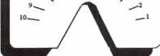

Call 1-800-645-5657

MasterKard prints any kind of code card for new locks, old locks, even locks that haven't been invented yet! With MasterKard you'll never buy another code card again and never have to wait weeks or months for a new code card to be made. Print millions of differ­ent code cards on white or brightly colored florescent papers, even heavy card stock too. Requires laser printer.

**Order # MasterKard 18995**

ITL-950

CodeMachine

Compatible*

Code Books on Computer from $399

CodeMaster™ is 20 Code Books on com­puter disk with virtually ANY code you'll ever need for American & Foreign Auto, Cycles, Padlocks, File Cabinets, Office Furniture, Tool Boxes, Letter Boxes, Luggage, Utility Locks, Vending Ma­chines and more! Full set is S679 (easy pay plan avail) or, purchase just what you want (Auto or General Codes) for just $399 (no payment plan avail) then up­grade to the full set later if you want to.

All info is on screen including bitting, space & depths, Ilco-Silca & Curtis Key numbers, 1200CM card number, Framon dimensions, silhouetted picture of the actual key cuts and more. Print out code info, indexes, work orders and authoriza­tions too. Want more? Our industry exclusive CodesOnCall™ hotline lets you get codes 24 hours a day using any touch tone phone, with or without a computer!

IMPORTANT NEW FEATURES

* Virtually ANY code you’ll ever need.
* CodesOnCall 24 Hour Service lets you get codes with or without computer!
* Search by code, application, key blank, even just a few matching characters!
* See actual drawing of cut key on screen
* Finds codes in less Than 1 Second
* Includes Ilco-Silca-Curtis Blank #'s
* HPC Card Number & Framon Specs
* Optional ITL Code Machine Mod­ule lets you cut keys by computer
* Optional MasterKard™ module lets you print code cards on laser printers
* New update subscription just 39.95
* Easy pay plan avail (full edition only)
* Or...buy just Auto or General codes now then up-grade to full edition later.
* Works on Palmtops, Note Books too
* OK for Novell or Lantastic Networks

|  |  |  |  |  |
| --- | --- | --- | --- | --- |
|  | Category orMfg | Application | Deo# |  |
| ' lKlSj^00,-30000 | HOMAK | TUBULAR | 1137S |  |
| 11R001-72R110 | FOREIGN AUTO | VW | VW71A |  |
| R1-R250 | YALE | DRAWERS | S7JA |  |
| R01-R02000 | FOREIGN AUTO | MASERATI | X50 |  |
| RR1-RRI00 | CHICAGO | FILE CABINETS | 104IT |  |
| 00001-22185 | FOREIGN AUTO | PATHFINDER | X237 |  |
| 10R01-16R99 | PADLOCK | MASTER | 1092V |  |

**Fl=Menu F2=Ma!Hifactim-'x Hotline FJ=Automotive Search F4=General Code Search F9= Repeat Last Search F10= Special**

Now 20 Code Books On Computer!

All Padlock Codes Included FREE (Save $200.00)

Full Set s679 Auto or General Codes s399*

(*upgrade to full set later for $280 if you want to) **Everyone** qualifies for the Treskat USA **Full Set** easy pay plan! 10 payments of 67.90 each-pay as you go. No application—no questions asked! Call Ray Nazzaro now at 1-800-645-5657 for **instant approval** and get started today.

Free Information - Reader Service Card #99



Legislative

**L Ipriate**

poHrTnreenan, CPL, CPS Committee Chairman

“Who is a locksmith? Tripth is, all you have to do is say you are a locksmith, and you are.”

Are you for or against licensing? This seems to be the topic of late. Nearly every industry publication or association newsletter this past year has a letter to the editor, an article, or an editorial about legislation.

Many locksmiths have complained that the police should leave car opening to lock­smiths—that lock picks and locksmith tools should only be sold to locksmiths—but who is a locksmith? What do you have to do to become a locksmith? The truth is, all you have to do is say you are a locksmith, and you are. There are no rules, no minimums, no requirements, no prescribed training, no testing, no background investigations. There is just the desire to call yourself a locksmith and you are as much as locksmith as the largest locksmith company in town. Therefore, anyone is a locksmith and anyone can open cars and anyone can buy locksmith tools.

I believe that the public assumes that the locksmiths are being regulated—that some­one is watching us. They believe that we are not convicted felons—that we have liability insurance, that we ask for identification when we provide access to vehicles, homes, businesses, safes and other secured areas.

They presume that we possess the skills and knowledge to competently recommend, pro­vide, install and service their security needs and products.

Well-written locksmith legislation should require that locksmiths be knowledgeable by passing a minimum test. That they are

responsible—by carrying a minimum amount of liability insurance. That they are trustworthy—by having background investi­gations. That they are careful—by asking for identification from consumers requesting access to secured areas. That there be penal­ties for non-compliance. The ALOA model law addresses these issues.

Legislation will require additional paper­work and it will require additional cost. It will also include the definitions of: Who is a locksmith? What do you have to do to Decome a locksmith? It will give locksmiths an identity and a firm ground to stand on when asking police to not open cars, and when asking mail order catalogs not to sell locksmith tools.

Next month: Part two of “Are You For or Against Legislation?”

***Legislative Comment is written by John Greenan, CPL, CPS, on behalf of ALOA’s Legislative Committee. Comments or questions can be direct­ed to him at: Fink Safe & Lock; 2307 N. Western Ave.; Chicago, IL 60647; (773} 486-2030; FAX (773} 486-4268. To contact ALOA’s national lobbyist: John Chwat & Company; 635 Slaters Lane, Suite 140; Alexandria, VA 22314; (703} 684-7703; FAX (703} 684-7594; E-mail chwatco@erols. com***

I About the Chairman: John

Greenan, CPL, CPS, is a fifth generation lock-  
smith and is vice president of Fink Safe & Lock in  
Chicago, IL. A locksmith for the past 12 years,  
John has also served on ALOAs Convention and  
Strategic Planning committees. He is chairman of  
the Allied Locksmiths of Illinois.

**Legislative Action Contact Network**

I am interested in:

* Working on Legislative Issues
* Fundraising
* Gathering/Giving Information

Company Address

Home Address

Telephone FAX e-mail

January 1997 Keynotes



They tell you your kid has spina bifida.

You cry. And you curse. And you clench that tiny new baseball mitt in your hands and vow never to throw it away.

It may take time, but you will play catch with your son.

Hope. That’s what Easter Seals  
is all about. At some point in their  
lives, 1 in 5 Americans will be  
affected by a disability. We  
provide physical, recreational  
and speech therapies to help  
children born with disabilities  
live with independence, dignity

and equality. But we  
can’t do it without  
your help. Support  
Easter Seals. Give  
ability a chance.

© 1995 National Easter Seal Society



Keynotes

January 1997

Upcoming

1 EveftS

February ’97

5-9

Texas Locksmiths Association Convention and Trade Show Corpus Christi Marriott Bayfront

Corpus Christi, TX Contact: Michelle Spears (409) 297-2413

8

Grand Canyon Chapter, ALOA Door Closer & Safe Deposit Mini Classes Bostrom High School Phoenix, AZ Contact: John Ilk, CRL (520) 474-0147 (work)

(520) 474-8879 (home)

(602) 420-2174 (page)

8 & 9

West Coast Lock Collectors

Association

Event

Embassy Suites Hotel Arcadia, CA

Contact: Robert Heilmann (310)230-3004

21

Vindicator Corporation Training Classes for Microlock Contact: Tamara Martell (512)314-1200 [lock@vind.com](mailto:lock@vind.com)

March ’97

11-14

ISC Expo

1997 Conference and Exposition

Las Vegas Convention Center Las Vegas, NV Customer Service (203) 840-5602

15

Vindicator Corporation Training Classes for Vindicator Lock II

Contact: Tamara Martell

(512)314-1200

[lock@vind.com](mailto:lock@vind.com)

15-16

Southern Lock

Annual Southern Lock Buyers Trade Show

St. Petersburg Bayfront Hilton St. Petersburg, Florida Contact: Bill Underwood (813) 541-5536

April ’97

19

Vindicator Corporation Training Classes for Microlock Contact: Tamara Martell (512)314-1200 [lock@vind.com](mailto:lock@vind.com)

May ’97

16

Vindicator Corporation Training Classes for Vindicator Lock II

Contact: Tamara Martell

(512)314-1200

[lock@vind.com](mailto:lock@vind.com)

Future Conventions

1997

ALOA ‘97, July 27-Aug. 2 Reno, NV

SAFETECH ‘97, May 5-10 Louisville, KY

SERLAC, Sept. 24-28 Grenelefe, FL

24th annual Tri-Regional Security Conference, Oct. 21-26 Bellevue, WA

1998

ALOA ‘98, June 15-20 Nashville, TN

SAFETECH ‘98, May 4-9 Valley Forge, PA



1999

ALOA ‘99, July 25-31 Cincinnati, OH

SAFETECH ‘99, May 3-8 Las Vegas, NV

2000

ALOA 2000, Date TBA Las Vegas, NV

SAFETECH 2000, May 8-13 Lexington, KY

2001

ALOA 2001, July 15-21 Baltimore, MD

For PRP dates, see p. 52.

For ACE dates, see p. 56.

Send in the dates of your orga­nization’s activities today!

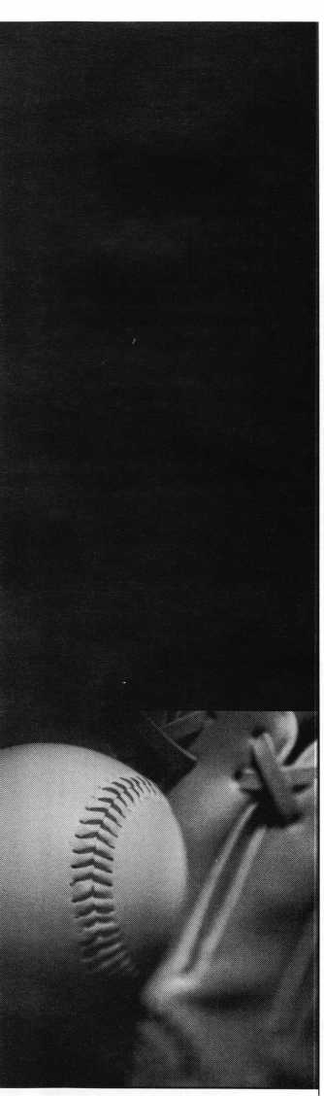

Applicants

For Membership

ALABAMA

Mobile

026537, D Haab, A SPONSOR: Diane Foto

CALIFORNIA

Eureka

026524, Bill H Davidson, A

COLORADO

Louisville

026540, John B Apjoke, A

CONNECTICUT

Bozrah

026539, Mark D Bennett, A SPONSOR: Charles McPherson

Stamford

026542, Alfonso C Sgritta, A SPONSOR: Alfonso Sgritta

FLORIDA

Mary Esther

026548, John W Leach, A

IDAHO

Boise

026522, Randy P Godfrey, A

ILLINOIS

Belvidere

026529, Arthur T Pankhurst, A SPONSOR: Bill Robertson

INDIANA

Hammond

026515, Patrick T Loughney, AP SPONSOR: Allen Konrath

LOUISIANA

Lake Charles

026547, David J Gramger, A SPONSOR: Kenneth Andrews

Metairie

026516, Dera A DeRoche, A

MASSACHUSETTS

Boston

026512, Keith S Mathews, A Bridgewater

026527, Peter V Bumpus, A SPONSOR: Michael Cornell

Stoughton

026517, Todd W Hewins, A

Worcester

026510, Fred T Rubio, A

MARYLAND

Lanham

026521, Eric O Perry, A

MICHIGAN

Detroit

026546, Michael J Hubbard, A SPONSOR: Matthew Knoche 026518, Kevin J Sykes, A SPONSOR: Matthew Knoche

East Lansing

026523, Karl F Gruber, AP SPONSOR: Julio Hernandez

MISSOURI

Chesterfield

026545, Michael D Gaines, A SPONSOR: Steven Wehofer

MISSISSIPPI

Columbus

026551, David J Turner, AP SPONSOR: Thomas Cole Stennis Space Center 026519, Richard Brady Sr , A

NORTH CAROLINA

Charlotte

026538, Joe J Silvestri, A SPONSOR: A Hoffman

Gastonia

026533, Michael H Martin, A SPONSOR: UW Hunt 026535, Timothy P Martin, A SPONSOR: UW Hunt

Lenoir

026543, Matthew S Eggleton, AP SPONSOR: Harold White

***The following applicants are scheduled for clearance***

***as members of ALOA The names are published for  
member review and comment prior to February 1, 1997,  
to ensure applicants meet standards of ALOArs Code of  
Ethics Protests, if any, should be addressed to the Mem-  
bership Department and must be signed. Active Mem-  
bership applicants (A) have worked in the industry two  
or more years. Allied Membership (ALJ applicants are***

***not locksmiths, but work in a security-related field.***

***wo***

*ire*

NEW HAMPSHIRE

Rindge

026525, John F Weir, A SPONSOR: Ronald Hagstrom

SOUTH CAROLINA

Surfside Beach

026528, Michael Chaky, A

SOUTH DAKOTA

Yankton

026550, Thomas C Petersen, AP SPONSOR: Scott Hansen

HONG KONG

Kowloon

026536, Shiu Chan, A SPONSOR: Hin-chor Mak

MACEDONIA

Skopje

026532, Jane V Skenderov, A SPONSOR: Nikolay Trendafilov

TENNESSEE

Knoxville

026549, Hobert C Banks, AP SPONSOR: Marian Swann

TEXAS

Arlington

026526, Lyndon Armour, AP SPONSOR: Kent Mikesell

Houston

026513, Gary E Bartlett, A SPONSOR: Ruben Lopez

Odessa

026511, Frank M Beam, AP SPONSOR: Dale Shaw

San Antonio

026530, James A Rowell, A

WASHINGTON

Vancouver

026520, Richard L Sweet, A

WISCONSIN

Neenah

026541, Todd SLaflin, A SPONSOR: Robert Erdmann

BAHAMAS

Nassau

026531, John N Zervos, A SPONSOR: Clinton Harding

ENGLAND

Essex

026544, David K Crossman, A SPONSOR: Peter Wosahlo

January 1997

Keynotes



**Industry**

News

Direct Buying at Medeco

Beginning Jan. 13, 1997, locksmiths and security professionals will be able to buy direct from Medeco Security Locks. This change allows for immediate access to deliv­ery of thousands of items from the Quick Shop facility, better pricing, direct sales and technical and marketing support, and a quicker response to the product and service needs. The company’s Quick Ship facility in Salem, VA, which will be staffed with cus­tomer service representatives and technical support and completely stocked, will be able to deliver orders by the next day by 10:30 a.m. local time.

Locksmiths may call toll free (800) 839- 3157 weekdays from 7:00 a.m. to 5:00 p.m. local time to place orders or receive techni­cal assistance.

For more information on becoming a fac­tory authorized dealer, call (800) 839-3157.

Getting to Know You

Getting to Know You, the largest home buyer welcoming program in North America, reports that 16.5% of homeowners plan to install a security or alarm system, and 13.9% of homeowners are seeking the ser­vices of a locksmith. In 1995, Getting to Know You packets reached over one million homes and featured 52,000 merchants and professionals. Only one business or service in a particular industry is printed in each directory, giving sponsors exclusive expo­sure. For more information, call Joyce at

(800)255-4859, x2517.

Moving

Beginning Jan. 2, 1997, Silca Keys USA, Inc. will have a new address:

5633 Hudson Industrial Parkway Hudson, OH 44236 (216) 656-5613 (phone)

(800) 648-9239 (toll free)

(800) 637-7361 (fax)

Please continue to remit payments to:

Silca Keys USA, Inc.

Box 1175218

Cleveland, OH 44011-2199

Although they will continue to accept



orders, Silca Keys USA, Inc. will be closed for inventory Dec. 21st through Jan. 6th.

Yellow Book

Interested in local advertising that taps into your specific market area? The Yellow Book is a highly localized, concise and easy to read phone directory that is delivered free to homes and businesses in the target area. Easily distinguished from the Yellow Pages, the Yellow Book is compact with large type. The Yellow Book also includes a “blue pages” section with import addresses and phone numbers. For more information, contact: **Larry Getlen Communications Group (561) 392-2300**

25th Annual Show and Conference

The American Security Distribution’s 25 th Annual Security Show and Educational Conference will be held April 8-13, 1997 at the Disneyland Hotel in Anaheim, California.

There will be over 80 classes and semi­nars offered on everything from manage­ment to marketing. The security show, held on April 12-13, will feature exhibits from over 200 of the industry’s leading manu­facturers.

For more information and a registration packet, call (800) 844-8545, x293.

Akron Handles Ives

The H.B. Ives line of door hardware prod­ucts will now be handled by Akron Hard­ware Consultants. The Akron Hardware sales staff has received Ives factory and in- house training so they will be familiar with every aspect of the Ives line. The company stocks approximately 700 different Ives items at the Ohio and Arizona warehouses. For more information, contact:

Akron Hardware Consultants 2579 South Arlington Road Akron, Ohio 44319 (800) 321-9602 (phone)

(800) 328-6070 (fax)

DHI Convention

The Door and Hardware Institute’s (DHI) 1996 Annual Convention and Exposition in Cincinnati, Ohio had an attendance of 3,800-a 19% increase over the previous year.

The DHI Convention and Exposition offers technical education, an extensive trade show, networking opportunities and profes­sional speakers. Next year’s Convention and Exposition will take place September 27-29 in Charlotte, NC. For more information, visit the DHI website at http:W[www.dhi.org](http://www.dhi.org) or call (703) 222-2010.

Aviation Security Conference

The Seventh International Aviation Security Conference will be held in Washington DC. on June 9—11 at the Ramada Renaissance Tech World Hotel. For additional informa­tion, contact:

Teresa Cendrowska, ASTM (610) 832-9718 (phone) [tcendrow@astm.org](mailto:tcendrow@astm.org) (e-mail)

Airborne At The Top

At a recent awards ceremony for outstand­ing commitment to customer service, Air­borne Express was named the number one company for “Most Improved Customer Service.” The nomination came from a nationwide survey, conducted by Knowl­edge Exchange, of more than 100 senior managers of U.S corporations. Call Airborne Express at (800)-MEMBERS (800-636- 2377, 8 a.m.-7 p.m. EST) for information on special member rates.

Name and Location Change

The Acme Security wholesale division of Acme Security Systems now has a new name and location:

Access Hardware Supply, Inc.

14359 Catalina St.

San Leandro, CA 94577.

Cencon Tops For ATM

NCR, a world leader in cash management devices, has chosen Cencon System 2000 from Mas Hamilton to be a key component

Keynotes

January 1997

|  |  |
| --- | --- |
|  | Industry |
|  | News |

of NCR’s First Line Maintenance program. Customer Service Vice President Gary Cot- shott says, “The Mas Hamilton lock is a perfect fit with NCR’s strategy to provide our customers a revolutionary and cost- effective solution to today’s most serious security challenges.”

For more information on Mas-Hamilton products, contact the company at (606) 253-4744; FAX (606) 253-4748; website [www.mas-hamilton.com](http://www.mas-hamilton.com)

■Other Local Reports Northwest Locksmiths

The Northwest Locksmith Association announces a change in officers:

President—Mike Forbragd Vice President—Charles Pigue Directors—Dean Nickel, Mike Stanley Secretary—Bert Balch Treasurer—Robert Kotovic

MLANJ and ALOA

The Master Locksmiths Association of New Jersey recently held their 65th Anniversary Convention in Atlantic City, NJ. The main objective of MLANJ has always been educa­tion, and there were 18 classes given over the four days with a total of 388 partici­pants. Allen C. Halverson taught three sell­out classes, “Basic Locksmithing,” “Impres- sioning,” and “Lock Picking.” Kellena Dunckley taught a real “hands on” class, “Vindicator Certification.” Steve Young debuted with “Import & Domestic Car Opening” and “Domestic Auto Lock Servic­ing.” And another popular newcomer was “PRP Prep,” instructed by William Neff, CML.

There were 160 booths on the exhibit floor and more than 144 manufacturers, dis­tributors, and trade organizations. The din­ner dance was held at the Trump Plaza on Saturday evening, and banquet chairman, Mike Ambrosi, CRL, was presented the Robert Bell Award.

Thanks to the efforts of the vice president of Convention, Nick Ambrosi, CPL, the booklet chairman, Harry Printz, CML, the registration chairman, Stewart Levine, CML, and the members and industry personnel, it was one of the best conventions to date.

West Coast Collecting

The 20th annual West Coast Lock Collec­tors Show & Sale will be held Feb. 8-9 in Arcadia, CA. Admission is $3 and experts will be on hand to buy or appraise col­lectibles. Many outstanding displays of antique padlocks, safes, locks and keys will be available for viewing Saturday and Sun­day morning, with the annual auction at noon Sunday.

For information contact Bob Heilmann, c/o Ace Lock & Key; 1427 Lincoln Blvd.; Santa Monica, CA 90401; Evening only phone (310) 230-3004.

Deduct Christmas Leftovers

Regular (C) corporations can earn a federal income tax deduction on inventory that did not sell during the holiday season when the inventory is donated to a qualified charity. Regular (C) corporations may deduct the

cost of the donated inventory plus half of the difference between cost and fair market value. Deductions may be up to twice cost.

S corporations, partnerships and sole propri­etorships can earn a straight cost deduction. For a free guide that explains the deduction process, and a formula for calculation poten­tial tax savings, call the National Associa­tion for the Exchange of Industrial Resources at (800) 562-0955.

Breakfast Meetings

The American Society for Industrial Securi­ty (ASIS) has begun its series of breakfast meetings for private security and public law enforcement professionals. The bimonthly meetings will include a speaker addressing pertinent topics. The next breakfast meeting is tentatively scheduled for February ’97.

Call (703) 312-6304 for more information.



**MAHA WHOLESALE Hardware**



FOLGER ADAMS MEDECO VON DUPRIN SCHLAGE LCN

NORTON

ROTON

YALE

DOR-O-MATIC LOCKNETICS ALARM LOCKS MAG. SECURITY LORI WEISER

YOUR RELIABLE HARDWARE SUPPLIER  
**\*GET IT QUICK\***

WE HAVE IT BEFORE YOU NEED IT!!

CALL TOLL FREE

800-238-4566 Fax: 800-538-4566  
402-444-1662 402-444-1668

CALL OR WRITE FOR FREE CATALOG



Security

Marketplace

Open and Shut Case

DoorKing introduces the Gate Tracker, a device designed to report operator statistics to a DoorKing programmable entry system to track all gate operator activity

Information is sent to a DoorKing 1815, 1817, or 1818 entry system 24 hours a day. The Gate Tracker reports on obstructions, operator cycles, forced entry attempts and failed loops, for example. With the Gate Tracker, gate operators, card readers, trans­mitters, and telephone entry systems are all linked, which allows programming, activity reports, and trouble shooting to be done from a PC.

For details on the Gate Tracker, call 800- 826-7493.

Reader Service #1

Tanner’s Going Nuts

Tanner Bolt and Nut Corporation announces an expanded selection of Tri­dent™ tamper-resistant nuts to use with bolts, machine screws, threaded rod and masonry anchors. The Trident Nut is cur­rently utilized in correctional institutions, hospitals, schools and other public and pri­vate facilities for securing electrical equip­ment, inmate furniture, traffic signs, com­puters, park benches, outdoor play equip­ment and tamper-resistant fasteners. Trident Nut specification sheets and a new Security Fastener Catalog are available upon request. Call (800) 456-2658.

Reader Service #2

Look Ma, No Wires!

Napco Security Systems, Inc. introduces the GEM-TRANS2 Wireless Window/Door Transmitter. The two-point unit features simple installation, a long life lithium bat­tery and reversible mounting positions. The GEM-TRANS2 is also supplied with a built-in reed switch, magnet, tamper and terminals.

For more information on Napco’s Gemini Product Line, call 800-645-9445.

Reader Service #3



The Right To Bear Approval

Vindicator’s MicroLock™ 20 and the MicroLock 30 have received the right to bear the highest security listing, the Type 1 Underwriter’s Laboratory mark. The MicroLock 20 and the MicroLock 30 are combo-key locks that are used with a MicroKey for ATM access. The dynamic combinations change with each use and since neither the combination nor key is sufficient to access the safe on its own, combo-key technology significantly increas­es the level of security. Call 512-314-1200 for more information on these locks.

Reader Service #4

Smile, You’re on Video!

Samsung Opto-Electronics America intro­duces the Picaso (SM) model SVP-4200, an advanced video presenter that uses a high resolution color CCD camera to capture images of flat or 3-D objects for video dis­play. An on-screen menu allows for easy set­up, a freeze frame function eliminates hand shuffling, and a microphone input and built-in amplifier with volume adjustment are provided. Two halogen lights are built into the camera, and break down is designed to be simple and compact. For more information, call 210- 902-0347.

Reader Service #5

One Thousand or Two?

JLM Wholesale now stocks the 1000 Series and the 2000 Series, two new SpaceSaver Electric Bolt Locks by Security Door Con­trols. The SpaceSaver fits in IX inch diame­ter frames with no wires in the door, and the UL listed auxiliary locks are mounted in the side jamb or header. The entire lock is concealed for simplier installation.

There are 12 design models in fail-safe or fail secure, 12 or 24 VDC, for any applica­tion need. Direct bolt throw designs are also available.

Call 800-522-2940 for more information.

Reader Service #6

Give ’Em The Slip

National Invention Services, Inc. introduces

The Slip, an audio decoy that gives the appearance of a stock radio. The Slip can be attached to the existing system by magnets, Velcro or with a slip-over edge made from a flexible plastic or rubber-like material. The Slip will benefit owners of expensive auto­motive audio equipment, insuring compa­nies and law enforcement agencies. The Slip fools passerbys and would-be thieves.

For more information about The Slip, now available to manufacturers for licensing or sale, contact National Invention Services, Inc., 4133 Hwy 17 N. Pawleys Island, SC 29585.

Reader Service #7

Very Safe

Lockmasters, Inc. introduces a new style GSA Safe Saver Pin, approved for use in the repair of Red and Black Label containers. Since a hole no larger than a quarter inch can be used when opening and repairing this equipment, the GSA Safe Saver Pins are only available in quarter inch. As with the regular Safe Saver Pins, drilling a properly installed GSA Safe Saver Pin is much more difficult to drill than any of the hardplate currently available. To order the GSA Safe Saver Pin, call 800-654-0637.

Reader Service #8

Turn the New Keys

Jet Hardware introduces the immediate availability of new key blanks for BMW, Toyota and Volkswagen automobiles. For a Catalog No. 596 supplement outlining these additions, contact Jet at 800 Hinsdale Street, Brooklyn, NY 11207.

Reader Service #9

Hello? Is Anyone Out There?

Blue Mountain Technologies announces the TU-DOR Doorman, a new, relatively inex­pensive front door intercom that allows resi­dents to answer the door from any phone in the house. The video Doorman includes a built-in camera that lets residents see any­one at the door on a TV or dedicated moni­tor. When the doorbell rings, the resident picks up the phone and is connected to the

Keynotes

January 199/

**Security**

Marketplace

door station. If someone calls when a resi­dent is on the intercom, an electric tone will sound, and simply hitting the phone’s hook switch connects the resident to the out­side call.

The Doorman is available in flush or ser­vice mount, and in black or white.

For more information, call 800-883-9388.

Reader Service #10

Safe Money

NCR has purchased 10 thousand Cencon System 2000 high-security locking devices from the Mas-Hamilton Group. The Cen­con System 2000 lock is designed specifical­ly for ATM security through the combined use of exception lock hardware, software and smart keys and enables users to control access ATM safes through one central authority.

The Cencon System 2000 also provides audit trail and retrieval capability at each lock, as well as time delay, silent duress and easy retrofit.

For more information, call 800-930-4744.

Reader Service #11

Arm of Steel

Sargent and Greenleaf announces the new Arm-A-Door, the first-of-its-kind back-door panic push bar. The Arm-A-Door provides the high security of a metal drop bar and easy-exit panic push-bar for life threatening situations. Made of 12-gauge telescopic steel tubing, the Arm-A-Door meets the life- safety codes of the National Fire Protection Association.

The Arm-A-Door offers water-resistant alarm and automatic relocking options. Standard installation takes about an hour.

For a demonstration video, call 800-800- 1194.

Reader Service #12

Lockinbar Lands in the US

A new security system, Lockinbar, is now being distributed in the United States. Easi­ly installed on the inside of the window and removed by key or foot pedal release, the Lockinbar locks intruders out without lock­

ing you in. All mounting hardware is con­cealed, and the Lockinbar can either be cus­tomized and shipped, or sent in 8-foot stock lengths.

For information on distribution, price lists or general information, call 503-318-1646.

Reader Service #13

Check Out This Point

Checkpoint Access Control Products Group introduces the AC-160 Series Keypads designed to provide reliable security under adverse conditions. Housed in weather-resis­tant Lexan for indoor and outdoor use, the AC-60 line is used for commercial and industrial facilities, schools, hospitals and businesses.

The AC-160R, AC-160RV, and the AC- 160RH accommodate an integrated prox­imity card reader within the keypad cover, making for smooth, sturdy installations and higher level security. The units are compati­ble with a wide range of other panels and Checkpoint’s Threshold Systems. Call 800- 257-5540 for more information.

Reader Service #14

**■Reference Material** Electrifying Literature

Security Door Controls (SDC) New Electric Bolt Lock Literature is now available from Security Door Controls (SDC). The book­let—which provides directions for easy installation and servicing, detailed opera­tions, metric dimensions and ordering infor­mation—comes with complete descriptions, photos, diagrams and specifications.

The SDC Electric Boat Lock Literature includes the SpaceSaver design for narrow frames, direct throw for wood frames, sur­face mounted, Electro-Mechanical GateLok, and the PanicLok for access con­trol of emergency panic devices. A com­plete line of SDC manufactured electric locking hardware and accessories is also included.

To order, call 805-494-0622.

Reader Service #13

Cutting Edge Catalog

Security Lock Distributors has issued its lat­est catalog of Life Safety and Security Prod­ucts. Containing detailed information on specifications, operational characteristics, finishes, functions, accessories and options, a copy of this 525 page catalog is yours free when you contact Security Lock Distribu­tors at 800-847-5625.

Reader Service #16

Closure Brochure

Dorma Door Controls, Inc. introduces a four-page, two-color brochure describing the ITS 96 closer. The ITS 96 closer is a new size adjuster closer for completely con­cealed door control where aesthetics or van­dal resistance are concerns. Consisting of a closer and track that can be concealed in the door or the header, the ITS 96 features a highly efficient cam and roller design with adjustable spring force sizes 1-3, according to the manufacturer.

For additional information, call 1-800- 523-8483.

Reader Service #17

Master of Master Keying

Fundamentals of Master Keying by renowned instructor Jerome Andrews, CML, has recently been reprinted and is available from the Associated Locksmiths of America, Inc.

The 232-page book covers system struc­ture and recordkeeping; basic mechanical and arithmetric concepts; and writing a sys­tem.

To order, send $44 (includes postage and handling) to: ALOA; 3003 Live Oak Street; Dallas, TX 75204; FAX (credit card orders only) 214-827-1701.

Reader Service #18

k_

January 1997

Keynotes

Board

Reports



(Spec]

Bylaws Committee

Members Present: Chairman

1. King; M. Blum, A.

Hoffman, L. Passarello, J. Shandy, R. Simpson, B. Tarbet,

1. Lowell Ex-officio, Members ExcusedJ. Andrews, Staff Present: C. Gibson

The meeting was called to order at 1:42 p.m. on November 15, 1996 at the Harvey Hotel in Dallas, TX.

The minutes of the previous meeting were approved as circu­lated.

The committee considered a suggestion by Ray D’Adamo for vote by mail, however no action was taken because voting by mail is not permitted under New York law.

The committee will develop a procedure manual. The manu­al will clarify where the com­mittee takes its direction from to draft proposals of change to the bylaws. This would avoid spending time drafting changes which the committee does not believe are valid or has no idea whether the board would ratify.

The Bylaws Committee rec­ommends that the Nominating Committee propose a full slate of candidates for all positions available at the 1997 member­ship meeting. Positions carried over as a result of lack of quo­rum in 1996 will be considered to have filled one year of the new term and the nominating committee will propose time periods for the new the slate accordingly.

The committee brings the following motion to the board with a second:

To interpret Article VII as providing the normal and mini­mum membership power of

electing 1/2 of the officers and 1/3 of the directors. Giving the membership the power to fill a larger number of elected posi­tions when more vacancies are available at the membership meeting is well within the spirit of the bylaws.

Meeting was adjourned at 4:51 p.m.

Carl King, CML-Chairman

Chapter Committee

The Chapter Committee was called to order at 2:00 PM on November 15, 1996

Members present were: D. Barnum, CML Chairman, J. Watt, CML, CPS V. Chairman, B. Leas, CRL, T. Ramunno, CML, CPS, B. Straub, CML, H. Printz, CML Trustee, M. May Staff Liaison, T. Hood, CML Excused, T. Freehling, CML Excused. D. Rule, CML Excused, E. Wersonick, CML, CPS Excused

The minutes from the last meeting were accepted as circu­lated.

The ACE class rebate pro­gram was discussed. Education informed Chapter committee that all chapter classes will be given on a cost + 10% basis which should actually result in lower chapter class costs.

The Chapter Officer Training Program was reviewed and it was thought that the ALOA Board of Directors should par­ticipate in the program.

The committee brings the following motion to the board with a second.

To hold a Officers Training Course for the ALOA Board of Directors at the next board meeting.

The meeting was adjourned

at 2:45 PM.

Dana Barnum, CML Chairman

Convention Committee

The Convention Committee Meeting was called to order on November 14, 1996, at 1:15 pm at the Harvey Hotel in Dallas, Texas.

The following were in atten­dance: Raymond C. Lusk, CML, Chairman; Dallas C. Brooks, Vice-Chairman; John J.

Greenan, CPL, CPS; Dana L. Barnum, CML; Mark E. Blum, CML, CPS; Barry K. Leas, CRL. Excused: Rick L Ohmit, CML; Donald E. Rule, CML. Ex- Officio: David M. Lowell, CML, CMS; James H. Glazier, CML. Staff Liaison: Carmen D. Murphey, CMP. Guests: Jessica D. Vasquez, Janelle L. Vergara, Charles W. Gibson, John D. Cannon, CML.

The Convention Committee submits the following report: The committee discussed plans for ALOA ‘97 to be held in Reno, Nevada. The host hotel will be the Reno Hilton. The convention will be held at the Reno-Sparks Convention Center. The proposed promo­tional schedule for ALOA ’97 Security Expo was discussed. An approximate increase of 90% in exposure is planned.

Advertising in additional relat­ed industry publications will be implemented.

Due to the changes in the convention format a proposed ALOA ’97 package pricing was discussed and accepted with the change to free exhibits. Attached.

The committee discussed hotel location from airport and

convention center. Shuttle schedule during classes and Security Expo was discussed and every effort will be made to avoid the long waiting..

Carmen updated the com­mittee on contracts for future sites. After much discussion and price considerations, the deci­sion was made not to cancel Cincinnati. Committee and staff will work extremely hard to promote attendance for the next two years in order to make Cincinnati a successful conven­tion.

The committee discussed the rotation plan beginning in 2000, Las Vegas (West); 2001, Baltimore (East); 2002, Chicago/Rosemont (Central).

The committee brings the following motions to the board with a second:

To change the name of the 1997 trade show from ALOA ’97 International Trade Show to ALOA ’97 Security Expo.

To initiate a three city, nine year, rotation plan of Las Vegas, Baltimore, and

Chicago/Rosemont beginning in the year 2000.

The meeting adjourned at 4:00 pm.

Ray Lusk, CML Chairman

Education Committee

The ALOA Education Committee Meeting was called to order November 14, 1996 at 8:00 am at the Harvey Hotel in Dallas, Texas. Those in atten­dance were Chairman, James H. Glazier, CML; Vice-Chairman, Robert H. Stafford, CPL; Recorder, Bruce J. Tarbet, CML; Breck H. Camp, CML; Carl King, CML; Convention

16**1** ***Keynotes***

January 1997

**Board**

Reports

Chairman Liaison, Raymond C. Lusk, CML. Staff present were Carmen D. Murphey, CMP; Jessica Vasquez, and Janelle Vergara. Members-at-Large, J. Thomas Hood, CML and Thomas P. Freehling, CML were excused.

The minutes from the previ­ous meetings as circulated were approved.

The committee reviewed and discussed the status of all ongo­ing projects.

The Education Committee requested that we start the lock­smith Manual production for 1997.

Education Chairman was directed by the Committee to get the final curriculum materi­al to and back from the instruc­tors. Chairman was then requested to bring together the List Council at the Spring Board Meeting to complete the glossary.

Education Chairman will rec­ommend to the board that Jim Glazier is to conduct the Association Officers Training during the Spring Board Meeting.

The list of proposed classes and seminars for ALOA ’97 was presented to the Committee. Discussion and adjustments were made. Staff was directed to include a banner indicating new classes in the ALOA ’97 brochure.

It is the committee’s policy on convention lunches- Instructors, assistant instructors, board members, volunteers, and staff are entitled to class lunches during convention unless prior arrangements are made. Additional guests will be charged the cost of the meal.

Profit and loss statements for

1. ACE Classes was reviewed. Classes scheduled for
2. were reviewed and dis­cussed.

Pine Tech’s request for PRP designations was discussed. The Committee suggested that ALOA would offer PRP sittings at Pine Tech to students upon graduation.

A letter from Ray D’Adamo was discussed and no action taken other than offer to the board for discussion.

Committee adjourned at 12:00 Noon.

James H. Glazier, CML Committee Chairman

Finance Committee

Members Present: D. Brooks, Chairman, J. Cannon, Vice Chairman, M. Blum, J. Glazier, R. Lusk, L. Passarello, R. Simpson, D. Lowell, Ex-officio.

Staff: B. Gibson, K. Romo, C. Murphey, Guests: Several other board members were in attendance at various times.

The meeting was called to order at 8:00 AM.

Minutes from the spring meeting were accepted as circu­lated.

The committee made adjust­ments to the trial budget based on the input that was received during the past week. The final budget will be completed in time to be presented to the entire board on Sunday.

The following motion with a second is brought to the board:

That the budget attached to this report be approved for 1997.

The meeting adjourned at 5:15 PM.

Dallas Brooks Committee Chairman

Legislative Committee

Chairman: John J. Greenan, CPL, CPS, Vice-Chairman: Jeff Nunberg, CML, CMS (excused), Recorder: Randy Simpson,

CML, Committee: Dallas Brooks, Hank Printz, CML, Steve Engel, CML, Lobbyist: John Chwat Staff: Col. Charles W. Gibson, Ex-Officio: David Lowell, CML, CMS, Guests: Greg Drake, AHC, Howard Johnson

The legislative committee met on Thursday, November 14, 1996. John Chwat explained the benefits of the new SIC code for locksmiths and will write an article for Keynotes to explain to the membership the benefits of this new code.

The committee discussed the Private Security Officer Quality Assurance Act (HR2092). This bill could define the security industries and does not include locksmiths. John Chwat will work with the representatives of the other security industries to include the locksmiths in this bill when it is reintroduced this year. If Mr. Chwat is unable to work out an agreement with these people, we will begin a grassroots lobbying effort to oppose this bill through the Federal House and Senate.

The ALOA Legislative com­mittee chairman will continue to work through the NBFAA and NASIR to include lock­smiths in any bills at the state and local levels.

Several states were reviewed for legislative activity in 1996.

A plan to continue to develop

the legislative contact program was discussed. The program will work as follows Chwat will con­tact the committee Chairman and Staff Administrator upon finding issues that concern ALOA. A mailing explaining the issue will be sent to the Legislative Action Contact Network, ALOA Chapters, local associations, ALOA members, distributors and manufacturers in the state that may be affect­ed.

Howard Johnson was avail­able for discussion about the lawsuit and proposed legislation in Texas. A proposal to postpone the pending lawsuit until the outcome of the 1997 legislative session has been sent to the Assistant Attorney Generals Office.

It was determined that a coalition of members from ALOA, NLSA and DHI should be formed to address and lobby issues that affect our industries

M/M Simpson/Engel to set up a meeting with DHI, NLSA and ALOA members with dates and location to be set ASAP to discuss fundraising and policy. Carried.

John Greenan and David Lowell will appoint this com­mittee.

Mr. Chwat and Guests were excused.

Budget discussion was held and it was decided that the final budget will be contingent upon the group meeting with DHI and NLSA.

John J. Greenan, CPL, CPS Committee Chairman

Membership Committee

Members Present: J. Shandy, Chairman, J. Watt, Vice

January 1997

Keynotes

Board

Reports

Chairman, D. Barnum,

1. Straub, S. Engel, D. Lowell, Ex-officio., Members Excused: J. Andrews, T. Freehling, D. Rule, R. Ohmit, T. Hood, Staff Present: B. Durrett, A. Banda,
2. Gibson

The meeting of the ALOA Membership committee was called to order at 8:05 am November 15, 1996 at the Harvey Hotel Dallas, Texas.

The minutes from the previ­ous meeting were accepted as circulated.

The committee went into executive session. The outcome of executive session was as fol­lows:

* Accept 01-S-96F
* Accept 02-S-96
* Accept F96P1
* Deny reinstatement to

F95P3

After executive session. The committee approved the mem­bership recruitment proposal presented by C. Gibson to the committee and board earlier in the week.

Committee directed staff to change, with 1997 renewals, from the credit card type mem­bership card used in the past to the less expensive plastic card presented at this meeting.

Committee directed staff to update and improve the booths that are sent to local shows The committee requests that the publications department promote Fundamentals of Masterkeying four times a year.

**Meeting Adjourned at 11:50.** John Shandy, CML Committee Chairman

Libraiy/Museum Committee

Members Present: Chairman T. Ramunno; A. Hoffman, C.

King, H. Printz, B. Tarbet, Members Excused: E.

Wersonick Staff Present: M. May

Meeting called to order at 8:00 a.m. on November 15, 1996 at the Harvey Hotel in Dallas, TX. Minutes of the pre­vious meeting approved as cir­culated.

The committee created a form which will allow members borrowing videos to comment on the content and quality of the video(s) they borrowed.

The museum hosted an open house on November 9 for the collectors attending Great Texas Antique Padlock Show. Several duplicate books and a few items from the museum’s “for sale” showcase at the office were sold to show attendees, generating $708 for the museums building fund.

C. King reported that some of the collectors on the west coast may contribute items for display at the Reno convention.

The committee requested funds from the finance commit­tee to purchase 12 copies of The Builders Hardware Industry and 12 copies of the new edition of The Padlock Collector for resale at convention and through the web page.

The meeting was adjourned at 10:43 a.m.

Tony Ramunno, CML, CPS Committee Chairman

Personnel Committee

Members Present: D. Brooks, Chairman, J. Cannon, S. Engel, J. Glazier, R. Lusk,, D. Lowell, Ex-officio., Staff: B. Gibson

The meeting was called to order at 5:15 PM.

Minutes from the spring

meeting were accepted as circu­lated.

The Staff Administrator reported on the current status of the staff.

Personnel policies were reviewed and changes were made as needed.

The committee discussed the future needs for the staff.

The meeting adjourned at 7:30

Dallas Brooks Committee Chairman

Proficiency Registration Committee

The ALOA Proficiency Registration Committee Meeting was called to order November 14, 1996 at 1:12 pm at the Harvey Hotel in Dallas, Texas. Those in attendance were Chairman: James M. Watt, CML, CPS; Vice-Chairman: Breck H. Camp, CML;

Recorder: Steven Engel, CML; Anthony J. Ramunno, CML , CPS; Bruce J. Tarbet, CML. Jerome V. Andrews, CML and Bill Straub, CML were excused.

The 1996 Budget & Budget Projections were discussed. Revenue is projected to be 7% less then budgeted. Expenses at 14% are less than budgeted.

The 1997 Budget was dis­cussed and adjustments were made to reflect ALOA’s current financial position.

The current sitting list and current proctor list were dis­cussed.

The sitting cost was raised $5.00 per candidate and upon passage of a PRP level and appropriate pin will be sent with certificate.

The list of current proctors and their confidentially non-dis­

closure agreements were dis­cussed and will be reviewed.

CPS and PRP Statistics were reviewed 5642 people are cur­rently in program 644 CMLs, 602 CPL’s, 2,278 CRL/RLs as of 09/30/96.

Sitting Policies were reviewed with chairman inform­ing committee about procedures making registration more friendly.

STPRP CMST Proposal was discussed after surveying the current number of CPSs avail­able for the program, only 11% said they would take the exam at SAVTA ‘97. The project was put on hold until 1998.

The State of Illinois will con­tract with ALOA to provide the state licensing test. Illinois will use the mandatory Basic Electricity and Life Safety Codes.

The committee will review and revise L07 and LI 3 by 12/15 via fax and E-Mail as a trial to further revisions.

Discussion concerning RL status gained by AEUs and fur­ther advancement through the PRP were discussed. The Committee decided that any further would have to be acquired by passing all require­ments for certification.

The Committee discussed Foley/Belsaw’s use of CPL. A letter of Cease and Desist will be sent to Foley/Belsaw.

Having no further business, the Committee adjourned at 5:01 p.m.

James M. Watt, CML, CPS Committee Chairman

Publications Committee

Members Present: Chairman J. Cannon; A. Hoffman, J.

***Keynotes***

January 1997

Shandy, J. Watt

Members Excused: J. Andrews, D. RulE, E. Wersonick Staff Present: A. Banda, A. Davis, D. Holiman, M. Sadler, Guests: C. Gibson

Meeting called to order at 8:03 a.m. on November 14, 1996 at the Harvey Hotel in Dallas, TX.

The committee reviewed and approved the minutes of the Spring 1996 meeting.

The 1997 Editorial Calendar was reviewed and no changes were made.

A discussion was held on the lack of demographic informa­tion we have on our members/readers and how that hinders advertising revenue, convention attendance and membership numbers. Each issue of Keynotes costs about $20,000 to produce and mail. This is roughly the cost of a professional, statistically valid survey.

The committee recommends partnering with NLSA or other organizations to fund a similar but industry-wide survey at a later date.

The committee reviewed and amended the budget requests for 1997.

There was further discussion on the amount of lost time and capability in Keynotes produc­tion as a result of the outdated computer equipment. The com­mittee strongly urges the board to fund $ 11,000 under budget line item 70-300-01. Current availability of lower priced Mac clones and the current low price of RAM makes this an ideal time to upgrade.

Meeting was adjourned at 11:44 a.m.

The committee brings the following motion the board with a second:

To combine the March and April issues of Keynotes into a single magazine and apply the funds for the missing issue toward a professional survey of our members, to be conducted. **John Cannon, CML Committee Chairman**

Public Relations Committee

Chairman: Randy Simpson, CML, Vice-Chairman:

John Shandy, CML

Recorder: Randy Simpson, CML, Committee: A.J. Hoffman, CML, Hank Printz, CML, John Cannon, CML, Evelyn Wersonick, CML CPS- Excused, Tom Hood, CML- Excused, Staff: Mary Sadler, Derek Holiman, Charles Gibson, Jr, Ex-Officio: David Lowell, CML, CMS

The meeting of the Public Relations Committee was called to order by Chairman Randy Simpson, CML, at 1:10 PM.

The commitee discussed the Web Page and advertising.

**Meeting adjourned at 2:15.** Randy Simpson, CML Committee Chairman

Scholarship Committee

The meeting of the ALOA Scholarship Foundation was called to order at 10:00 AM November 14, 1996 at the Harvey Hotel, Dallas, Texas.

The following were in atten­dance:

President: David A.

Paulsrud, Sr., CML, Vice President: William T. Straub, CML, Board Members: Barry K. Leas, CRL, Tony Ramunno, CML, CPS, Ex-Officio: David

Lowell, CML, CMS - President, ALOA, Staff Liaison: Kathy Romo , Guests were: Staff Administrator - Bill Gibson, Dana L. Barnum, CML, Mark L. Blum, CML, CPS, Len Passarello, CPL, Board member Evelyn Wersonick, CML, CPS was excused.

The meeting of the Foundation began with President Paulsrud accepting the resignation of the following Foundation board members:

* David Lowell, CML, CMS
* Randy Simpson, CML
* John Shandy, CML

Also noted was the vacated position of Treasurer that was left open since the past Treasurer retired in September. After receiving the resignation of these members the Foundation was then free to elect new members into the Foundation.

The following were elected to the Foundation Board to fill the vacancies.

* Dana L. Barnum, CML— Secretary
* Kathy Romo—Treasurer
* Mark E. Blum, CML
* Len Passarello, CPL The board then heard a

report from the President of SAVTA, Henry Printz, CML,. Henry reported on the plans underway for the SAVTA con­vention and reviewed with us his interim report to the stock­holders. He reported on the bal­ance sheet and balances of he SAVTA account.

President Paulsrud reported that he received a letter from Reg Moxley of the ALOA Open Golf Tournament. In the letter Reg reported that next years ALOA Open in Reno would be

**Board**

Reports

held on Tuesday of the conven­tion week.

Having no further business, the meeting adjourned at 12:15 PM.

David A. Paulsrud, Sr., CML President

Trustees Committee

The Trustees of the Associated Locksmiths of America, Inc. made attempts to schedule their normal lunch meeting.

However, time constraints, together with the desire to effect a savings for the association, resulted in a non-meeting for the three tmstees present at the Harvey Hotel, Dallas, Texas, during the week of 11-17 November 1996. Trustee Evelyn Wersonick, CML, CPS, was excused from the non-pro­ceedings.

Breck H. Camp, CML Committee Chairman

January 1997

Keynotes

By Claire Cohen, CML

Down To The Wire.

You’ve registered to take the PRP and need to spend some time preparing. Now you know your test date.

Now you know your two elective categories you have registered to take. Now you have your deadline to pre­pare. Experts on test taking agree that information is retained far better when it is taken in small doses, instead of cramming it in at the last minute. So start now...don’t wait until the 11th hour..and prepare to be successful on the PRP examination. It’s tough to get started—but you’re down to the wire—the test date is set—and you want to be ready to do your best.

Effective and Efficient Study Habits

Everyone differs greatly in their style of studying and learning. Know what is best for you by developing your own routine for studying.

Choose a regular time to study. When do you have some time to study? Is your attention span the greatest in the morning, afternoon or in the evening? What time of day presents the least interruptions?

Choose a regular place to study. What room will be the best to concentrate? Do you study better in a straight chair, at a table or desk or do you prefer a more relaxed position on a sofa or in a recliner?

Choose a study astmosphere. Do you do better with silence, music or background noise. Do you do better with bright lights or a dimly lit room? Do you prefer warm temperatures or cooler temperatures? Do you study better with snacks close by or with no food around? Do you study better when you can walk around or when you remain still?

Choose a method of study. Do you remember some­thing best when you see it, say it, write it, or hear it?

After you answer each question for yourself, identify

the time, place, atmosphere and method that seems to suit you the best. Remember that everyone is different and has their own unique method of studying.

Psyche yourself up!

Believe in yourself from the start. Believing you can conquer the subject material is a large factor in success. Think of your past successes in locksmithing. Was there a type of lock that you always had problems fixing—but now, it presents no challenge at all? Think of successes in other areas too.

Some Tips

Break long material in smaller parts and demonstrate your progress to yourself. Make yourself a list of what needs to be studied. For example, look at the subject of masterkeying. There is more to the subject of masterkey­ing than pinning a lock! Terminology, keyset designa­tions, using a key bitting array, writing masterkey sys­tems—these are some of the parts of the subject of mas­terkeying. As you conquer a portion of the subject mate­rial, cross that off your list.

Use the “Preview, View, Review” system. Preview all the material that needs to be covered. This is an

20Keynotes

January 1997

overview of the entire subject. Next, the longest part of  
study is Viewing, or actually studying, the material.  
Finally, Review the material.

As you are going through the test material, one of the  
best rewards you will have is using the material that you  
have learned in your daily work to earn a better living!

As you are going through the material, ask yourself: If  
I were writing questions on this subject, what would I  
ask? You may be surprised at how close you come to the  
questions that actually appear on the PRP!

The PRP questions are in a multiple choice or  
true/false format. There are approximately 250 questions  
on the PRP mandatory portion, and each elective catego-  
ry contains between 15 and 50 questions. Taking a prac-  
tice test on your own in preparation of the PRP is a  
good idea because you will become familiar with the test  
format.

You may want to study with others who are review-  
ing the same material. One, two or a dozen people in the  
group—size doesn’t matter as long as you pick a subject  
and stay on track (no war stories, please!). Here’s another  
chance for you to make up potential questions. Pick a  
subject of the day—key duplication, impressioning, pro-

fessional opening techniques, and throuw out  
questions to the group. Answer the questions  
and then review your answers so that each  
member of the group understands.

Study up to two days before the test. The

night before the test, do a final review. Get plenty of  
rest, and try to relax.

The big day is here!

It’s the day of the test. Be sure to arrive at the test site early. Registration only takes a few minutes. But arrive early. Sit down, relax and set your mind to taking the test and doing well.

When taking the PRP, keep the time limits in mind and occasionally look at your watch. It is natural to feel a little nervous.

You are given instructions on filling out the form. Make sure you understand all of the directions If the test directions seem confusing, you should raise your hand and ask for an explanation of the directions before test­ing is started. Before the test begins is the time to ask questions. The test is machine scored. If you are unfamil­iar with marking the answers on the answer sheet, ask for assistance.

You have four hours to take the PRP. Use your time wisely! Read the questions slowly and carefully. Make sure you understand each question. Answer the questions that you know first. Make a sincere attempt at every question. If you positively don’t know an answer to a question, make an educated guess. Is there one answer that is totally wrong? Eliminate that answer. Don’t

throw up your hands and say, “I give up on this ques­tion.” Eliminate answers that you know are totally wrong. Now you have given yourself a better chance of answering with the correct answer. Look for possible answers that may be located in other sections of the test. Guess, even if you are not sure of the answer. There is no penalty for wrong answers.

If, on the test, you come to an item that will take you much longer than the other items to work out, mark the question number down on a piece of scratch paper, or put a small mark next to that question number and come back to it at the end of the test if you have time. If you can rule out only one choice in a four-choice ques­tion, you should mark one of the three remaining choic­es and come back to the item at the end if you have time.

There are no trick questions, but you do have to read the questions carefully. When in doubt of identifying the correct answer, remember that the PRC is looking for the most professional answer.

After you have finished the test, check your answers. Go back to the questions that you were unsure of. Make sure that you have answered question 19 of the test on

There are no trick questions, but you c have to read the questions carefully.

answer 19 on the answer sheet. Remember... one answer in the wrong spot could mean the difference between passing and failing the PRP!

Be very wary of the words always and never. Does this always occur? Does this never happen? These can be some of the trickiest questions on the true/false sections of the test.

As mentioned earlier, you have four hours to take the test. Everyone takes tests at their own speed. Some peo­ple finish earlier than others. Just because others are fin­ished, doesn’t mean that you should rush. Go over your test a second time, if you can. One more correct answer can make you a Certified Registered Locksmith!

I About the Author: Claire Cohen, CML, is the sec-

ond woman to become a CML and has been writing for  
Keynotes since 1987. She and her husband, Jerry Cohen,  
CML, have taught PRP Prep Classes to many local associations  
in the past few years.

January 1997

Keynotes

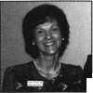

The BBC's of CCTV

Modern closed-circuit  
television cameras can do some  
amazing things. But one trick  
they haven’t been taught yet is  
how to hang in thin air. In  
designing your CCTV system  
you will have to determine  
how each camera will be  
suspended. This usually  
requires some type of camera  
mounting bracket.

ounting

At the same time you are evaluating how each camera

be mounted, it is a good idea to consider what

protection each unit may require. Cameras installed out-  
doors d )n’t like getting too hot, too cold or too wet—  
any more than you do. Exterior applications, therefore,  
require environmental housings. While indoor installa-  
tions may not require protection from temperature or  
moisture, interior housings protect against other threats.

meras may be vandalized, disconnected or even stolen.

In addition, some housings are designed to disguise the  
camera, or to make it uncertain which area is being  
observed. Then there are also purely aesthetic reasons for  
enclosing a camera attractively.

If you decide to use a mounting bracket without any  
housing, your selection will depend upon, a) the mount-  
ing surface, b) the camera and lens size and c) the ideal  
camera location and view.

Conventional CCTV mounts attach to walls and ceil-

Keynotes

January 1997

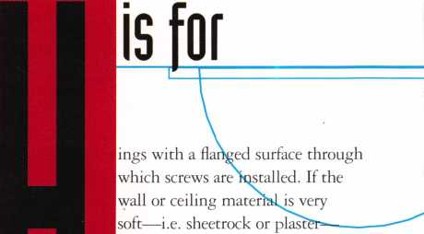

H Wm ■anchors, molly bolts or toggles mm Wm ■ should be used. Ill sonic cases, tam-

* WM ■pcr-rcsistaiu hardware might be

Hil m ■preferred. W hen hanging a camera Wm Wm ■ from a suspended ceiling, spec ial

mm m I mounts that attach to the T-track

* Wm Hare available. Camora brae bets for m Wm ■ temporary installations use a spring

■clamp to grab ceiling track, win­dow frames, desk legs or many other surfaces without leaving any holes or other scars when later removed.

If you use A” or lA” CCD cameras, even the lightest brackets will usually be okay. If you are using a long telephoto lens or a power zoom lens, a medium or heavy duty mount is required. Likewise, if a pan/tilt unit is being placed between the camera and a wall bracket, that bracket must be heavy-duty. (We’ll discuss pan/tilt units in a future article.)

The final bracket consideration is based on where the mounted camera needs to be. Ascertain the best camera location to obtain the image you want. This will deter­mine the length of the bracket arm, as well as help to determine whether a wall, ceiling or some other mount­ing surface is best.

If you choose to encase the camera in some type of enclosure, there are many designs from which to choose. The first step is to determine where the camera is to be located and why an enclosure is being used.

Outdoor Housing

As mentioned above, outdoor applications require an environmental housing. Appearance is usually less of a factor in outdoor settings. A basic environmental hous­ing will be a rectangular box, made of metal or plastic, with a window at one end for the camera to “see” through. Gasketing is used to keep moisture out. These enclosures come in various lengths. Add the length of



**Paul**

**Chandler, CRT,**

the camera to the length of the lens to be used. Then allow two or three inches for cable connection to the back of the camera. This will tell you how big a housing you will need. If you are in doubt, pick the larger size.

Outdoor housings are available with heaters, blowers and sunshields. Unless the housing is going to be installed in complete shade, a sunshield is recommended. This keeps the interior temperature of the hous­ing lower and reduces glare on the window. A blower is also used to reduce heat. A ther­mostat activates this fan, which ventilates the housing. Heaters are also thermostatical­ly controlled to keep the interior at an acceptable temperature. In addition, heaters remove frost and condensation from the win­dow. Unless your installation is in the desert, I recommend that you include a heater to keep both cold and humidity under control. Heaters and blowers will require power, usu­ally 24vac, so be sure that you have access to a nearby receptacle where you can plug in a transformer. Always use separate power sup­plies for the heater/blower and for the camera.

There are a few more options you may wish to consider in an outdoor housing. Van­dal-resistant housings use security fasteners

to mount the assembly and keep  
the enclosure sealed. They also  
provide protection for the cabling.  
Bullet-proof housings may be nec-

essary in high-crime areas. Stainless steel  
enclosures are made for highly corrosive  
environments, like marinas or chemical  
plants.

Mounting brackets for enclosures must be selected to hold the total weight of the cam­era, lens and housing. Wall mount, ceiling mount, parapet mount and pole mount brackets are available. Most manufacturers will cross-reference an appropriate mount for each of their housings.

Interior Housings

Interior housings are used either to protect the camera from tampering, to disguise it, to make it more attractive, or a combination of these reasons. If appearance is not an issue, a box-like housing, not unlike the exterior units, may be used. Box housings for interior use are less expensive because they don’t need moisture gasketing, heaters, blowers or sunshields. Depending on how accessible the housing is, you may want to choose a van­dal-resistant type.

When appearance is important, there are

several options available. Box style housings  
and brackets may be ordered in architectural  
finishes like bright brass or satin black. Cor-  
ner enclosures are surface mounted just  
below the ceiling. This location is very  
unobtrusive, and usually offers a good area of  
view. Where you have suspended ceilings,  
wedge shaped housings take the place of a  
ceiling tile and attract little notice. These are  
especially good for corridor areas. For truly  
discreet surveillance, tiny board cameras can  
be installed in all sorts of disguises, such as

locks, thermostats and smoke detectors.

Another attractive enclosure is the dome

housing. These may be spheres (ball-shaped)  
or hemispheres (half a ball). Like plastic bub-

bles, these may be clear or smoked. Smoked  
domes prevent observers from seeing where  
the camera is pointed, but they also cut  
down on the light reaching the camera. Use  
these only in well-lit areas. Domes are espe-

ially suitable for enclosing cameras

‘quipped with pan/tilt positioning devices,

'he hemisphere domes are designed to

mount in a suspended ceiling while the full-

iphere types are suspended from wall or ceil-

ing brackets. Full-sphere domes are also  
available for outdoor applications.

Self Contained Housings

In recent years some manufacturers have introduced all-in-one units which include a board camera, a lens, an enclosure and a mount. Ball cameras hang from the ceiling and look like inverted lollipops. Self-con­tained units for outdoor use are available in box, wedge, or miniature dome shapes.

In planning your CCTV application, keep in mind that every camera will need a mount and that every outdoor camera needs a housing. Carry at least one manufacturer catalog with you on site surveys and involve the customer in decisions about housings. With every other component in your system, the customer will be primarily concerned with how it works. When it comes to hous­ings, you want to be sure he or she also likes how it looks.

About the Author: Paul Chandler, CRL, is the manager of the Electronic Security Department for I.D.N-ACME in Houston, TX.

January 1997

Keynotes



**Motorcycle Locksmithing, Part 2**

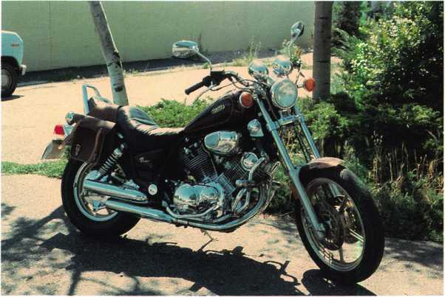

The Yamaha

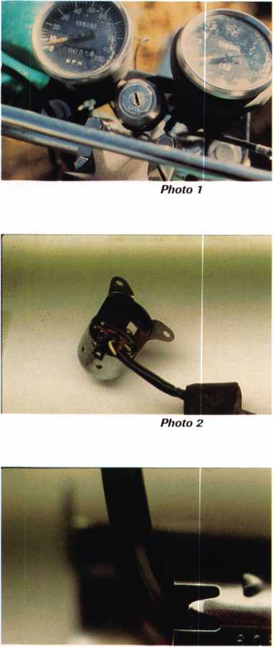

Photo 3

**A Keynotes** January 1997

Motorcycle

This article is written as a documentation

and chronology of the Yamaha motorcycle in  
the United States, dating from the late  
1960s. It puts the evolution of Yamaha lock-  
work, and others of its family tree into per-  
spective.

The term “motorcycle” here, applies to two-, three- and four-wheel, motorized, open-air vehicles that do not possess an enclosed passenger compartment. The dates used in this article are approximate because some overlap occurs during transition zones, periods and when manufacturers switch from an old to a new key system.

When determining whether an auxiliary compartment lock is keyed to the bike’s sys­tem, we apply the following rules. If the compartment is part of the vehicle, the lock in it is most likely keyed to the usual group—ignition, tank and seat locks. If it is not part of the vehicle, like an extra luggage compartment on the back when the piece was fitted as a factory installed addition for instance, then the lock in it is most likely keyed to the rest of the vehicle. If the piece was purchased and installed afterwards, and is a piece of Yamaha equipment, then it is only possible that the lock in it is keyed to the rest of the vehicle. If the piece is not original Yamaha equipment, then it is very unlikely that the lock in it is keyed to the rest of the vehicle. The off-road cycles do not use key locks, but use toggle switches and buttons to enable the lighting and ignition circuits. The all terrain vehilces (ATVs) are usually fitted with an ignition switch only.

By Ray D’Adamo, CML & Tina D’Adamo,CRL

Code Series: 1209-2700 Keyblank: Various

The earliest Yamaha bikes with which we have any service experience, were manufac­tured in the late 1960s. They utilize single throw disc locks, operated by single bitted keys. As time passed, double bitted, reversible keys replaced the single bitted keys. The key code is stamped into the face of the lock plug—a very conspicuous loca­tion. We are not sure what locks were keyed alike, but many keyways and keyblanks were used. The Silca Automotive Keyblank cross- reference has a section in the back totally devoted to motorcycles. It is set up chrono­logically and is very helpful when determin­ing the appropriate keyblank for the key code you may be working with.

The ignition (photo 1) is a keyed electric switch, mounted at the console with two screws and connected to the rest of the bike’s wiring harness inside the headlamp cavity. An assembled and removed assembly can be seen in photo 2.

To disassemble an early model, first pry back the two bent metal tangs, one on each side of the terminal plate at the back of the switch housing (photo 3) and remove the terminal plate, the switch plate and accom­panying parts—two each: contact, spring, insulator and ball bearing. Next, remove the two crosshead screws securing the switch plate locator to the cylinder casing and remove the switch plate locator. This metal disc is corrugated and interacts with the two ball bearings and springs in the switch plate

to hold the switch plate firmly in each posi­tion of operation. The insulators between the springs and ball bearings in the switch plate prevent the metal parts in each stack from grounding to each other through the metal switch plate locator. After the switch plate locator has been removed, the cylinder can be removed from the front of the switch housing and the cylinder plug can be removed from the rear of the cylinder casing. Photo 4 displays the entire unit disassem­bled. For reassembly, reverse the procedure.

**Yamaha Fork Locks**

As an attempt to further deter theft, Yamaha made its move to lock the fork to the steer­ing head of the frame. At first, like Honda, Yamaha did not utilize a fork locking igni­tion switch, as is commonly used today. Instead, a separate lock was used for this purpose. The early model fork lock was mounted in the fork, and its locking pin fell into a strike in the steering head of the frame. A later model fork lock was installed in the steering head of the frame, and its locking pin fell into a strike in the fork.

To lock the fork to the frame, turn the fork to the far left. This aligns the locking pin at the back of the cylinder with the strike. With early units, insert the key and turn it clockwise until it stops, push the cylinder plug towards the back of the casing until it stops, turn the key counterclockwise until it stops and remove the key. To unlock the fork, reverse the procedure. For later units, reverse the clockwise, counterclock­wise motion.

The early fork lock (photo 5) found on models manufactured in the late ‘60s, con­tains four combination discs. This lock is retained in a steel mounting bracket by a drive pin. The key code is stamped into the face of the plug. To remove the lock, pull out the drive pin (photo 6) and push the lock out the front of its mounting bracket. After the lock is removed, unless the unit is inoperative, further disassembly is not neces­sary, as all four discs can be seen and decoded through two openings in the casing (photo 7). To disassemble the lock, remove the pin that keeps the plug at the front (unlocked) or rear (locked) of the casing, and remove the plug and return spring from the casing.

***Photo 5***

***Photo 6***

***Photo 7***

***Photo 9***

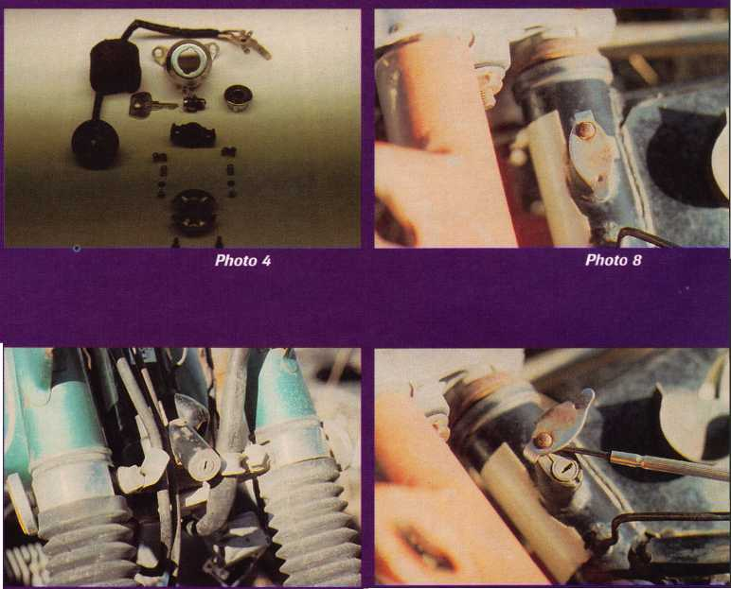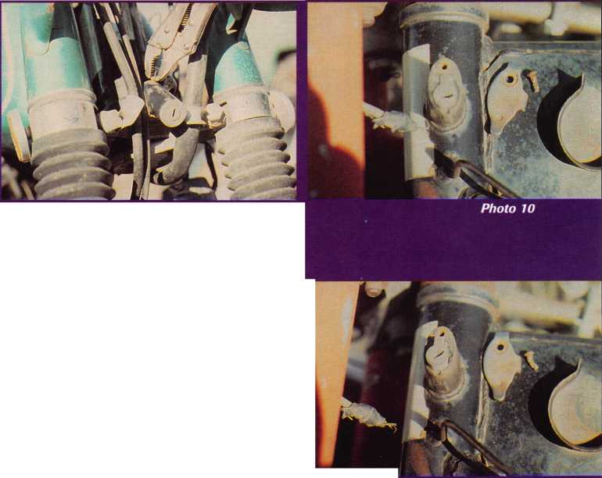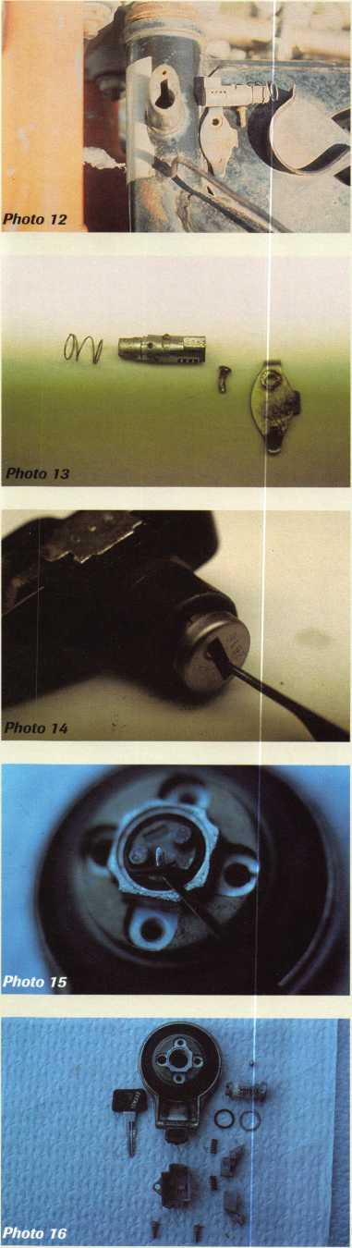

The later fork lock is also a four-disc unit and is mounted in the steering head of the frame. In front of it is a mounted dust shut­ter (photo 8). This shutter protects the cylin­der from road contaminants and pivots from a drive pin located above the cylinder. The cylinder is not stamped on the plug face, but on the top of its faux bible with the key code. Therefore, the key code cannot be viewed until the cylinder is removed. To remove this cylinder, the dust shutter must first be removed, and this process is the same for the Hondas discussed in our first cycle article in the November ‘96 issue.

To remove the dust shutter, first remove its drive pin pivot. If you choose to use the shutter as a lever to pry out the drive pin, you risk bending or, worse yet, breaking off the shutter. Be careful! One procedure that works well is to open the shutter (photo 9) and slip a flat, chisel pointed tool between the shutter and the frame just beneath the drive pin. With a small hammer, drive the tip of the tool between the shutter and the frame as close to the drive pin as possible. Next, pry out the drive pin and shutter together, using the tool as a lever against the frame. The removed shutter and drive pin can be seen in photo 10. If the shutter and pin bend a bit during this procedure, they both can be straightened before reinstalling to once again operate perfectly.

After the shutter is removed, remove the cylinder. Insert and turn the key counter­clockwise (or in our case out at the wrecking yard, pick the lock, as in photo 11) until the cylinder and its return spring can be pulled from the lock housing (photo 12). After the lock is removed, all four discs can be seen through two openings in the casing (photo 13). To disassemble the cylinder, remove the two tension pins in the plug and separate the components.

Seat locks of this period were usually stamped with the key code on the face of the plug, and contain all system discs. They can be disassembled, or the plug can be removed with a pick. Put the pick to the back of the plug, depress the retainer disc and pull the plug from the assembly. This “Pick and Pull” process (photo 14) does not seem very important here, due to the explicit key code display, but its importance as a service fea­ture will be greater realized when we discuss



Keynotes

January 1997

other manufacturers later in this series.

The tank lock of this period also is usually stamped with the key code on the face of the plug. To disassemble it, remove the two crosshead screws from the cap’s bottom cover plate and remove the plate. Next, remove the two spring loaded latches and return springs from inside the cavity of the bottom cover plate—that is if they haven’t already ejected themselves under their own spring pressure. These latches are retracted by the two studs or “drivers” on the back of the plug when the key is turned to unlock the cap, and extend to lock by their own driver springs. Next, pry out the rubber O ring (photo 15) at the back of the plug. With the O ring removed, depress the spring loaded plug retainer disc at the back of the plug and push the plug out the top of the cap.

For reassembly, the latches must be pre- loaded before the bottom cover plate can be installed. Lay the latches and return springs in the bottom cover plate. Compress the latch return springs by pushing the latches towards the center of the plate. Place the cover plate onto the bottom of the cap body and make sure the drivers on the back of the cylinder plug engage with the retraction notches in the latches. Hold the assembly tightly together until the bottom cover plate retainer screws are installed and tight. When assembled, check the unit for proper operation.

When servicing gas tank locks, remember that some of the parts contained in the cap—usually ball bearings, springs and O rings—prevent moisture contamination, unwanted emissions and affect fuel feed per­formance. Keep especially good track of these parts and make sure they are rein­stalled correctly or the engine may not run correctly. A completely disassembled Virago tank lock can be seen in photo 16.

Code Series: 3551-4150 Keyblank: Various

During the early 1980s, a new code series was introduced along with new keyblanks. This five-disc, key-alike system incorporated the ignition, helmet/seat, tank and other compartment locks when fitted. As with earlier series, the locks used in this series were also conspicuously stamped with the key code.

It was also during this period that the

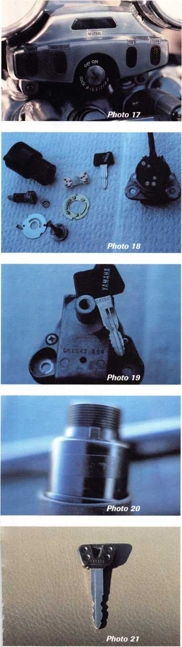

ignition lock configuration split into two models. Yamaha fitted the existing, non-fork locking ignition switch to smaller displace­ment models, and fitted a new, fork locking ignition switch to large displacement models.

Although it was stamped with the key code on the face of the plug, the non-fork locking ignition switch cylinder plug can be removed from the front of the assembly with a pick, as discussed with seat locks in the previous section. Be careful not to drop the discs, as they are not staked into the plug.

The Yamaha fork-locking ignition (photo 17 installed) is different in design from the Honda version, and more easily serviced. To disassemble it, first remove the two crosshead screws securing the bolt housing to the bottom of the assembly and remove the bolt housing. The black plastic terminal plate of the switch will come away from the assembly with the bolt housing. With the bolt housing removed, lift out the switch plate. It is keyed to the drive shaft attached to the back of the cylinder plug. This shaft drives the switch plate and the locking bolt through all functions. Next, remove the two crosshead screws securing the drive shaft mounting plate, and remove the mounting plate and drive shaft. Lift out the “push to lock” function return spring, located on the end of the cylinder plug, and lastly, depress the plug retainer and remove the plug from the top of the assembly. A disassembled ignition assembly can be seen in photo 18. From right to left the parts are: the bolt housing and terminal plate; the operating key; the switch plate and locator; the upper housing; cylinder plug; “push to lock” return spring; drive shaft retainer plate; and drive shaft. For reassembly, reverse this process.

Code Series: A-F 11234-79897 Keyblank: Various

This five-disc series was introduced in 1980, and most of what it has to offer in the way of service challenges has already been covered in the previous series. The most important aspect of it is that the key code was removed from the face of the cylinder plugs and relo­cated to only one place—the bottom of the ignition assembly (photo 19). Here, the key code is not highly visible while the assembly is still on the bike, but depending on the

tools at hand, it can be seen with an inspec­tion light and a mirror without removing the unit.

ATVs

The ATVs are usually fitted with an igni­tion lock only. To remove it and view the code, remove the bezel near the top, or plug face, and read the code on the side of the plastic casing. The code is stamped into a piece of black tape on the side of the casing and is difficult to read (photo 20).

Code Series: A701-A-8500 Keyblank: HY35RBP (Silca)

This series was introduced in 1993 and is being used concurrently with the system just preceding it. At this point, all we have on it is that it is a four depth, seven-disc system with a maximum adjacent cut specification (MACS) of three and utilizes a new keyblank (photo 21).

The future and the changes it brings are what motorcycle locksmithing is all about, and that’s what keeps it interesting. See you next time when we look into another excit­ing facet of the world of motorcycling lock- smithing.

_ About the Authors: Raymond DAdamo, CML, has been uniting technical arti­cles for Keynotes since 1983. He works at Fort Security Center in Ft. Collins, CO, with his wife Tina, CRL. Ray has been a member ofALOA since 1978 and Tina since 1988. Tina DAdamo began locksmithing in 1983 and immediately showed a great interest in motorcycle lockwork. She soon realized the lack of motorcycle lock service information available to locksmiths, and began compiling her own based on her experi­ences, hoping to someday release it to locksmiths in the form of articles like these in this series.

January 1997

Keynotes

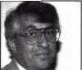

ASSA has recently introduced a mogul ylinder designed to work with deten­tion lock hardware. Photo 1 shows the large sized cylinder and a pair of ASSA twin 6000 keys. The internal construc­tion of the lock cylinder is quite similar to most any ASSA high security cylin- ’er, with its twin locking action.

Six pin chambers operate very much like those in standard pin tumbler locks, except for a few important improve­ments. Spool type top pins and counter millings in the lower pin chambers dra­matically increase the pick resistance. Add to that the five side pins and side- bar component, and you end up with a highly manipulation-resistant lock cylin- 'er. Combine that with drill-resistant :>ins and you have a very impressive high ecurity lock cylinder.

There is an important distinction between a standard mortise cylinder and a mogul cylinder (photo 2). The mogul cylinder dwarfs the standard cylinder with its massive size. Likewise it has an overly long cam to complete the pack­age.

A top view of the cylinder can be seen in photo 3. The six standard type pin chambers can be accessed through the top for loading or unloading tumblers and springs. Like the ASSA deadbolt, the mogul cylinder uses threaded cap screws to plug the pin chambers. This view almost gives the impression that the pin chambers are uncapped, but in fact the cap screws are threaded far down from the top so that standard length top pins can be used. It takes quite a few turns of an Allen wrench to completely unthread a cap screw far down into the pin chamber.

Photo 4 shows one of the cap screws at the end of an Allen wrench. Also, the plug has been removed to give a view of the sidebar. A much clearer view of the sidebar is shown in photo 5. Alongside

SfmKM

Photo 4

The ASSA mogul cylinder will also be made available in a Twin V-10 ver­sion. The original ASSA Twin 6000 design has huge masterkeying capabili­ties, while the Twin V-10 can be mas- terkeyed with key changes counted in the millions. Truly astronomical.

With compatible keying, master key systems can be created to integrate detention type hardware and standard body locksets. Besides the high security applications, the ASSA hardware and keys are designed for key control, with restricted keys that can be cut on stan­dard key cutting equipment. For addi­tional information on the ASSA mogul cylinder or any other ASSA products,

Photo 5

the bottom of the key blade, you can see the five pin chambers for the five side pins that interact with the sidebar. The sidebars are reversible, which creates two distinct side milling key patterns per sidebar (for the Twin 6000). The plug must always be removed when switching the sidebar position. By con­trast, standard rekeying can be accom­plished merely by removing the cap screws and changing the tumblers.

Then, after replacing the top pins and springs, the cap screws can be put back in place.

I

Wmm mm

:(■'

Photo 3

HU iiMAbout the Author. Sal Dulcamaro,

CML, has hem in the locksmith business for over 21 years. He is the president of All Pro Security, Inc. in Michigan and has hem an ALOA mem­ber for 13 years. A past presidmt of the Lock­smith Security Association of Michigan, Sal cur- rently serves as editor of the association newsletter. He was named “Keynotes Author of the Year”

By Sal Dulcamaro, CML

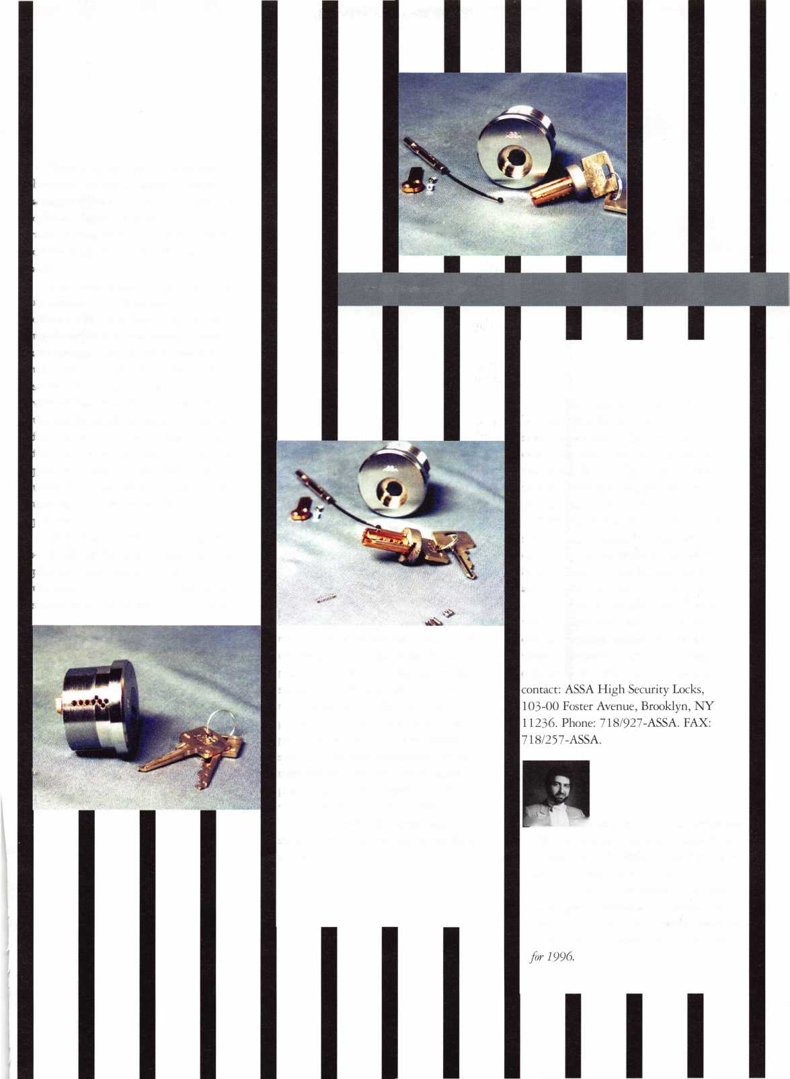

Seaman Third Class

Becoming a Boat  
Locksmith

By Ray Iglesias, CPL

T

he headline reads, “Locksmith Who Specializes In Marine Hardware Retires Rich and  
Happy At An Early Age.” My dream life! And, after one boat call, my dream seemed to  
be falling into place.

The captain explained that his 120 foot yacht was in much need of work. And, when he asked, “Do you do boat hardware?” I almost screamed into the phone, “Sure, I’ll be right over!”

Boats, yachts, captain and crew.. .the owner has money falling out of his pockets, and I’m going to get rich on this job. Well, maybe not rich, but this isn’t a little old lady who I’m trying to sepa­rate from her social security money. On this job, my motto will be “Have no mercy!”

This is the job I’ve been waiting for my whole life: on a yacht in the sun on the water, challeng­ing work and a captain who assures that money is no object! I am locksmith here me roar!

Okay, let’s see, Captain says the boat’s on dock Q, so I grab my tool box, my drill cords, two hammers (one large and one even larger), and I stuff picks, screwdrivers, ink pens, and pencils in my pockets. What am I forgetting? Oh yeah, the bill book and battery powered makita. Gee, I think I’m ready.. .Let’s go!

“Hey Dockmaster, where’s dock Q? Way down there? You gotta be kidding! I’m a young man, but by the time I reach the boat, my life will be half over!”

The dockmaster is laughing at me, but that’s okay. I’m tough and I’ll make it, but gee, this tool box sure is heavy.

Keynotes

January 1997



At the end of the sea wall, there’s a pier. At the end of the pier is a floating dock. At the end of the floating dock is my boat..

She’s a real beauty—120 feet of fiberglass, aluminum.. .and money. That toolbox was so heavy, and that throbbing pain in my arm may go away, oh, let’s say, in a day or two, but that’s okay. I’m ready to make money.

“Hey, Captain,” I yell. “Permission to come aboard? What do you mean, I gotta take my shoes off first? Okay, okay!”

And as I pull off my shoes, I think, gee, look at that, there’s a big hole in my sock and my toe’s hanging out! My, my. That’s okay because with all the money I make, I’m going to by a new pair of socks. Let’s go to work.

The captain informs me that he’s anxious for me to get to work, but I must leave that “dirty old tool box” on the pier.

“No problem,” I reply cheerfully

And he adds, “Please be careful with all those tools poking out of your pockets; the white gelcoat on the bulkheads will chip easily.”

He shows me the wing doors first. They are teak with etched glass. Expensive, I bet. Sure enough, the captain whispers back, “Three thousand a door.” Yikes! Polished brass mortise hardware with the letters GSV proudly displayed. Never seen this stuff before, but what the heck, I’m a locksmith, I can fix anything.

The screws won’t come out. I’m starting to sweat in this wonderfully hot sun. I pull out my large hammer and channel lock pli­ers. I know I can do this. All the screws need are a few good whacks and brute force. But the screws don’t want to come out.

I go for the extra hammer because I hon­estly believe that no lock will ever defeat me. The captain implores me to please be careful, and I detect a note of whining in his voice. (Perhaps he senses the frustration starting to fester inside me.) So, I soothe his fears.

“I’ve never been beaten by a screw yet!”

He raises his eyebrows as if to say, “I hope so!”

But the screws won’t come out!

Okay. I have a plan. I grab for my big,

yellow De Walt motor drill with variable speed and reverse and enough drill bits to open a Mosler TL-15. I hear a small whim­per from the captain and he scurries off, leav­ing me alone, red faced and breathing heavy, with my hair sticking up and shirttail hang­ing out.

Okay, I say to myself. Maybe this won’t be easy money, but those screws are coming out.

Hours later and soaking wet, I leave the boat with lock in hand, dragging that rusty old tool box with me. The sun is still beat­ing down, and I silently promise to never go to the beach again.

I’ve promised the captain quick results, so I start by calling my good friend, Kris, the guru of boat hardware. When I explain to her what I have and what I’ve done, she starts to laugh uncontrollably. She explains that the lock hadn’t been manufactured in 10 years and that no known repair parts exist on the face of the earth. I wish she would stop laughing. But that’s okay. I honestly believe that no lock will ever defeat me.

I go to my machine shop to have the needed parts fabricated. “How much?!” I cry. But, that’s okay. The lock now works and soon I’m going to have lots of money.

Back to the boat I go, but this time I’m smart. I leave the tool box behind, along with both hammers. The lock goes in very smooth and I’m starting to lick my lips in anticipation of presenting that fat, juicy invoice, when the captain abruptly turns to me and snaps,

“Are those ferrous metal screws? Because if they are ferrous metal screws, they will be unacceptable!”

“Yes,” says I.

Suddenly, I’m facing that long walk down the pier again. Also faced with he fact that I’ll have to find a hardware store that stocks brass screws, I yell to the captain that I’ll be back tomorrow with the proper screws and an invoice. “That’s fine, but please don’t be later than nine,” is the captain’s return.

“Ya, Ya!” I yell back into the bright sun with a weak smile and the hint of a migraine. Someday this hell will be over.

He shows me th wing doors firsl They are teak witl etched glass Expensive, I bel Sure enough, th captain whisper back, “Threi thousand a door. Yikes! Polishet brass mortisi hardware with th< letters GS^ proudly displayed Never seen thi stuff before, bu what the heck, I’n a locksmith, I cat fix anything

January 1997

Keynotes



The next morning I open the shop doors and I’m ready to work. The first thing to come in is the little old lady. She’s locked out of her apartment. By the time she finished counting out 35 dollars in nickels, dimes, and quarters, it’s after 10. I better get back to that boat.

Jogging down the pier, I jin­gle with a pocket full of brass screws. I feel the heat rise from the dock to warm my scorched face, and, as I turn down floating dock Q, I realize that boat is not there! Only the miserable dock- master.

I stand waving my invoice in my hand. “Where is she?” I cry out.

The dockmaster turns star­tled, and then begins to laugh.

“Why, gone to Europe for the summer!” he howls with tears running down his face.

. , .... About the Author:

Ray A. Iglesias, CPL has been an ALOA member since 1988. He is President and otmer of Safeguard hock and Safe, and is currently involved in Medeco High Security Lock 2X Process for business oivners

January 1997

Keynotes

as, CP

[mm

aworthy

**arine and**

Boat hardware, like automotive locks, is  
complex and endless, and to write an article  
to encompass it all would be impossible.

But there are a few ground rules to live and  
die by when servicing yachts.

First, when I mention yachts, I ‘m think-  
ing of boats 30 feet and longer. And most of  
the work will be done on boats over 100 feet  
in length. I recently had a locksmith ask me,  
“How can you make money on boats? They  
only have a little bitty ignition switch!”

Most yachts have many door locks, hatch  
locks, cabinet locks, etc. Almost all have at  
least one safe, and sometimes three or four.  
Boat owners and captains can spend large  
amounts of money on hardware and installa-  
tions, but they are not fools and can be very  
demanding. Be prepared for this and allow  
ample time for small details.

Materials

Marine hardware from all countries should  
have one thing in common: it will be made  
from marine grade materials. No metals  
such as steel or iron should be used because  
they rust and corrode quickly with the salt  
air. Parts should be brass, bronze, stainless or  
at least chrome plated. Please, when work-  
ing on boat locks, do not use steel screws or  
rivets. Take the time to locate proper brass  
or stainless steel screws. Also, many of these  
locks use metric threads and the standard  
thread will not do. Marines and boatyards  
are a good source for locating these parts,  
and many marinas are not only happy to  
help, but also may become a good source for

| future boat work leads. If time is short, ask  
the captain for assistance. Odds are he has a  
large assortment in his engine room.

European locks are used primarily on larger yachts, and measurements in metric are easier to work with than inches. Remember, the Golden Rule of “25 mil­limeters per inch,” and conversion becomes simple.

Details

The more common backsets are 40, 55, and 60 millimeters. Other backsets do exist and I’ve seen 22 to 300 millimeters on various hardware. When trying to replace existing

**Boat Hardware**

boat locks, I believe in measuring every­thing—twice. This would include door thickness, backset, strike, size of trim, etc. Sometimes I will draw the lock on paper with all the measurements written down. I will also include knob designs and color.

This spec sheet is invaluable when you’re still trying to track that lock down a week later. And since I mentioned color, here is a neat trick to make some serious money. If the hardware is brass and the crew is always polishing it, mention to the captain that you could have it all gold plated, and he could not only save hours of his crew’s time, but that the shear beauty of gold is awesome. Most captains will say no at first, but since these vessels are status symbols of the wealthy, few owners will be able to resist the urge once they get word of it. This trick, of course, does require that you have the ser­vices of a quality plater available to you. European Approach The reason you see more European locks than American on boats is that doors on boats are very elegant and door thickness can be as small as one inch. Europeans make quite a few different mortises that can be used on doors with an inch to an inch-and-a- quarter thickness. Also, they have an abun­dance of different sliding hardware all in marine grade materials. Europeans using the standard profile cylinders that come in vari­ous lengths will allow boat builders the con­venience of combining security with style and ease of installation. The Europeans also hand doors somewhat differently than Americans. There is only a left-hand or right-hand; they skip all that reverse-hand foolishness. They also hand the sliding doors, and if you use a rim mount device, it will suddenly become clear why. Please refer to the drawing if you have a question on this. Common Problems One of the two most common problems I come across is rekeying a boat due to sale or loss of keys. If the boat is using profiles, I live and die by a few rules: if no working key exists or a key cross section looks extremely difficult to find, I source the new product

and replace. These locks are difficult to tear down and reassemble, and they are usually filled with salt and sea crude. Do the boat a favor and replace them. You could be saving yourself a callback, and it’ll make the job quick and smooth. You should not use Lori or Schlage profiles on boats due to the large amounts of ferrous metal in them. At the Medeco factory, I was recently informed that they would do a profile with stainless steel set screws for the pin chambers upon request.

Quality profiles are expensive, but you must remember that the boat you stand on may well have cost millions of dollars, and these prices are just one small drop in a rather large bucket. Show no mercy and make money.

The second lock problem I frequently encounter is that duplicate keys will spin in the lock but not lock or unlock the door. This is caused by the key blade length being too short. There is a spring loaded plunger that the key has to push back and forth. It’s located between the plugs to engage the locking cam. Using original key blanks will solve this problem, but if you are desperate, trim the shoulders back a few millimeters and recut the key.

Help

My last bit of advice will be: when request­ing help from a manufacturer, a distribu­tor—or another locksmith like myself—you should first draw a clear picture, or photo­copy the lock you’re trying to locate, add all your measurements, and fax it to the party you are asking for assistance. Please don’t forget your name, phone number, and area code on the paper. After this is done, it then becomes time to follow-up with a phone call. This works really well and saves time trying to explain just what it is you are look­ing for. Time is so valuable and organization is the key.

From attending to details of small things, great things will be born.

January 1997

Keynotes



rom

ust Say No To Saws

The Shackle Protector has

high security padlocks. Ma<

padlock protection against

is fixed onto the body of the

No matter what weather coi

cover for padlocks to protect

motorcycles and more are  
chain lock.

All Mul-T-Lock products ar<

For more information, call

lAfell-.lsn’t

That

Special?!

**Mul-T-Lock offers a wide selection of padlocks in**

**various sizes and shackle types, and because  
the shackle and shell are made of hardened**

**alloy steel, Mul-T- Lock padlocks resist most saws and wire cutters.**

designed specially for Mul-T-Lock

of malleable cast iron for added

ing and cutting, the Shackle Protector

:k by screws,

tions arise, Mul-T-Lock offers a rubber

against the elements. And boats, gates,

ected by the cut-resistant, hardened

available masterkeyed.

L) 778-3222.

on

Specialty

Locks

King-pin Truck Lock

One System Fits All

Key Mark is a line of patented key control interchangeable cores designed to fit most locks. KeyMark cylinders from Medeco have an angled Security Leg keyway that allows for differention by angle and prevents other manufacturer’s keys from entering the cylinder. The seven pin cylinder increases pick resistance. Built with solid brass for durability, KeyMark cylinders are patented, tested, and available now. KeyMark from Medeco is sold through KeyMark Service Centers.

For more information, call (800) 839-3157.

Trailer Ring Lock

Mul-T-Lock has introduced a new Trailer Ring Lock. This product fits into a trailer’s towing eye. It is made of a heavy duty material and is equipped with a special shutter to keep dirt and grime off of the mechanism.

For more information or to order, call (210) 778-3222 or (972) 416-8716.

**Mul-T-Lock USA has  
intmrinrerl its King-pin**

**Truck Lock, it secures  
the king-pin of a semi-  
trailer and includes a  
#10 high security  
padlock. It is made of a  
heavy duty material,  
unlike most similar  
products on the  
market The only  
comparable product is  
manufactured by JJ  
Gauge, which uses a**

**Medeco cylinder. High value cargo and  
trucks are ideal candidates for this product  
which takes seconds to install. It is  
equipped with a special shutter to keep dirt  
and grime off of the mechanism.**

**For more information or to order, call (210) 778-3222 or (972) 416-8716.**



Keynotes

January 1997



By

Saf-T-Lok:

Security

For

Handguns

I first saw this  
interesting  
product at the

1996 ALOA

convention and trade show. The Saf-T-Lok is a gun lock that becomes part of the gun. You don’t have to find a place to store the lock when the gun is being used, and you don’t have to search around to find the lock when the gun is put away and secured.

Sal

Dulcamaro,

CML

January 1997

Keynotes

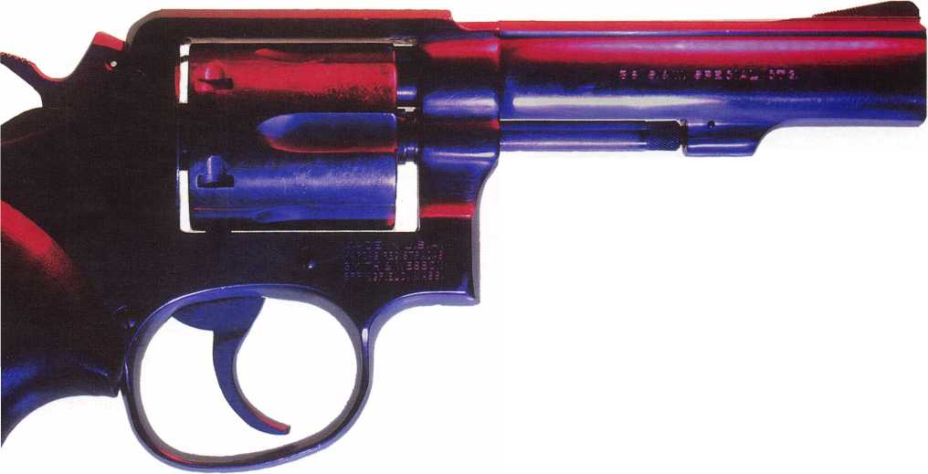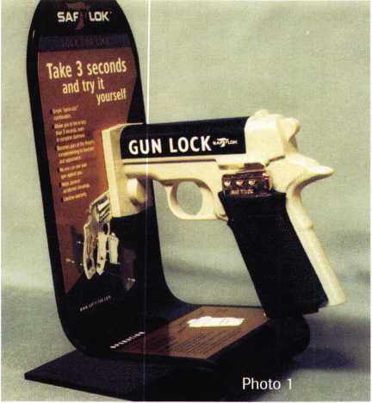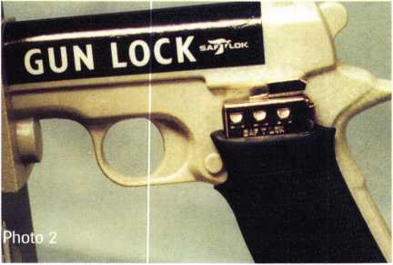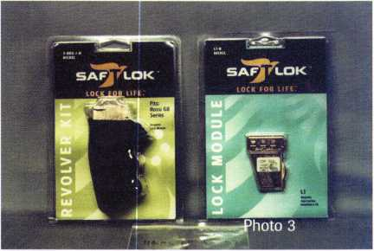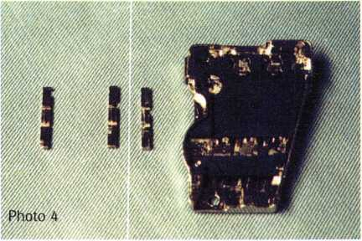

Keynotes

January 1997

Photo 1 shows a plastic mock-up demonstrator. The three button combination lock can be clearly viewed just above the rubber handle grip in photo 2. The buttons have a clicking action, and the changeable combination lock has a number range from 0-0-0 to 9-9-9, with any possible arrangement of the digits. With a variety of dif­ferent installation kits, the Saf-T-Lok can be installed on a wide variety of revolvers and automatic pistols. The plastic demonstrator gun is designed to look like an automatic.

On an automatic pistol, the lock is usually mounted on the left grip side. When it is engaged, the lock secures the gun’s safety. When the proper combination is entered, the safety slide (of the Saf-T-Lok) will retract. After the Saf-T-Lok is unlocked, the gun’s safety can be disengaged and the gun can be operated. Some other pis­tols work differently.

For a revolver, the Saf-T-Lok is generally installed on the right grip side. The lock works differently to secure a revolver. When locked, it actually interferes with the (motion) operation of the trigger and hammer, so that the hammer cannot be cocked, and the trigger cannot be pulled.

The Unexpected Waiting Period

When I contacted Saf-T-Lok to write an article on their product, I was eager to get started with the project. My first task was to locate a gun, which turned out to be much trickier than I had expected. My older brother is a postal inspector, so I called him and asked what type of sidearms he used in his job. He told me that he used a dock and a Beretta. Those two guns didn’t appear on the list sent to me by Saf-T-Lok, so I called them and asked if they might have added them since the list was printed. They informed me that they were engineering the kit for the dock, but it wouldn’t be available until early 1997.

I had to think quickly, because I was less than two weeks from my copy deadline. Talk about hectic. I had to locate a gun, inform Saf-T-Lok so they could send me the appropriate kit, wait for the kit to arrive, photograph the installation procedure, get the pictures back from the photo processor, and then write the article and mail it out in time.

I checked with a local police officer and found out that his department (and many other municipal depart­ments) had switched to the dock automatics. We already know that the locks for them are still on the drawing board. I checked with my brothers-in-law (because they are hunters), only to find out that they have rifles and shotguns but no handguns.

To make a long story short(er), I finally found a local gun shop owner who graciously allowed me to photo­graph an installation at his store (licensing restrictions

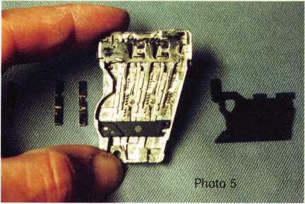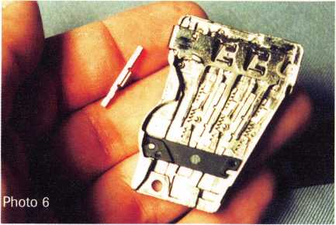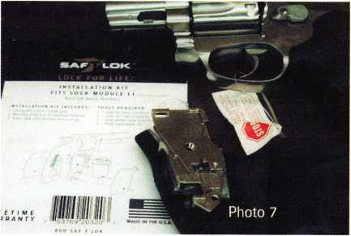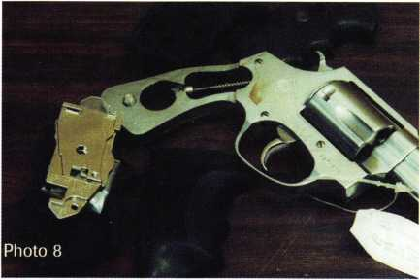

prevented me from doing it off premises). Once I received the appropriate parts from Saf-T-Lok, I was ready to go. I packed up my tripod, camera and tools; and the rest is history.

The Saf-T-Lok

For all practical purposes, the Saf-T-Lok is two compo­nents: a combination lock and an installation kit. Photo 3 shows the lock module on the right and the installa­tion kit for a Rossi revolver on the left. The lock module is mostly standard, while the installation kits adapt to the particular models of handguns. Since revolvers don’t have safeties, the lock blocks the hammer stirrup so the hammer can’t move. Automatic pistols with safeties have the trigger safety secured. For those without safeties, the device blocks the draw bar (the connecting mechanism between the trigger and the hammer). The quick click action of the three buttons allows the gun to be easily (and quickly) unlocked, even in the dark.

The lock combination is changeable, but disassembly is required. A back view of the lock module is shown in photo 4. Just to its left are three combination change gates. These parts determine the combination of the lock. Each gate, depending on how it is positioned, allows for two different combination numbers. There are five different gates available: LGO-1 for 0 or 1 stroke; LG2-8 for 2 or 8 strokes; LG3-9 for 3 or 9 strokes; LG4- 5 for 4 or 5 strokes; and LG6-7 for 6 or 7 strokes. The gates next to the lock module in photo 4 are (left to right) LGO-1, LG4-5 and LG6-7.

The plastic cover has been removed and set to the right in photo 5. The existing gates and ratchet bars are exposed to view. The combination is changed by replac­ing or rearranging the gates. With the current combina­tion 3-2-3, you have access to the same numbers in a dif­ferent sequence, or by turning over some of the gates, you have the alternate numbers. The #3 can be turned around to become #9, and the #2 can become #8.

The gate in the position furthest to the left has been removed in photo 6, and is setting just to the left of the lock module. They are somewhat small, so tweezers are recommended for removal or insertion of the combina­tion change gates. The raised ridge on the side (in the center of the gate) fits into a cut-out in the ratchet bar. A different number on each end of the gate indicates the combination number.

Installing a Saf-T-Lok

The gun I used for the installation was a Rossi M-88 revolver. The procedures to be shown are specifically for this particular gun, but installation is fairly similar for other handguns. The lock will be installed on the right grip side of the gun (as is the case for most revolvers). Automatic pistols will generally have the lock installed on the opposite side.

January 1997

Keynotes

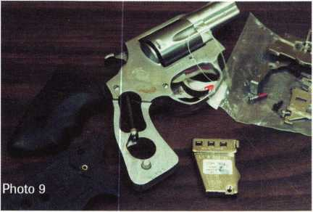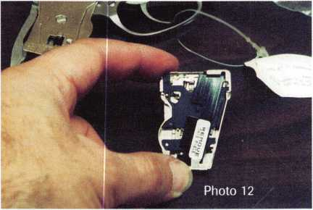

Keynotes

Before starting, you should always make sure that the gun is unloaded. Second, make sure you have the right installation kit and tools. I used a medium and small slotted screwdriver, small Phillips screwdriver and a paper clip.

Photo 7 shows the Rossi M-88 revolver and the prop­er installation kit required for installing a Saf-T-Lok to this handgun. The first step of the installation involves removing the old grips. The old grips have been removed in photo 8, and they are just above the exposed frame of the gun handle. The modified grips and instal­lation kit are just below the revolver. The parts of the installation kit—including the mounting plate and lever—have been unpacked and are lying on a plastic bag in photo 9- The lock module is just below them.

The lever has been attached to the mounting plate in photo 10. When the Saf-T-Lok is locked, the lever is the part that blocks the motion and prevents firing of the gun. If you look at the empty frame of the handle, you’ll see what looks like a narrow rod that runs downward toward the heel of the gun. When the trigger is pulled or the hammer cocked, the rod moves down into the cir­cular hole in the handle. When locked, the lever is moved into the path of that rod. Since the lever blocks the path of the rod, the gun cannot fire. When unlocked, the lever shifts out of the path of the rod, and operation of the gun is unimpeded.

In photo 11, the left side grip has been attached as has the mounting plate and lever. A slotted head screw, sticking out in the middle of the mounting plate, will connect the parts. Make sure that the lever operates freely and doesn’t stick.

Photo 12 shows the back view of the lock module. A narrow plastic piece runs the height of the module to prevent parts from falling out. This plastic piece must be removed before installing the lock module to the mount­ing plate. In photo 13, the safety slide is next to the lock module. The safety slide has been positioned on top of the lock module in photo 14. Also, a very narrow spring runs from left to right near the top of the safety slide. A paper clip is being used in photo 14 to stretch the spring and attach it to a post near the right side of the lock module. When the correct combination is entered, that spring will pull the safety slide back and unlock the gun lock.

The lock module is attached by hooking the upper end of the lock over the top of the mounting plate. The end of the lever should fit into a cavity on top at the back of the safety slide. The lock module should be posi­tioned so the attaching hole in the mounting plate will accept the small Phillips head screw (see arrow, photo 15.) With the screw tightened, only the right side grip needs to be attached to complete the installation in photo 16.

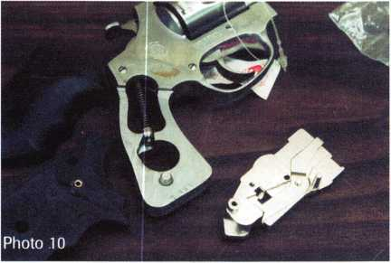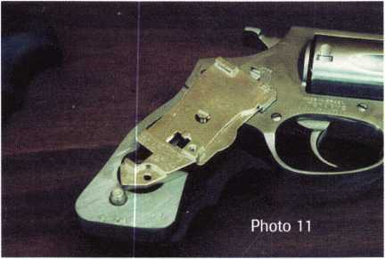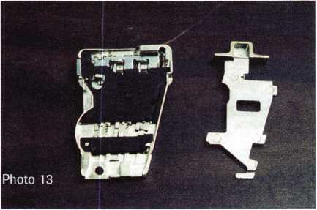

January 1997

Operating the Saf-T-Lok

Accidentally locking the Saf-T-Lok at an inopportune moment could prove to be disastrous. To minimize such a possibility, it requires two deliberate motions to lock a gun fitted with a Saf-T-Lok. In photo 17, I’m using my finger to push the safety slide to the right. With the safety slide moved all the way to the right, pressing my thumb against the reset button activates the locking mechanism. Pushing the safety slide alone won’t cause the gun to lock up.

The combination is entered by sliding down on the buttons. Each downward motion will generate a clicking sound. With the factory set combination of 3-2-3; the first button would click three times, the second button two times, and the third button three times. The opera­tion can be done without looking at the lock, which means it can be done in total darkness. If you lose count or click one of the buttons too many times, pushing the reset button lets you start all over again.

It doesn’t matter what order you push the buttons. The lock will release after the last click, regardless of the order. When the first two buttons are pushed, the lock is still set, with the safety slide toward the right. After it is clicked to complete the combination, the spring inside pulls the safety slide back to the unlocked position in photo 18.

The Saf-T-Lok is fairly easy to install, and it has a sug­gested retail price of $89-95. That price should include a lock module, installation parts and replacement grips. Like the Glock that I mentioned earlier, they are con­stantly adding more handguns that will accept a Saf-T- Lok. For additional information, contact: Saf-T-Lok, 18245 SE Federal Highway, Tequesta, FL 33469- Phone: 800/SAF T LOK, or 561/743-5625. FAX: 561/745- 6601. Internet address: [www.saf-t-lok.com](http://www.saf-t-lok.com)

I About the Author. Sal Dulcamaro, CML, has

been in the locksmith business for over 21 years. He is the presi-  
dent of All Pro Security, Inc. in Michigan and has been an  
ALOA member for 13 years. A past president of the Locksmith  
Security Association of Michigan, Sal currently serves as editor  
of the association newsletter. He was named “Keynotes Author  
of the Year” for 1996.

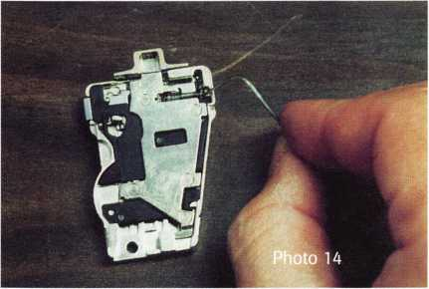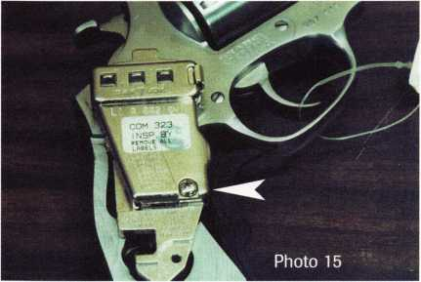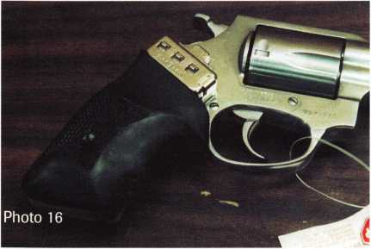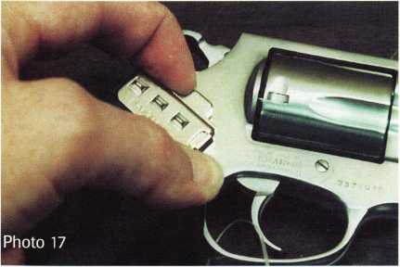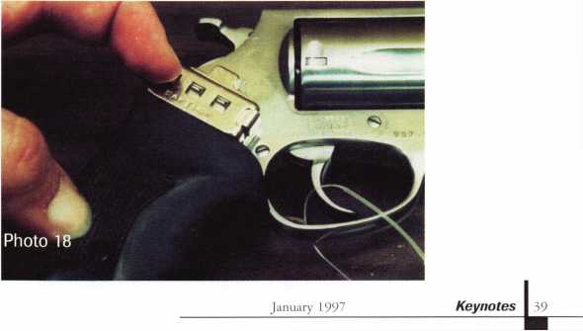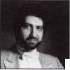

ooking through the Help Wanted adds in the trade magazines, I noted one thing in almost every advertisement, “Experience required in all phases of the locksmith trade.” As the world changes, so does the locksmith trade. More shops today are specializing in one or two phases of the trade and as a result, there are fewer locksmiths experienced in all phases of the trade. One way to ensure a supply of skilled workers for your shop is to set up your own training program.

The first step in setting up any training program is to establish a training plan. The training plan allows you to organize what you intend to accomplish. Your plan helps you decide what you have to do, what job must you train for, and what skills one must have to do the

**work. To develop your plan, consider the following:**

1.

Identify normal day to day work

requirements

What jobs do you perform on a regular basis? This will be the primary focus of your training plan. These are the skills you must build in your employees.

2.

Identify special work requirements

What tasks require special skills or certification? Depending on the job, your employees could require professional training and certification for you to qualify for some contracts.

3.

Identify skills that require periodic continuing training

Some tasks may require that your employees be trained

on regular and frequent intervals. These may be tasks that your shop does not perform on a regular basis. You may have tasks that change due to manufacturer design changes and updates. Employees may have to be retrained due to certification requirements of a certifying agency.

4.

Identify available time for training

There must be time for training. Even in the busiest shop, there is time. You may have to train in shifts or break your tasks into phases to accomplish that training. Look at all the possibilities.

**In setting up a training plan, yon must be flexible.**

Plan it out and stick to that plan, keeping in mind that, as the work environment changes and as business dic­tates, you may have to adjust your plan.

Now that you know what training is required and the time available you must prepare to train. Training can be accomplished either in-house or on the job out of the shop. When the training is conducted in-house, several things should be considered.

1.

Identify yo**ur most qualified trainer**

This is the one point where you must be completely objective. Are you the most qualified to conduct train­ing, or is one of your employees the true expert? In addi­tion to expertise at the task, the trainer must have good organization and communication skills. For training to be effective, use the best qualified person for the job.

2.

Identify needed equipment

This should be simple for most shops. Most of the time you will only train for jobs that you plan on doing or have done before. This usually means the equipment and supplies for the training are already available. If this is not the case, you will have to get the necessary material

**together prior to conducting the training**

3.

Develop Ifissnn plans

You have planned out what to train, who will do the training, and what equipment is required to present the material. Conducting the training requires a lesson plan. A lesson plan is nothing more than an outline of what you plan to cover and the order you plan to cover the material. It can be as formal or informal as you wish. Break your material down into brief, logical steps. Between each step allow your trainee a chance to apply the task or portion of the task being presented. Annotate that time on your lesson plan to keep from forgetting it during training. At several points during and at the end of your lesson plan include a reminder to recap the mate­rial you have presented.

By ensuring the most qualified person is conducting

January 1997



the training, having the necessary equip­ment and preparing and using a complete lesson plan, your training program should be a success.

Once you have the basics, the rest is easy. The next step is to consider some training principles that will help you teach effective­ly. Looking at the list you may say that these are common sense, but most training pro­grams fail because the person conducting the training failed to remember these very sim­ple points.

JL

Go from the known to the unknown

You know your employees and the experi­ence they have had. Use this information to your advantage. This will tell you where to start. You may have to start at the very beginning, but if your employees have some experience you can start at a more advanced stage, saving you time.

2.

Go **f**rom easy to the difficult

Start with the basics. Lay out your plan in an orderly fashion. An example would be learn­ing to pick a lock with only one pin. Once they have successfully picked one pin, pro­ceed to pick two pins, then three and so on until they have mastered that task. This will work on many other tasks as well. Starting with an easy task and then progressing not only increases their knowledge, but their confidence as well. A confident student (employee) will strive to learn more.

3.

Emphasize accuracy and understanding, rather than speed

Time is money, but rushing a task will usu­ally cost you more than it saves you when mistakes occur. When an employee is learn­ing a task, take it step by step, explaining the importance of each step and what prob­lems may occur if they fail to understand and apply the basic procedures.

4.

Explain the big picture

Understanding how the pieces fit together and why they work will enable the employee to apply this same concept to other work. If they only know how things fit together and not the reason why, the same skill will have to be re-taught for each new application.

This one step, if properly applied, will

enable your employee to accomplish any task encountered.

5.

Learn by doing

Hands on training is a must. Let them do what they have been taught. Allow them to apply their knowledge immediately and fre­quently. If they study a task and wait to try it out for several weeks, most likely they will forget the fine points and fail the task. Practice-Practice-Practice.

6.

Allow skills to develop

Mistakes will happen, let them happen in training and under your guidance, rather than out on the job. Let them learn. You guide. Don’t dominate the training, but keep control. Let the employee do the work and solve problems as much as they can.

This will increase the learning process. Most people remember more from their mistakes than they do from their successes.

1

Feedback

You must let the employee know how they are doing and what they are doing right or wrong. Without this feedback and reinforce­ment, positive or negative, the training is not complete. Feedback is not one-sided though. You must also encourage questions and comments from the employee. This will give you the insight necessary to know how successful the training is going. Listen to the comments and adjust your plan as needed.

Training is nothing more than a lot of simple steps put together and applied in a logical manner. Keeping this in mind, along with the information presented, will help you design and conduct productive and prof­itable training programs. Good training pro­grams will increase production and profits.

About the Author: Richard L. Dyer, CRL, has been a locksmith for over eight years. He is the owner of J & R Lock and Key Service in Colorado Springs, Colorado and has been an ALOA member since 1991. A past president of the Central and Southern Colorado Locksmith Association, Rick currently serves as the assocation Member at Large. He has been teaching technical and occupational education for over 18 years and is certified as a Master Instructor.

January 1997

**Employee Training**

|  |  |
| --- | --- |
| T T 1 | Construction _ _ |
| Under |  |
| What doesn’t change is t gain the knowledge you  The theme for advertising the ALOA Securi­ty Expo ’97 (Convention) is “Under Con­struction.” One of the problems with using this theme to describe the activities associat­ed with the production of Convention is that | ■  hat this is the best opportunity you will find to need to improve profit.  it may leave you with the impression that participated, but it can be better. Much of  something was terribly wrong with Conven- what we do seems repetitious. We have tion the way it was. This is really not the classes, a trade show, banquet and some  case. Convention has always been a pleasant, tours. We will still be having these activi-  meaningfiil experience for those who have ties, but we have rearranged the schedule  and added some new classes. We have the |

tours that are available in the area—some educational and some just for fun. We have a banquet with a theme that will be unique each year. There will be a business meeting for the association. At this meeting, we will elect new directors, officers and a president to set the course for the next few years. The membership will consider bylaws changes that affect how the association will be run.

In short, the meeting is important and is one of the most significant and most overlooked membership benefits.

I wrote an article for Keynotes a few years ago that equated knowledge to profit. With­out education, there are many jobs you can’t do at all, and there are others you can’t do well or would take too long to be profitable. There is nothing profitable about a “call­back.” The ALOA convention offers the most impressive variety and quality of classes in the industry. The format will be different the next time and may change again. What doesn’t change is that this is the best oppor­tunity you will find to gain the knowledge you need to improve profit.

One of the things that the board approved during the last session—in an effort to make the convention more stable and profitable for you, the owners—is to have a three-year city rotation starting in the year 2000. The three cities, in order, will be Las Vegas, Baltimore and Chicago. These three cities have histori­cally produced the best attendance. Allow­ing the staff to negotiate a multiple year contract with these cities may result in some cost savings. It will certainly result in sav­ings of the costs related to site inspections and planning for the different cities we have investigated. This plan will not please every­one, but it will, apparently, meet the needs of the majority of members.

About the Author: Retired Lt. Col. Charles W.

Gibson. Jr., serves as the staff administrator for ALOA.



h

The Leader In Electric Strike Technology

For Over Twenty Years.

* 1976 The first electric strike with a full ANSI opening.
* 1976 The first electric strike to release a 1" deadbolt.
* 1980 The first "Offset" electric strike to align with mortise locks.
* 1982 The first "High Security" electric strike capable of withstanding over  
  2,000 lbs. of force before releasing.
* 1986 The first "Universal" electric strike to provide flexibility for the user.
* 1988 The first "Extra Offset" electric strike to align with Sargent, Schlage  
  and Yale mortise locks.
* 1989 The first electric strike to be "Field Reversible" from fail secure to fail safe.
* 1989 The first electric strike able to release under a "Pre-Load."

»1991 The first "Total Electric Strike System" -

Twenty-four interchangeable models.

* 1994 The first "Smart-Strike™."
* 1994 The first electric strike to use  
  "Photo-Optic Monitoring."
* 1996 The first "Compact/Heavy Duty" electric  
  strike able to release under a pre-load.
* 1996 The first "Low Profile" electric strike with  
  only a 1-1/16" set back for ANSI installations.

h.e.Sv Designing Electric Strikes To Meet Today's Changing Needs, While Setting The Pace For Tomorrow's Technology.

Hanchett Entry Systems, Inc.

Manufacturing Products for  
Access Control

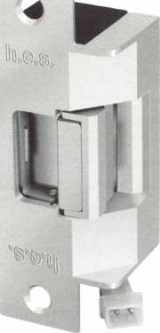

2040 W. Quail, Phoenix, AZ 85027 (602) 582-4626 • Fax (602) 582-4641

Call Or Write For A Free Catalog.

**MODEL 7501**

*NEW ITEM

-4

Reader Service #20

Keynotes

January 1997

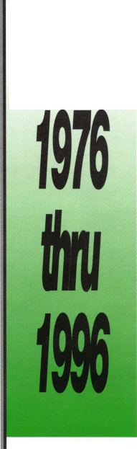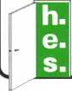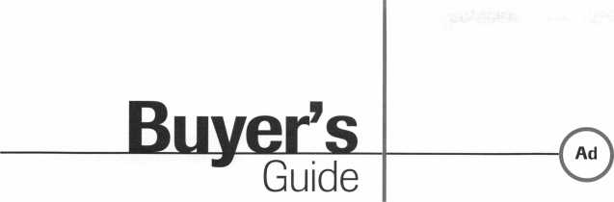

Allstate Locksmith Insurance Program

As a retail or  
mobile locksmith,  
you understand  
how important it  
is to rely on a  
solid, reputable  
company to help  
you with your  
business insurance  
needs. If you have  
any questions  
about your insur-  
ance needs in gen-  
eral, an Allstate  
Agent can provide  
you with addition-  
al information. To  
be referred to an

Allstate Agent, please call 1-800-669-6711.

Reader Service # 22

SPEEDYPIK"

The automatic key ID system. This com-  
pact unit fits inside your IBM compatible  
computer in a 51/4 bay the same as a disk  
drive. The latest addition is a 5,000 key  
pre-programmed database. Now you can

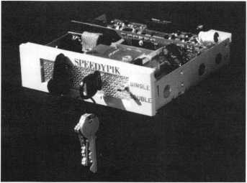

leave the key cutting in the care of an apprentice without a long training period. This will free the locksmith up to do other work.

(617) 567-1111; FAX (617) 277-7777; e-mail: [SPEEDYPIK@juno.com](mailto:SPEEDYPIK@juno.com) Reader Service # 23

NewSDC 1571 EmLock®

The New SDC 1571 EmLock® is in stock and features the first breakthrough in years

Allstate

Locksmith  
Insurance  
Program

Competitive Maim From A Repu table Company

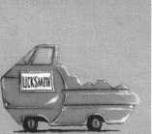

Allstate

gaffe i» good hsoda.

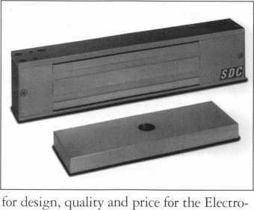

magnetic Lock. Features include: a patent­ed welded steel core construction that elimi­nates epoxy and increases stability, field selectable 12 and 24 VDC, 1200 pounds of holding force, easy installation and the first all aluminum housing. For nationwide shipping, call Intermountain Lock and Sup­ply at (800) 453-5386 (Salt Lake City) or (800) 323-8046 (Denver).

Reader Service # 24

Does Doubling Your Profit Interest You?

Your customers are sure to select one of our North American-made, high quality pewter key chains at the same time they purchase a new lock or cut a new key.

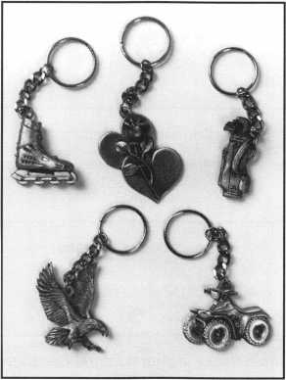

PO. Box 1641 Champlain Mall Rd. Champlain, NY 12919

Reader Service #25

Key CAD, Inc.

Master Key Designer is the premier product from Key CAD, Inc., a North Carolina based software development corporation.

Cfc Eat lie** Iocfe fids

S] 111 '4jhJ f

I - If.- fr-* i ..Vf'

@~.g|Retcuc*

B ft—-**

’ Fiont Door 721121 Lobby

721343 Lobby  
721665 Lobby  
723145 Hallway  
723327 Hallway  
723683 Hallway  
723861 Hallway  
725163 Hallway

07708/83 Janitor and Maintenance CM

07708/36

07708/33

07708/93

07708/33

07708/93 Ooof had damaja to I ha ed gi 12716/95 Original installation on 0770871

I f - .t I.

The software combines a master key system generator with a storage database. Unlike several other master key programs, Master Key Designer does not use any of the stan­dard progression models for its generator. While this tends to limit the number of keys generated, it does allow the customer to have complete control over key assign­ments, with cross-checking between each key. In fact, Master Key Designer will even generate new change key numbers from a preexisting system, regardless of what the system was based on, using its own safety criteria. Other nice features of the program are the details available for each key, and an extensive key locating ability.

Reader Service 26#

Offer your customers quality at a low price with a money back guarantee. FAX or phone today!

FAX (514) 425-5793 or Phone (514) 425- 5794

Milman Manufacturing

January 1997

43

Keynotes

Associate

Members

|  |  |
| --- | --- |
| Manufacturers | Allied-Gary Safe Company  West 425 2nd Ave.  Spokane, WA 99204 (509) 458-2633; FAX (509) 458-2633  © © |
| Access Protection Mfg.  216 Plaisto Rd.  Plaisto, NH 03865  [603) 382-0822; FAX (603) 382-0833  © | American Lock Co.  3400 West Exchange Road  Crete, IL 60417-2099 (708) 534-2000; FAX (708) 534-0531  © © |
| ASSA High Security Lock  10300 Foster Ave.  Brooklyn, NY 11236 (718) 927-2772; FAX (718) 257-2772  © | American Security Products  11925 Pacific Ave.  Fontana, CA 92337-6963 (909) 685-9680; FAX (909)685-9685  g ^ |
| Abloy Security, Inc.  6015 Commerce Drive Ste. #450  Irving, TX 75063  (972) 753-1127; FAX (972) 753-0792  © | Arrow Lock Company  10300 Foster Avenue  Brooklyn, NY 11236 (718) 257-4700; FAX (718) 649-9097  g g g g |
| Abus Lock Company  P.0. Box 47507  Plymouth, MN 55447-0507 (800) 225-5348  © | Auto Security Products (A. S. P.)  P.0. Box 10  Redmond, WA 98073-0010 (206) 556-1900; FAX (206) 558-1205  g g |
| Adams Rite Manufacturing Co.  4040 S. Capital Ave.  City of Industry, CA 91749 (310) 699-0511; FAX (310) 699-5094  g g | Baton Locks & Hardware Co.  14275 Commerce Dr.  Garden Grove, CA 92643 (714) 265-3636; FAX (714) 265-3630  g g |
| Adrian Steel Company  906 James St.  Adrian, Ml 49221  (517) 265-6194; FAX (517) 265-5834  © | Best Locking Systems of Louisville  10310 Bluegrass Pkwy  Louisville, KY 40299 (502) 491-4042 |
| Aiphone Intercom Systems  1700-130th Avenue, NE  Bellevue, WA 98005 (206) 455-0510; FAX (206) 455-0071  g g g | Cannon Safe, Inc.  9358 Stephens St.  Pico Rivera, CA 90660 (800) 242-1055; FAX (310) 692-7252  g |
| Alarm Lock Systems, Inc.  345 Bayview Ave.  Amityville, NY 11701 (800) ALA-LOCK; (516) 789-3383  © | Chicago Lock Company  P.O. Box 0069  Pleasant Prairie, Wl 53158 (414) 947-7177; FAX (414) 947-7178  © |
| All-Lock Company  900 Ravenwood Dr.  Selma, AL 36701  (334) 874-9001; FAX (334) 874-6011  g (g | Corbin Russwin Architectural Hardware  P.O. Box 25288  Charlotte, NC 28229 (704) 283-2101  g g g g |
|  |  |



Associate members of the Associated Locksmiths of America (ALOA) manu­facture or distribute materials or equip­ment, or provide services, for the securi­ty industry. Many have donated money, services and equipment to ALOA in addition to their annual dues. Their sup­port of ALOA projects enhances overall membership benefits and we encourage our members to patronize these firms. If you know of a potential candidate for associate membership, please contact the ALOA Sales staff at (214) 827-1701. Associate member dues are $500 per year and entitle the payor to use the ALOA logo, and selected discounts on ALOA products and services.

Legend

© Alarms: Personal, vehicle, electronic, fire, burglar, and exit

@ Bank security equipment

® Automotive: Lockout equipment, key chains/rings

® Builders Hardware: Door closers, furniture/decorative hardware, viewers emergency exit devices

® Business/Technical & Educational:

Books, reference guides, publications, computer software

® CCTV/Photo Imaging: Cameras, monitors, photo ID equipment, cables

® Electric/Electronic Security: Card access control and readers, surveil­lance, electric/magnetic locks and strikes, keypads

® Lock Devices: Auto locks, cylinders, emergency exit/entrance control, lock* (various types), strikes

® Tools & Supplies: Key blanks, cutters picks, rings/hooks, custom van/truck supplies

® Safes/Vaults

® Other

Keynotes

January 1997

Associate

Members

|  |  |  |
| --- | --- | --- |
| Curtis Industries  6140 Parkland Blvd.  Mayfield Heights, OH 44124 (800) 555-5397 | Grobet File Co. of America  750 Wasahington Ave.  Carlstadt, NJ 07072 (800) 962-7242; FAX (800) 243-2432 | KABA High Security Locks  P.O. Box 490  Southington, CT 06489 (860) 621-3601; FAX(860) 621-9727 |
| 0 0 | © | 0 |
| DOM Security Locks North America  100 Central Ave,  Brockville, Ontario, Canada K6V 5W6 (800) 363-4803; FAX (613) 498-5820 | GT-85 International, Inc.  P. O. Box 21185  St. Petersburg, FL 33742-1185 (800) 525-GT85; FAX (813) 526-1234 | Kenstan Lock Company  166 W. Hills Road  Huntington Station, NY 11746 (516) 271-2700; FAX(516) 271-2759 |
| © | <9 | 0 0 |
| Don-Jo Manufacturing, Inc.  P.O. Box 929  Sterling, MA 01564 (508)422-3377; FAX (508) 422-3467 | H.E.S., Inc.  2040 W. Quail Ave.  Phoenix, AZ 85027 (602) 582-4626; FAX (602) 582-4641 | KEY-BAK; Div. of W. Coast Chain Mfg. Co.  1460 S. Balboa Ave.  Ontario, CA 91762 (909) 923-7800; FAX0O9) 923-0024 |
| 0 0 | 0 0 0 | 0) 0) (0 (0 |
| Door Controls International  2362 Bishop Circle East  Dexter, Ml 48130  (800) 742-3634; FAX (800) 742-0410 | Highland Glen Products, Inc.  218 Parkdale Ave.; P.O. Box 924  Buffalo, NY 14213 (716) 883-1110; (800) 248-KEYS | Knaack Manufacturing Co.  420 E. Terra Cotta Ave.  Crystal Lake, IL 60014 (800) 456-7865; FAX(815) 459-9097 |
| © © (0 0 | 0) (0 | (9 |
| Emtek Products, Inc.  15250 E. Stafford St.  City of Industry, CA 91744 (800) 356-2741; FAX (800) 577-5771 | Hill Security Products  711 East Walton Avenue  Spokane, WA 99207 (509) 487-1142; (800) 722-1142 | Kwikset Corp.  One Park Plaza, Suite 1000  Irvine, CA 90638  (714) 474-8818; FAX (714) 474-8879 |
| 0 0 | <9 | 0 (0 |
| ESP Lock Products, Inc.  375 Harvard Street  Leominster, MA 01453 (508) 537-6121; FAX (508) 537-1699 | HPC, Inc.  3999 N. 25th Avenue  Schiller Park, IL 60176 (847) 671-6280; FAX(847) 671-6343 | LCN Closers (Division of Ingersol)  121 W. Rail Road Ave.  Princeton, IL 61356 (815) 875-3311; FAX (815) 875-3222 |
| <9 | 0 0 0 | 0 |
| Federal Lock Company  14247 E. Don Julian Rd.  City of Industry, CA 91746 (800) 682-9851; FAX (708) 378-4767 | Hurd Corporation  Box 1450, 503 Bohannon Ave.  Greeneville, TN 37744-1450 (423) 787-8800; (423) 787-8817 | LAB Security  700 Emmett St.  Bristol, CT 06010  (800) 243-8242; FAX (203) 583-7838 |
| © | 0) (0) (0 | <9 |
| Folger Adam Company  16300 W. 103rd Street  Lemont, IL 60439  (708) 739-3900; FAX (708) 739-6138 | llco Unican  400 Jeffreys Road  Rocky Mount, NC 27804 (919) 446-3321; FAX (919) 446-4702 | La Gard, Inc.  3330 Kashiwa Street  Torrance, CA 90505 (310) 325-5670; FAX (310) 325-5615 |
| i0 0 | © |0) (0 (0 0) (0 0 | 0 |
| Fort Lock Corp.  3000 N. River Rd.  River Grove, IL 60171 (708) 456-1100; FAX (708) 456-9476 | Industries, C.L. Inc.  9730 Gouin Blvd. West  Pierrefonds (Qc) Canada H8Y 1R5 (514) 683-6282; FAX(514) 683-9015 | Locksmith Publishing Corp.  850 Busse Hwy.  Park Ridge, IL 60068 (847) 692-5940; FAX (847)692-4604 |
| 0 |0) 0 0 0 0 | (0 (0 | 0 |
| Gardall Safe Corporation  P.O. Box 30  Syracuse, NY 13206 (315) 432-9115; FAX (315) 434-9442 | International Electronics, Inc. (I.E.I.)  427 Turnpike St.  Canton, MA 02021 (800) 343-9502; FAX(617) 821-4443 | Lockmasters, Inc.  5085 Danville Rd.  Nicholasville, KY 40356 (606) 885-6041; FAX (606) 885-7093 |
| 0 | <9 | 0 0 0 0 0 |
| Glenncraft Corporation  205 Fortin Dr.  Woonsocket, Rl 02895-6116 (401) 769-0101; (401) 766-1170 | Jet Hardware Mfg. Co.  800 Hinsdale Street  Brooklyn, NY 11207 (718) 257-9600; FAX(718) 257-0973 | Lori Lock/Delta  P.O. Box 1040  Southington, CT 06489 (203) 621-3605; FAX (203) 621-5972 |
|  | <9 | 0 0 |
| © Alarms  © Bank security equip.  ® Automotive © Builders Hardware | © Business/Tech & Ed.  © CCTV/Photo Imaging © Electric/Electronic Sec.  ® Lock Devices | © Tools & Supplies © Safes/Vaults @ Other |

January 1997 Keynotes

45

Associate

46

Members

|  |  |  |
| --- | --- | --- |
| Lucky Line Products  7890 Dunbrook Rd.  San Diego, CA 92126 (619) 549-6699; FAX (619) 549-0949 | New England Lock & Hardware  46 Chestnut St.  South Norwalk, CT 06856 (203) 866-9283; FAX (203) 838-4837 | Schlage Lock Co.—PRIMUS  3899 Hancock Expy.  Security, CO 80911 (719) 390-5071 |
| m | (01 0 | 9 9 |
| Lund Equipment Co., Inc.  P.O. Box 213  Bath, OH 44210  (216) 659-4800: FAX (216) 659-9347 | Newman Tonks  P.O. Box 548  Shepardsville, KY 40165 (502) 543-2281; FAX (800) 777-8229 | Schwab Corporation  3000 Main Street  Lafayette, IN 47903 (317) 447-9470; FAX (317) 447-8278 |
| 0 0 0 | 0 0 | 0 |
| M.A.G. Engineering & Mfg. Inc.  15261 Transistor Lane  Huntington Beach, CA 92649 (714) 891-5100; FAX (714) 892-6845 | NT Falcon Lock  2650 Orbitor Street  Brea CA, 92621-6265 (800) 266-4456; FAX (800)777-8229 | Securitron Magnalock Corp.  550 Vista Blvd.  Sparks, NV 89434  (800) 624-5625; FAX (702) 355-5636 |
| 0 0 | 0 0 | 9 9 |
| MARKS USA  5300 New Horizons Blvd.  Amityville, NY 11701 (516) 225-5400; FAX (516) 225-6136 | Pach & Company  941 Calle Negro  San Clemente, CA 92672 (714) 498-2951; FAX (714) 498-6879 | Security Door Controls  P. 0. Box 6219  Westlake Village, CA 91359-6219 (805) 494-0622; FAX (800) 959-4732 |
| 0 | © ® | 9 |
| Master Lock Company  2600 North 32nd Street  Milwaukee, Wl 53210 (414) 444-2800; FAX (414) 449-3114 | Prime Line Products Company  4185 Hallmark Pkwy.  San Bernadino, CA 92407 (909) 887-8118; FAX (909) 880-8968 | Sentry Group  900 Linden Ave.  Rochester, NY 14625-2784 (716) 381-4900; FAX (716) 381-8559 |
| 0 0 | 0 0 | 0 |
| Medeco Security Locks  P.O. Box 3075  Salem, VA 24153  (540) 380-1684; FAX (540) 380-5010 | Pro-Lok  655 North Hariton Street  Orange, CA 92668-1311 (714) 633-0681; FAX (714) 633-0470 | Silca Key U.S.A. Inc.  9049 Dutton  Twinsburg, OH 44087 (216) 487-5454 |
| 0 (0 0 | 0 (0 | 0 (0 |
| Meilink  101 Security Parkway  New Albany, IN 47150 (800) 634-5465; FAX (800) 896-6606 | Rainbow Technology  261 Cahaba Valley Pkwy.  Pelham, AL 35124-1146 (800) 637-6047; FAX (800) 521-6896 | Star Key Industries,Inc.  145 Brite Ave.  Scarsdale, NV 10583-1426 (914) 235-1700 |
| 9 | 9 | 9 |
| Metalurgica Odis S.A.  Porto Seguro 4395 Quinta Norma  P.O. Box 107-2; Santiago, Chile (562) 776-6511 | Rev-A-Shelf, Inc.  2409 Plantside Dr.  Jeffersontown, KY 40299 (502) 499-5835 | STRATTEC Security Corp.  3333 W. Good Hope Rd.  Milwaukee, Wl 53209 (414) 247-3333; FAX (414) 247-3329 |
| 9 | <9 | 0 0 0 |
| MUL-T-LOCK USA, Inc.  300-1 Route 17 South Suite A  Lodi, NJ 07644  (800) 562-3511; FAX (201) 778-4007 | Rofu International Corp.  2004-B 48th Ave.; Court E  Tacoma, WA 98424 (800) 255-7638; FAX (206) 922-1728 | Sully Tools Inc.  3515 Nodding Pine Ct.  Fairfax, VA 22033  (703) 689-3416; FAX (703) 787-0869 |
| 0) (0 (0 | •9 | 0 0 0 |
| National Cabinet Lock  200 Old Mill Road, P. O. Box 200  Mauldin, SC 29662 (864) 297-6655; FAX (864) 297-9987 | Rutherford Controls Inti.  2697 Internal Pkwy, Bid 5 #100  Virginia Beach, VA 23452 (804) 427-1230; FAX (804) 427-9549 | Treskat USA  725 Adriane Park Circle  Kissimmee, FL 34744 (800) 645-5657; FAX (407) 870-9696 |
| 9 | 9 | 9 |
| The National Locksmith Magazine  1533 Burgundy Parkway  Streamwood, IL 60107 (708) 837-2044; FAX (708) 837-1210 | Sargent & Greenleaf, Inc.  P.O. Box 930  Nicholasville, KY 40340-0930 (606) 885-9411; FAX (606) 887-2057 | Trine Products Corporation  1430 Ferris Place  Bronx, NY 10461  (718) 829-4796; FAX (718) 792-9127 |
| 0) | 0 0 0 0 | 0 0 0 |
| ® Alarms  © Bank security equip.  ® Automotive © Builders Hardware | ® Business/Tech & Ed.  © CCTV/Photo Imaging ® Electric/Electronic Sec.  ® Lock Devices | ® Tools & Supplies © Safes/Vaults @ Other |

Keynotes January 1997

Associate

Members

|  |  |  |
| --- | --- | --- |
| U-Change Lock Industries  1640 W. Hwy. 152  Mustang, OK 73064 (405) 376-1600; FAX (405) 376-6870 | Armstrong’s Lock & Supply, Inc.  1440 Dutch Valley Place NE  Atlanta, GA 30324  (800) 726-3332; FAX (404) 888-0834 | Foley-Belsaw Company  6301 Equitable Road  Kansas City, MO 64120 (800) 821-3452; FAX (816) 483-5010 |
| ® ® ® | ®®®®®®®®®® | Hi ® ® ® |
| Vindicator Corp.  3001 Bee Caves Rd.  Austin, TX 78746-5561 (512) 314-1200; FAX (512) 314-1270 | Boyle & Chase Inc.  P. O. Box 74  Accord, MA 02018-0074 (800) 325-2530; FAX (617) 335-5342 | Fried Brothers, Inc.  467 N. 7th St.  Philadelphia, PA 19123 (800) 523-2924; FAX (800) 541-3489 |
| • • • • | ® (0 (0) | ®®®®®®®®®® |
| Weiser Lock Company  6700 Weiser Lock Blvd.  Tucson, AZ 85746  (520) 741-6231; FAX (520) 741-6363 | Canada Lock Products Ltd.  70 Floral Parkway  Toronto, ON Canada M6L 2C1 (416) 248-5625; FAX (416) 248-9945 | H. Hoffman Company  7330 West Montrose  Chicago, IL 60634 (708) 456-9600 |
|  | ®®®®®®®®®® | ® ® ® ® ® ® ® ® |
| Wilson Safe Company  3031 Island Avenue/P.O. Box 5310 Philadelphia, PA 19153 (215) 492-7100; (800) 345-8053 | Clark Security Products, Inc.  4775 Viewridge Ave.  San Diego, CA 92123-1641 (800) 854-2088 | HS&S Wholesale Distributors  12915 West 8 Mile Road  Detroit, Ml 48235 (800) 521-2202 |
| ® | ®®®®®®®®®® | ® ® ® ® ® ® ® |
| Yale Security Inc.  P.O. Box 25288  Charlotte, NC 28229-8010 (704)283-2101 | Cook’s Building Specialties  2441 Menaul Blvd. NE; P.O. Box 37320 Albuquerque, NM 87176-7320 (505) 883-5701; FAX (505) 883-5704 | Hans Johnsen Company  8901 Chancellor Row  Dallas, TX 75247  (214) 879-1550; FAX (214) 879-1530 |
| ® ® ® | ® 0 ® ® ® ® | ® ® ®®®®®® |
| Distributors | DiMark International  3117 Liberator St., Unit A  Santa Maria, CA 93455 (800) 235-2435; FAX (805) 928-8034 | Hardware Agencies, Ltd.  1220 Dundas Street East  Toronto, ON M4M 1 S3 (416) 462-1921 |
|  | <s> « | ®® ®®®®®® |
| Accredited Lock Supply Co.  P.O. Box 1442  Secaucus, NJ 07096-1442 (800) 652-2835; FAX (201) 865-5031 | Dire’s Lock & Key Co.  2201 Broadway  Denver, CO 80205 (303) 294-0176 | Hardware Suppliers of America  P.O. Box 2208  Winterville, NC 28590 (800) 334-5625 |
| ® ® ® ® ® ® ® | ®®®®®®®®®®® | © © |
| Ace Lock & Security Supply Co.  565 Rahway Ave.  Union, NJ 07083-6631 (908) 688-7666; (800) ACE-FAX4 | Doyle Lock Supply  2211 W. River Road N.  Minneapolis, MN 55411 (800) 333-6953; FAX (612) 521-0166 | IDN, Inc.  1000 S. Main, Suite 280  Grapevine, TX 76051 (817) 421-5470; FAX (817) 421-5468 |
| ®®®®®®®® | Hi ® <0) ® ® | ® ® ® ®®®®®®® |
| Akron Hardware Consultants, Inc.  2579 South Arlington Road  Akron, OH 44319  (800) 321-9602; FAX (800) 328-6070 | Dugmore & Duncan Inc.  30 Pond Park Rd.  Hingham, MA 02043 (800) 225-1595; FAX (617) 740-4043 | IDN—Armstrong’s, Inc.  1440 Dutch Valley Place NE  Atlanta, GA 30324 (800) 726-3332 |
| ® ® ® | ® ® Hi © ® ® ® |  |
| American Security Distribution  4411 E. La Palma  Anaheim, CA 92807 (714) 996-0791; FAX (714) 579-3508 | Ewert Wholesale Hardware  4709 W 120th St  Alsip II 60658 (800) 451-0200 | Intermountain Lock & Supply Co  2300 W. 2nd Ave., Unit B  Denver, CO 80223  (800) 323-8046; FAX (303) 698-2094 |
| ® ® ® ® ® ® ® | Hi ® © ® ® | ®®®®®®®®®® |
| Andrews Wholesale Lock Supply  544 S. 9th St.  Lebanon, PA 17042-6608 (717) 272-7422 | Fairway Supply, Inc.  2631 Lombardy Lane  Dallas, TX 75220  (214) 350-0021; FAX (214) 352-4299 | Jo-Van Distributors Inc.  929 Warden Ave.  Scarborough, Ontario MIL 4C6 (888) 752-7210; FAX (416) 752-3845 |
| ® | ® ® ® ® ® ® ® | ®®® ®®®®®®®® |
|  |  |  |

January 1997 Keynotes 147

Associate

Members

|  |  |  |
| --- | --- | --- |
| JLM Wholesale, Inc.  3095 Mullins Ct  Oxford, Ml 48371-1643  C8003 522-2940; FAX (800) 782-1160  0 0 0 | New England Business Service, Inc.  500 Main St.  Groton, MA 01471 (508) 448-6111 | U.S. Lock Corporation  77 Rodeo Drive  Brentwood, NY 11717 (800) 925-5000; FAX (800) 338-5625  0 0 0 0 0 |
| Key Sales & Supply Co., Inc.  9950 Freeland Ave.  Detroit Ml 48227 (313) 931-7720; (313) 931-7758  0 0 0 10) 0 ® © 0 0 | Omaha Wholesale Hardware  1201 Pacific Street, PO Box 3628  Omaha, NE 68108 (800) 238-4566  (0) (0 0 | Webster Safe & Lock Company, Inc.  3020 Millbranch  Memphis, TN 38116 (901) 332-2911; FAX (901) 332-2878  0 0 0 0 0 0 0 |
| Lockmasters, Inc.  5085 Danville Road  Nicholasville KY, 40356 (606) 885-6041  0 0 0 © | E. L. Reinhardt Co., Inc.  3250 Fanum Road  Vadnais Heights, MN 55110 (800) 328-1311; FAX (612) 481-0166  0 0 0 0 © 0 | Service |
| Locks Company  2050 N.E. 151 St.  N. Miami, FL 33162 (800) 288-0801; FAX (305) 949-3619  0 0 0 0 0 © 0 | Security Lock Distributors  40 A Street  Needham Heights, MA 02194 (800) 847-5625; FAX (800) 878-6400  0) 0 {0 | Allstate Insurance Company  2775 Sanders Road, Suite A5  Northbrook, IL 60062 (847) 402-8196; FAX(847) 326-7509  © |
| Locksmith Store Inc.  1229 E Algonquin Rd. Suite E  Arlington Heights, IL 60005 (847) 364-5111; FAX (847) 364-5125  0 0 0 © | Sentry Security Fasteners  8109 N. University  Peoria, IL 61615  (309) 693-2800; FAX (309) 693-2872  ® ® | GE Capital Fleet Services  Three Capital Drive  Eden Prairie, MN 55347 (612 828-2928; FAX (612) 828-1766  © |
| M. Zion Company  17 Murray Street  New York, NY 10007 (212) 349-8677  i0 0 0 (0 0 © | Southern Lock and Supply Co.  Box 1980, 10910 Endeavor Way  Pinellas Park, FL 34664 (800) 237-2875; FAX: (800) 447-2299  000000000 | Gil-Ray Tools, Inc.  P.O. Box 801, 1306 McGraw St.  Bay City, Ml 48707 (517) 892-6870; FAX (517) 892-6870  ® |
| Mayflower Sales Company, Inc.  614 Bergen Street  Brooklyn, NY 11238 (718) 622-8785; FAX (718) 789-8346  0 0 0 (0 0 © 0 | Southwest Mini-Keys Inc.  2323 N. Central Expwy, Suite 165  Richardson, TX 75080 (214) 669-1704  ® | National Key & Road Service  124 Stratford Dr.  Louisburg, NC 27549 (919) 497-0474; FAX (919) 497-5555 |
| McDonald-DASH Locksmith Supply  5767 E. Shelby Dr.  Memphis, TN 38141 (800) 238-7541; FAX (901) 366-0005  000000©0 | Stone & Berg Wholesale  99 Stafford Street  Worcester, MA 01603 (800) 225-7405; FAX (800) 535-5625  000 0000000 | Pine Technical College  1000 4th Street  Pine City, MN 55063 (800) 521-7463; FAX (612) 629-7603  © |
| McManus Locksmith Supply, Inc.  P.O. Box 9231, 1309 Central Ave.  Charlotte, NC 28299 (702) 333-9112  0 © 0 | Strauss Safe & Lock Company  1801 Second Avenue  Des Moines, IA 50314 (515) 288-9571; FAX: (515) 288-9752  0 0 0 0 0 0 |  |
| McMaster-Carr Supply Company  600 County Line Rd,  Elmhurst, IL 60126-2081 (708) 833-0300; FAX (708) 834-9427  0 0 0 (g © 0 | Top Notch Distributors, Inc.  P.O. Box 189  Honesdale, PA 18431 (800) 233-4210  0 0 0 |
| Monaco Lock Co., Inc.  339-345 Newark Ave.  Jersey City, NJ 07302 (800) 526-6094; FAX (800) 845-LOCK  (0) 0 0 | Turn 10 Wholesale  P.O. Box 746  Marietta, OH 45740 (800) 848-9790; FAX (800) 391-4553  0 |
| ® Alarms ® Business/Tech & Ed. m _ , _ _  ® Bank security equip. ® CCTV/Photo Imaging ^ Safps/Vaulte  ® Automotive ® Electric/Electronic Sec. jjk  © Builders Hardware ® Lock Devices * er | | |

48

Keynotes

January 1997

Keynotes

Classified

**Classified advertising space is provided free of charge to ALOA members, and for a fee of $.60 per word, $15 minimum for non-members. Classified ads may be used to advertise used merchandise and overstocked items for sale, “wanted to buy” items, business opportunities, employment oppor­tunities/positions wanted and the like. Members or non-members wishing to advertise services or new merchandise for sale may purchase a “Commercial Classified Ad,” for a fee of $1.30 per word, with a minimum of $40. Each ad will run for two issues. For blind boxes there is a $5 charge to members**

**and non-members. All ads must be submit­ted in writing to the ALOA office by the fif­teenth of the month, two months prior to issue date. Send to Keynotes Classifieds, 3003 Live Oak St., Dallas TX 75204-6186. ALOA reserves the right to refuse any clas­sified advertisement that it deems inappro­priate according to the stated purpose of the classified advertising section.**

HEmployment Opportunities

Locksmith Wanted

Locksmiths wanted for growing company in Dallas area. Applicants should have back­ground in all phases of lock work, professional attitude and appearance and a desire to grow and advance. Five day work week, good wages and fun atmosphere.

Key Express Locksmith 2519 N. Josey Lane Carrollton, TX 75006 (972) 245-9583

Need Two Locksmiths

Looking for two automotive specialists with residential expe­rience. Your own vehicle and tools a plus. Great crew. Great opportunity. Great money. Live in the area that Money Magazine called “the best place to live in America.

Call (919) 286-2383 and tell them you saw this ad!

Experienced Locksmith

Experienced locksmith good with hands, excellent with peo­ple. Room to grow with expanding company in Texas. Five day week, health and life insurance, paid vacation and holidays, profit sharing plan, and uniforms. If you want a professional work place with multiple locations, send resume with references and earnings record to:

Darvid, Inc.

4021 Belt Line Road Suite 104

Dallas, TX 75244-2322

Locksmith Wanted

Experienced in service work. Must have communication skills and clean driving record. Paid vacation/holidays and sick leave. Insurance is also available. Salary negotiable according to experience. We are a 20-year company with two shops and five vans in a growing commu­nity.

Contact:

Bill at Bill’s Lock and Safe

No.Little Rock Arkansas (800) 374-4604 (phone)

(501) 376-0046 (fax)

Security Technician

No gamble here! Come join our people-oriented firm and gross 5OK plus per year in thriving Las Vegas. We are a fast-paced results-oriented company of 17 motivated people. Annual com­pany sales at $1.3 million and growing fast. Paid holidays, paid vacations, health insurance, retirement, new vans, clean work environment. Come and be on the winning team and make all your dreams come true. Must be a qualified CRL or better, drug free, clean cut, no criminal record, good with people and a team player. For the opportunity of a lifetime, FAX your resume or contact: Gary Schaff

A&B Security Group, Inc.

3400 West Desert Inn Rd., Ste #14 Las Vegas, NV 89102 (702)362-0222 (702)362-9646 (FAX)

Experienced Locksmith

Fast paced, rapidly growing company in Chicago NW sub­urb seeks self motivated profes­sional individual(s). Must have experience in door repair, resi­dential and commercial hard­ware installation, and basic knowledge of safes a plus. Send or fax resumes to:

Fox Valley Lock Service, Inc.

827 E. State Street Geneva, IL 60134 (630)232-8281 (FAX) [foxlock@inil.com](mailto:foxlock@inil.com) (e-mai)

Experienced Locksmith

We are a 28-year old company seeking the qualified individual who is motivated, clean cut, with excellent communication and salesmanship skills. Must be bondable. Salary negotiable upon experience. There is an option to purchase our well- established company with excel­lent reputation to that person. Located in east Tennessee area near the great Smokey

Mountains, we are the only full service locksmith in over a 40- mile radius. Respond to: Keynotes Classified 3003 Live Oak St.

Dallas, TX 75203 (214)827-1701 (214) 827-1810 (FAX)

Experienced Locksmith Wanted

Knowledgeable in all facets of commercial, residential and automotive locksmithing. Must be bondable and flexible to do service calls or assist in busy shops. Positions available for day and some nights or all night position. Group health insurance and 401K plan avail­able. Send resume or fax to:

A to Z Lock & Safe 100 Love joy Rd.

Ft. Walton Beach, FL 32548

(904)664-7557

(904) 664-6768 (FAX)

Ambitious Individuals

Established locksmith company seeks ambitious individuals. Experience preferred, but will train. Paid holidays and vaca­tions; fully equipped van pro­vided. Profit sharing plan, group health insurance, and night commissions available. Send resume and salary history to:

Webster Safe and Lock Company, Inc. Attn: Danny Knight 3020 Millhranch Memphis, TN 38116

Locksmith Needed

Experience required in commer­cial and industrial. Salary, bonus program and benefits. Send resume to:

The FM George Safe & Lock Co., Inc. P.O. Box 3398 Knoxville, TN 37927

Automotive Locksmith Wanted

Throw away your deadbolts and three-keys for a dollar. South Florida Lock and Safe needs a commission-based subcontractor for the third shift that includes nights, weekends, and some weekdays. We run more than 250 calls per week. You MUST have your own van, tools, and have code cutting equipment for foreign and domestics. Please don’t call if you don’t have your own equipment. (800) 928-2926

Roadweary?

Tired of working on the road? We are looking for a first class inside counterman for a well established safe and lock shop in Houston, TX. Please call mark or send resume to:

10210 Westheimer Houston, TX 77042 (713) 497-5555

Experienced Technician

If you are good at locksmithing and/or access control, consider this. A well-established compa­ny in suburban Arlington, VA is looking for motivated indi­viduals. You will earn the best salary and monthly bonuses, excellent retirement plan, paid medical and dental, paid vaca­tions and holidays, all tools, truck and uniforms, paid classes. No on-call. You should be a team player, hard-working with a positive attitude, and well- versed in locksmith skills.

Access control and safes a plus. Call:

Federal Lock and Safe (703) 525-1436 (703) 525-1637 (FAX)

Locksmith Needed

Well established lock shop

January 1997

Keynotes



needs locksmith in northern New Mexico, experienced in all phases of locks, safes and outside calls. Residential, commercial and auto experience required- two year minimum. Vehicle fur­nished. Ability, appearance, atti­tude and clean driving record very important. Please send resume to:

Territorial Safe and Lock, Inc.

P.0. Box 4703 Santa Fe, NM 87302 (303) 982-8471

Locksmiths Wanted

Locksmiths wanted for growing company in Dallas area. Applicants should have back­ground in all phases of lock work, professional attitude and appearance, and a desire to grow and advance. Five-day work week, good wages and fun atmosphere.

Key Express Locksmith 2319 N. Josey Lane Carrollton, TX 73006 (972) 243-9383

High Skill Opening

Highly skilled lock work involving electronics card access programming, repair and some installation; making data entry of card access records. Performs skilled lock work in installation, maintenance and repair of locks, panic bars and key system. Excellent benefits. Equal Opportunity Employer. Send resumes and applications. Georgia Tech

Office of Human Resources 933 Fowler Street NW Atlanta, GA 30332-0433

■Business for Sale

Albuquerque Metro Area

Locksmith and security systems business for sale. Exclusive high profile location. A generation of established customers, large commercial and institutional accounts. Ask for Laura.

Cumbre Investment Co.

(505) 243-2300

College campus located in city just 70 miles from Minneapolis/St.Paul. Grossed $22,300 by end of 1996 third quarter on a part-time basis. With a full time person, could be a lot more. Asking $11,500 firm. Service vehicle not includ­ed. Contact:

Dale Dohms All-Dunn Locksmithing (713) 232-9043 (phone)

(713) 232-9043 (fax)

Locksmith Shop For Sale

Turnkey operation, well estab­lished, successful family busi­ness since 1968 with good repu­tation. The only full service locksmith in 40-mile area. Located near Gatlinburg in East Tennessee. Complete inventory, store front location and stocked mobile shop with all tools and machines. Gross income over $100,000. Respond to:

Keynotes Classifieds 3003 Live Oak St.

Dallas, TX 73203 (214) 827-1701 (214)827-1810 (FAX)

For Sale

North central Indiana locksmith business. Over 70 years old, grossing over $350,000 in 1995. Growing, high volume employment area. Three service vans on the road. Owner retir­ing because of health and age. Owner will partially finance. Write to:

P.O. Box 204 Elkhart, IN 46313 (219) 264-6940 (phone)

Shop for Sale

Southern California locksmith shop in beautiful mountain community. Established over 20 years. Handles 75 percent of surrounding community. Large commercial accounts. Residential, automotive servic­ing. Grosses $110,000 per year. $95,000 with substantial down. Seller will carry. Call: (909)272-5871

For Sale

Home-based locksmith business for sale in Menomonie, Wisconsin. Owner willing to assist in transition period.

Excellent Opportunity

Excellent opportunity for owner/operator in retail/service locksmith business located in northeastern Connecticut.



Keynotes

January 1997

$200,000 total price with 50% seller financing, inventory, equipment, trucks and training included. Large no-competition service area.

Michael Rice Century 21 (860) 436-9288

■Wanted to Buy/Sell

For Sale

Having retired from operating a Mobile Locksmith business for over 15 years, I wish to sell all of my locksmith tools and inventory.This would be a good start-up inventory for a new locksmith or for anyone adding another van. Included are: new and used Kwickset, Schlage, Weiser and Westlock locksets and parts; hundreds of different keyblanks with various quanti­ties of each; hundreds of Kwikset, Schlage and Westlock factory pre-cut keys; mortise cylinders, cam locks, depth and space key sets; Ford and GM tryout keysets; auto lockout tools; many lock servicing kits; Taylor 144MT key machine; Curtis #15 clipper; Locksmith instruction publications cover­ing many subjects; and more. Value is well over $4,000, but will sell all for $ 1,800 plus shipping. Will not divide.

Call Ray Hanson, CRL at (317) 726-0980.

For Sale

Two tons locksmith equip­ment—deadbolts, code machine, padlocks, key duplica­tors, codebooks and more. $18,000. Training available.

Call: (909) 654-2079.

For Sale

Framon two code machine, seven spacing blocks, three slot­ting blades (safe deposit),

Medeco blade. Spacing and depth book. Guaranteed excel­lent condition. $975 plus ship- • ping. Contact:

R.W.Staples, CML 219 S. 10th St.

Mt. Vernon, WA 98274 (360) 336-1020

For Sale

Automatic pick gun. Paid $150

for it from Australia; will sell for $50! Lee safe manipulation kit, used once-$150. GM total pick kit with extra combs, big battery and vibrator cost $509- Will sell for $340. Nose and door safe deposit puller kit- $160. Hundreds of levers and parts for Yale and S&G locks- $.80 each. Medeco locks and cam box, dealer less 1/3.

Kit to install locks on alu­minum doors-$250. 40 differ­ent keying units, mostly auto­mobile, dealer less 1/3.

3 GM VATS adapter kits-$35 each. Auto tryout keys for most autos, dealer less 1/3. IBM com­patible computer 386, 200 MB 28.8 Hayes modem, 25 MHZ, 4MB RAM, 3.5-inch floppy, other items and software avail­able $450-$ 1250. Champion total bookkeeping system, never used-$500.

Call Stan: (303) 795-7600

For Sale

Microfiche viewer and reed codes-$300; ILCO style D25 key machine-$125; automatic key machine-$150. You pay shipping. Call Carol at:

(618) 372-8090

Wanted

Best/Falcon I.C. Cores, any fin­ish, length or key way. prefer used, but will buy any amount of new as well. Also want cap­ping blocks, new or used. Contact:

Randy Main 13630 2nd St.

Yucaipa, CA 92399 (909) 793-2320

Wanted

Old original Hurd and Briggs & Stratton auto key blanks.

Will pay $1.00 each. Contact: Douglas Vogel 1100 Shady Oaks Ann Arbor, Michigan 48103

For Sale

Yale: IC cores and mortise IC cores. Osborn: safety deposit locks, drawers and cabinets.

Call: Tony’s Locksmith (714) 492-5700

For Sale

Turret Key machine in very

**Keynotes**

Classified

good condition with all up-to- date cutters. Best offer. Contact: Iffy’s Lock Shop 448 Pleasant St.

Brockton, Massachusetts 02401 (508) 584-4055

For Sale

Ilco-Orion KD55, new, cut less than 25 keys. With 62 HS blanks. Sell for $1,000 plus shipping. Call Russ at:

(609) 327-2878

For Sale

Lightly used Reed (general) code books, numbers 1 through 11. Reed padlock: #1,2, and 4. Microfiche machine with Master Combo lock, plus GM general codes. All 14 books and fiche for $450. I’ll pay freight.

Los Osos Lock and Key 1440 Pismo Ave.

Los Osos, CA 93402 (805) 528-4350

For Sale

IIco Duplicon-$500 New Belsaw key machine with space micrometer added-$150 Magnetic drill rig and 12-inch borescope, new-$2,000. Four-foot, flexible borescope straightview with 90-degree adapter, color camera with lens attachment, five-inch color monitor, etc. All new-$3,600 or trade for ??? Curtis #14 clipper with American set-up and metal box-$200. X07 Lock. New in box-$550. S&G 8500 MP locks in lots of six, new-$75 each. FBI 4600 XL alarm pan­els. New in box with keypad and transformer-$75 each.

For any items listed call:

(314) 865-4720

For Sale

Well established locksmith business in Casa Grande, halfway between Phoenix and Tuscon. Successful family busi­ness for 27 years in downtown location. The only full service locksmith in Pinal County. Excellent business and invest­ment opportunity. Call Milton Thompson, CML or Florence Thompson:

(520) 836-7662 (daytime)

(520) 836-8810 (evenings)

For Sale

Safe deposit locks, parts, sec­tions of S&G boxes and bank equipment parts, etc. For infor­mation, price list, or ordering,

call: (800) 642-8763 (972) 289-8476 (fax)

Wanted

Used Curtis #15 Clipper with or without cams and carriages. Call from 8 to 5, Monday through Friday: (512) 575-0080.

For Sale

1200 CM Rytan 100, rediline generator (500-watt), Curtis Clipper, Micro-film reader, and Micro-film codes, numerous key code books and other manuals, plus other items too numerous to list. For complete listing, send SASE to:

A. Wayne Wisely 306 Debbie St.

Colchester, IL 62326 (309) 776-3756

■Joint Ventures

Israel Seeking US

We are a small factory in Israel with a worldwide reputation (since 1935) as producers of mechanical care protective prod­ucts against robbery (special products). We are interested to achieve a trade and business relationship with a similar enterprise or a serious agency in the safety branch.

Mr. O. llani P.O. Box 7653 Ramat-Gan (Nave-Ram) for Y.

ISRAEL

■Commercial Classified

Help! Masterkeying.

Let us do your masterkeying. Computer generated custom systems created. We can: formu­late only (key schedule/bitting); formulate and supply system (“soup to nuts”); key your cores

sent to our facility; high securi- ty-Medeco, Schlage, Primus, etc.; cut all keys necessary. Commercial Lock, Inc.

Ill Broadway NY, NY 10006 (212)-766-0744

New Tools

Ford 10-cut masterkeys. 135 keys for doors and ignition, $165 ppd. Free catalog, “GM, Ford, Chrysler, Saturn, Masterkey.” (CODs $5).

Pully’s Lock 1120 East Park Taylorville, IL 62568 (217) 824-8696

-Larry Ellison, CEO and Jim Abrahamson, Chairman, Oracle Corporation

When your employees volunteer for community service, like teaching kids how to read, everyone benefits. Reading skills go up right along with employee morale. You can do for your community and company what Oracle is doing for theirs and we can help show you how, just call **1-800-888-7700.**

o **Points of Light**

January 1997

Keynotes

k



E

£ .c O o o

-C

CL

“Thankd to To to and Lei Tung,  
Becky’d reading level id up two graded,  
and our productivity id up 21%’.’

PRP

Report

| James Watt, CML Committee Chairman

Acceptance of the PRP fay the State of Illinois will ultimately lead to other states undergoing state locksmith licensing reviews.

PRP Dates

February 9, 1997

Corpus Christi, TX Texas Locksmith Association Contact: Wanda Robbins (210) 923-4381

February 9, 1997

King of Prussia, PA Valley Forge Lock Shop Contact: Robert H. Cook, CML (610) 265-3380

February 16, 1997

Cincinnati, OH

Ohio Valley Chapter of ALOA Contact: C. Robert Sutton, CPL (513) 772-4392

March 9, 1997

Sacramento, CA Clark Security Products, Inc. Contact: Bob Danielson (800) 343-1337

March 23, 1997

Livonia, Ml

IDN-Hardware Sales, Inc. Contact: Fred Strosberger (800) 521-0955

April 6, 1997

Fort Lauderdale, FL South Florida Chapter of ALOA Contact: Jerry Moeller (305) 944-0469

April 11, 1997

Bellevue, WA

KDL Hardware Supply, Inc. Contact: Alan Characa (800) 926-7716

April 13, 1997

Anaheim, CA AM LOCK Security Show Contact: Debbie Lussier (909) 371-1088

April 25, 1997

Red Deer, Alberta, Canada P.L.A.A.

Contact: Dave Kennedy (403) 948-9997

April 26, 1997

Eau Claire, Wl

Wisconsin Indianhead Chapter Contact: John Dorsey (715) 832-4207

A Keynotes January 1997

A. major piece of the legitimacy test of the Proficiency Registration Program being iccepted as a national standard for locksmith testing has now fallen into place.

The Illinois Department of Professional Regulation has contracted with ALOA and iccepted the Mandatory Section, Basic Electricity and Life Safety Code Electives as the official Illinois State Locksmith Licensing Exam.

ALOA and the PRC , through the efforts i)f Ricardo Ohmit, CML—former PRC zhairman—along with Stanley Haney,

CPL—former ALOA President—started negotiations with the Illinois Department of Professional Regulation after the Locksmith Licensing Bill was passed, to get the PRP iccepted.

While the Mandatory was obviously a logical choice for the exam, the Life Safety Code Elective was chosen to underscore that locksmiths must be concerned about the proper hardware and public safety. The argu­ment for the knowledge of Life Safety Codes was used in helping get the Illinois Locksmith Licensing Bill passed.

Basic Electricity was also pressed into icceptance to give credibility to the notion that locksmiths have been, are and will be in the future, involved with all forms of securi­ty—electrical and non-electrical. The electo­ral devices installed by locksmiths are an integral part of the locksmithing industry— not a side line. The inclusion of basic elec­tricity will also give credibility to other locksmith legislative causes when introduced in other states.

If all goes according to schedule, the con­tract between the State of Illinois Department of Professional Regulation and ALOA should be signed by years end with the first testing to be scheduled in the first half of 1997.

For ALOA, the first major hurdle in uni­versal acceptance of the PRP has been rleared. Acceptance of the PRP by the State Df Illinois will ultimately lead to other states undergoing state locksmith licensing reviews to look favorably at the PRP

At this time, it is my understanding that

those persons who have previously passed the Mandatory, Basic Electricity and Life Safety Code electives will be able to be licensed without examination by submitting an application showing successful completion of those categories.

Additionally, any person who will sit for and successfully pass the Illinois State Licensing exam in the future will be able to apply to ALOA for CRL status. The exact details for this application process will be announced right here by the second quarter of 1997.

ALOA would like to again thank Ricardo Ohmit, CML and Stanley Haney, CPL for their efforts in making the acceptance of the PRP by the State of Illinois a reality. Their efforts have helped immeasurably to gain a legitimate standing for ALOA’s Proficiency Registration Program nationwide.

ALOA and the Proficiency Registration Committee would like to graciously thank Joey Dalessio and Medeco for the donation of Medeco Padlocks and Keys for PRC’s use on the shipping cases. All previous padlock stock used were donated by the individual PRC Chairman at their own cost.

Thanks Medeco—it is really appreciated.

**New Certifications**

CRLs

Burgau, Lonny R./East Grand Forks, MN Calabro, Anthony C./Exeter, NH Fiorini, Anthony C./Kenhorst, PA Griswold, Fred B./Old Saybrook, CT Holger, Roger G./Stillwater, MN Lindemann, Michael, D./Coon Rapids, MN Murray, Stephen K./Douglas, MA Nichols, Roderick K., Jr./Hampton, CT

■dJHAAw/ the Chairman:James Watt, CML, CPS, owns and operates Art and Ray's Lock and Safe in Missoula, MX He has been an ALOA member since 1977 and is also serving as the Northeast Regional Vice President of ALOA.

Trader2"

’91 Caddy

I would like to pass along a car opening technique for a 1991 Cadillac Sedan Deville. This particular model has a sheet metal guard beneath the window glass preventing the entry of the recommended car opening tool (HPC CO-62). There is no shield in the area above the door handle for obvious rea­sons. Opening the door is really easy when you think it out:

1. Spread the weather stripping with your wedge and insert the pro lock inspec­tion/probe light. You will see the back side of the door handle and lock cylinder.
2. Use an HPC CO-75 to grab the lock link, and with a convenient tool—I used a length of Vie, dia. rod—disconnect link from the retainer on the lock pawl, unlock the door and open.
3. Reconnect link to lock pawl-this should not take more than 10 minutes-remove tools, collect your fee, and leave.

Kenneth W. Cloughley, CRL #22182

Totally Tubular!

When one of our customers would come into the shop with a tubular key to be cut, they used to have to wait until I returned to the shop to cut it for them. It was not because my wife did not know how to cut them—it was becuase she has weak wrists and could not get the lock nut tight enough to keep from moving out of position. We have a Scottsman 747K and, like other cut­ting machines that have the same type of locking nut, they are hard for even me to tighten.

The first thing I did was take off the lock nut from the machine. I put it in my drill press and drilled an % inch diameter hole

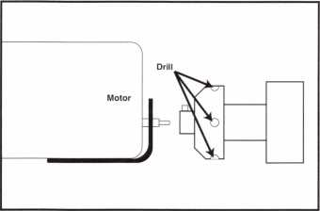

about % inch to Vi6 inch deep. I placed one of these holes about every M inch all the way around it. Make sure not to drill too deep. Now, with a Schlage “D” series spanner wrench, even the weakest wrist can tighten or loosen the nut quickly—with no effort. Carl F. Thompson #022042

Congratulations to Lonnie McKinney, CML for sending in last month's winning tip, entitled “1996 Lexus. ”

1 About the Department Editor: Tony

Ramunno, CML, CPS, owns and operates Allied  
Locksmiths of Youngstown in Youngstown, OH.  
He has been in the locksmithing business for 25  
years and has been an ALOA member for 23  
years. He also serves as the chairman of the  
Library-Museum Committee for ALOA.

yg How To Become A Trade Tipper

Each month, the Associated Locksmiths of America [ALOA] holds a “Trade Tips” con­test in Keynotes for ALOA members. In addition to helping other locksmiths by sharing your knowledge, there are three levels of prizes to be awarded:

As a departure from our usual Trade Tips prizes, donated products will be given out to monthly winners for the remainder of the year.

February 1997 Sargent & Greenleaf 6120 electronic safe lock

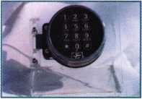

Authors of any Trade Tip published will still receive $20.

Want to Participate?

Mail your best idea [including photos,

illustrations or parts, if necessary) to

Keynotes

Trade Tips Editor

3003 Live Oak St.

Dallas, TX, 75204-6186.

All entries are sent to the Trade Tips editor with the author’s identity deleted. The tips must be submitted exclusively to Keynotes and become the exclusive property of ALOA. Tips are judged on the basis of accuracy, professionalism, ethical stan­dards and usefulness.

January 1997

Keynotes

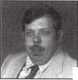

***Do you belong in the***

ALOA

President’s

Club?

How can I join the President’s Club?

You can earn membership in this  
prestigious club by recruiting just  
10 new members for ALOA.

Any ALOA member may participate.*

What do I get?

When you recruit 10 members, you receive a handsome blue blazer with  
a President’s Club crest. For each additional five members you recruit,  
you receive a lapel pin with gold-filled numbers, indicating your  
recruiting successes.

You also get the satisfaction of knowing that

you are helping your association, helping your industry grow, and you  
are helping fellow locksmiths achieve success.

How do I get started?

Contact the ALOA office for a supply of applications. One President’s  
Club credit is awarded for each new applicant. Credit is awarded only  
after the membership application is approved. However, the credit will  
apply for the period in which the application is received. Failure to  
identify yourself as the sponsor on

the application form at the time it is submitted to ALOA for processing  
will forfeit any credit.

*ALOA Board of Directors not eligible for membership in the  
President's Club.

PRESIDENT’S CLUB ROSTER

131 Members 013186 Kwok-kei Leung

73 Members 019882 Henry Raymond

67 Members 005354 Stewart Levine, CML

58 Members 012566 Mary Ohmit, CPL

49 Members 022598 Allen Konrath

40 Members 012103 Jack Hobin, CPL

36 Members 022907 Toshihiro Asano

35 Members 021172 Myeong-Rae Cho

30 Members 011133 Salvatore Dulcamaro, CML

29 Members 006072 Charles Robertson, CML

27 Members 010464 Jeanne Lodge, CML

26 Members 008951 William Neff, CML

26 Members 016675 Roy Renderer, CML

23 Members 018521 David Federico

22 Members 003296 Danny Rudd, CPL

22 Members 014474 Robert Carroll, CPL

21 Members 004371 John Elliott, CML

21 Members 007215 Jerome Cohen, CML

20 Members 004475 Larry Warnick, CML

20 Members 019244 Eugene Altobella

18 Members 007051 D Lee, CPL

18 Members 009049 John Heckman, CML

18 Members 014144 James Fowler, CML

18 Members 014996 David Harris, CML

18 Members 019138 Robert DeWeese, CPL

17 Members 002501 John Kerr, RL

17 Members 015283 Ronald Heidzig

16 Members 007012 Joseph Ferrero, CML

16 Members 008154 Diana Barnum, CRL

16 Members 018691 Brian Reetz

16 Members 023788 Jim Williams

15 Members 008617 William Grant, CRL

14 Members 001657 Rex Parmelee, RL

14 Members 005329 Marian Swann, CRL

14 Members 007129 Thomas Vandersteen, CML

14 Members 008168 Charles Cole, CML

14 Members 008361 James Cawby, CML

14 Members 015696 Barbara Watt

14 Members 016056 Elvis Hammerschmidt, CPL

13 Members 007009 John Dorsey, CPL

13 Members 008916 James Gruber

13 Members 009172 Peter Gauthier, CPL

13 Members 022358 Russell Fuller, CRL

12 Members 000712 Edwin Scott

12 Members 001825 Walter Lascar, RL

12 Members 004361 Robert Rodocker, CRL

12 Members 015305 Lonnie McKinney, CML

11 Members 003430 Lawrence Smith, CML

11 Members 009546 Gary Teams, CPL

11 Members 010266 William McElheney, CML

11 Members 010909 Rolando Bouza

11 Members 018034 Michael Robinson, CRL

11 Members 018805 Robin Horsley

10 Members 004993 Ernest Wright

10 Members 009305 Frank Hartung, CML

10 Members 009482 Lester Brodsky

10 Members 010602 Herbert Dusenberry, CML

10 Members 011316 Robert Duman, CML

10 Members 016525 Philip Rovenolt, CPL

10 Members 016726 Dale Knowles, CPL

Yes! I want to join the ALOA President’s Club.

Please rush meapplications so I can start now to earn credit toward membership in the ALOA President’s club!

Name:

Company:

Address:

City: State: Zip:

|  |  |
| --- | --- |
| ALOA | / |
| Extra | \ |



Dept

Here’s Your Chance

OK, you’ve been meaning to write that letter to the editor, or call in to ALOA headquarters with your concerns and ideas but... there just aren’t enough hours in the day. Well, that’s no good. We need to know all about what you think and who you are and what you need if we’re going to do a good job for you.

So, let’s make it as easy as possible. We’re planning an early spring membership sur­vey to hear you out. The questionnaire will be easy to complete, not too terribly long and the best chance we’ve had in a long time to heed the silent majority. The Marines may be looking for a just few good men, but we’d rather hear from everybody.

We know what you’re thinking—these things cost money. True. But without input from ALOA membership, none of our pro­grams can be tailored to fit you. So we’re planning to combine the November and December 1997 issues of Keynotes to fund the poll. And, of course, we’ll let you know what we find out. Be sure your voice is counted when the time comes.

Staff Change

We at ALOA bid a fond farewell and congratulations to former Associate Editor Jim DeSimone who has left us to fill an edi­torial position with Today’s CPA During his time with Keynotes, Jim contributed signifi­cantly to the quality of the magazine, win­ning an IABC Silver Quill for feature writ­ing. He told us to say goodbye to all the good friends and terrific authors he worked with through ALOA.

Jim’s replacement, Laurie Kline, is no slouch herself. A gifted writer, Laurie hold a MA in Communications from the Universi­ty of North Texas and teaches one night a week a junior college here in Dallas. Feel free to call her with industry information or article ideas, and get acquainted. Welcome, Laurie!

Wrong Zip

On p. 12 of the December issue, we inadvertently published the wrong zip code

for mark bates Associates. The correct zip is 40356.

Leukemia Pledge

ALOA member Barbara Sharp, #19074, will be running 26.2 miles in April to raise money for the battle against leukemia in honor of her 31 -year-old co-worker who recently succumbed to this illness. More than 5,000 volunteers nationwide partici­pate in this program to fight a disease that is the #1 killer of children in the United States. Members wishing to make a per- mile pledge for Barbara can send checks or signed credit card orders (please note expira­tion date) to: Leukemia Society of America, Inc.; Central Connecticut Chapter; 1125 Dixwell Avenue; Hamden, CT 06514.

Don’t forget to note Barbara’s name as the designated runner on your pledge.

In Memory

A respected friend and generous member of the locksmithing community, David House, recently passed away. One of the first to write master keying software, David was, for many years, an active member of ALOA, the Institutional Locksmiths Association and the Texas Locksmith Association. The Institutional Locksmiths Association has established a special scholarship in David’s name. Contributions can be sent to: ILA; P.O. Box 450; Falls Church, VA 22040- 0450.

**Keynotes** Reprint Policy

Keynotes magazine, the official interna­tional publication of the Associated Lock­smiths of America, Inc., currently extends, as a courtesy, permission to reprint portions of the publication to ALOA members, ALOA chapters and regional locksmith associations. This policy is based on the assumption that the material is being used for informational purposes only and that no direct profit is to be made by the reprinting party. The Keynotes reprint policy carries the following stipulations:

• The party wishing to reprint a portion of

Keynotes will inform ALOA, in writing, of

what is to be reprinted, where and for what purpose.

• The reprinted information must appear verbatim—i.e., exactly as published— with a notation that the material appears “courtesy of Keynotes magazine, Associat­ed Locksmiths of America, Inc., [issue date].”

If the party wishing to reprint a pub­lished portion of Keynotes stands to profit directly from re-publishing this material, arrangements must be made with the author/owner of that material. Contact information for authors is available from ALOA. [This is primarily a requirement for any for-profit publications. This does not, for example, apply to an ALOA member who wishes to make photocopies of Keynotes material to educate consumers about profes­sional standards such as the recommended ALOA Positive ID Policy.]

If the party wishing to reprint a pub­lished portion of KEYNOTES—either on a profit OR nonprofit basis—wishes to use the photography or illustrations from the magazine, arrangements must be made with the artist/owner of that material. Contact information for artists is available from ALOA. (Note: Art executed by ALOA staff is “work for hire” and does not fall under this provision.)

Keynotes Advertisers Index

|  |  |  |
| --- | --- | --- |
| RS# | Advertiser | Page |
| 20 | H.E.S. | 42 |
| 99 | Jet Hardware | BC |
| 21 | Locksmith Publishing | 57 |
| 19 | Omaha Wholesale | 13 |
| 100 | Treskat | 8 |

January 1997

Keynotes

Focus

On Education

Jim Glazier, CML Education Chairman

Closed Circuit Television: There is a real need for trained installers and service personnel for these systems.

Upcoming ACE Classes

Texas Locksmith Association

Feb. 5-9, 1997

Corpus Christi, TX

Call Wanda Robbins for information

(210] 923-4381

9 certified ACE class days

Grand Canyon Chapter of ALOA

April 5-6, 1997 Phoenix, AZ Contact: John Ilk (520] 474-8879

Combination Lock Manipulation Instructor: Ken Lee, CPL

Master Locksmith Assoc, of New Jersey

April 17-21, 1997 Somerset, NJ Contact (201] 267-2441 19 full-day classes and two evening seminars

ALOA ’97

July 27-Aug. 1, 1997 Reno, NV

Contact: ALOA Meetings Department (214] 827-1701 (800] 532-2562 Approx. 64 full-day classes, 25 half-day classes and six evening seminars More information TBA

Well, Christmas and New Years have come and gone and hopefully you have made one of your New Year’s Resolutions that of gain­ing more and better education. Our industry is changing rapidly and, as a result, you and I must continue to become more familiar with the new technology and products. By so doing, we can guarantee a nice income and provide for our families in spite of taxes and all the new regulations.

One of the most rapidly advancing tech­nologies is in the area of Closed Circuit Television. The demands for newer and bet­ter products are greater than ever and there is a real need for trained installers and ser­vice personnel for these systems. Recently, I read of a new wireless system, complete with infrared, which can see in almost absolute darkness. This system was being used by a police department to monitor drug activity in their area and they indicated that they had cut the rate of drug activity almost 90% with a large number of arrests being made. Can you think of ways in which this could be valuable to your customers?

The results of the 1995 Uniform Crime Reports, released by the FBI show a marked rise in crime rates during the past 30 years. The Locksmith Ledger recently made a compari­son between 1966 and 1995 which follows:

**1966 1995**

1. 618,800
2. 23,305 13,991,600

|  |  |
| --- | --- |
| Auto Thefts | 486,000 |
| Robberies | 118,900 |
| Aggravated Assaults | 34,700 |
| Murders | 5,600 |
| “Serious” crimes | 2,780,000 |

$120 billion per year. That relates to $4 to $ 12 per employee per day. Other statistics reveal that employee theft is the cause of 30% or more of all business failures.

What does this mean to our industry? It means that if we are trained and knowledge­able in the security systems such as CCTV, Electronic Access Control, and we properly advise our customers, we can be financially secure in supplying a need for security and surveillance. How about it? Was one of your resolutions to become better educated in 1997? I truly hope so!

We have some great new ACE classes— some of which will preview at ALOA ’97 in Reno—and others which are now available to Chapters and Associations for the asking. These include Forensic Locksmithing for Investigators; Servicing Aluminum Doors; one day High Security Auto Service; one day hands-on Access Control for the Locksmith and Simplified Pricing/Cost Techniques.

Join us in Reno and see what ACE has to offer there. You will soon receive a complete listing of the many full and half day classes, as well as some excellent free seminars on Monday and Tuesday evenings. Plan now to partake of some great education and fine fel­lowship with your fellow locksmiths.

the Chairman: James

Glazier, CML, #14240, is a retired police officer  
and operates Security Plus in Mount Airy, MD.  
He also serves on the Finance, Convention and  
Personnel Committees of the ALOA Board.

Amazing isn’t it? “We’ve come a long way baby!” Some other recent statistics indi­cate that 70% of vendors steal from their customers and almost 90% of employees steal from their employers in some indus­tries. It is estimated that 1% or more of all cash register sales are illegally pocked by cashiers, according to Security Concepts, November 1996 issue. This same publica­tion suggests that losses of goods and cash to worker theft now reach between $40 and

Keynotes

January 1997

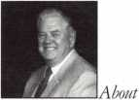

**AN INVESTMENT**

**yOU CAN'T AFFORD NOT TO MAKE.**

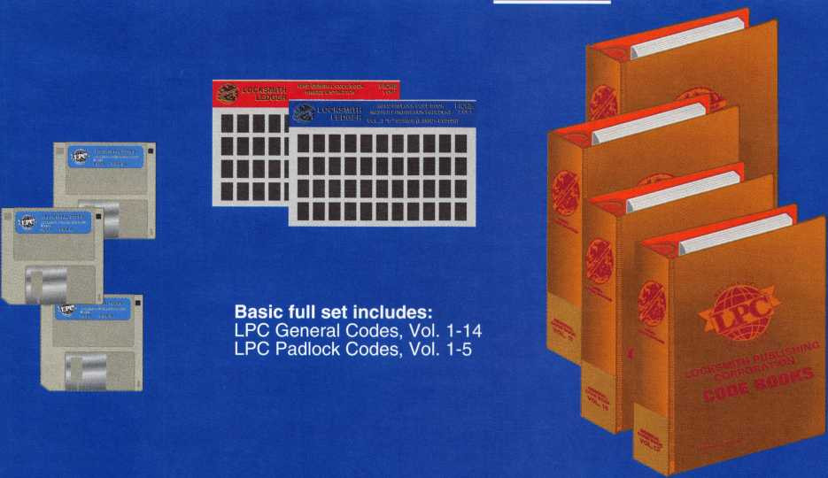

ie Locksmith Publishing Corporation’s Code System contains the most accurate, up-to-date code information ailable anywhere, and provides you with more codes than any other system on the market today.

* Available in 3 formats: books, microfiche, software.
* Card and key guide numbers and hand cutter information are included to facilitate use of the codes with all of today’s popular code cutting equipment, including llco, HPC, Curtis, Framon and ITL.
* Spacings and depths data is provided with code series. Keyblank cross-reference information is also included.
* Codes are provided for the most popular makes of utility and vehicle locks, and also for the more obscure series not found in any other system, but still in circulation today.
* Our codes are NEVER deleted. We continually update and expand existing code series, and add new codes as soon as they become available.
* When applicable, code series are cross referenced to codes for similar locks designed on the same general principles.

*lecialty books/microfiche for Chrysler, GM, Ford, BMW, Motorcycle Master and Tubular Codes also available.*



**Locksmith Publishing Corp.**

**Reed Code Division**

**850 Busse Hwy., Park Ridge, IL 60068 Tel: 847-692-5940 Fax: 847-692-4604  
Or visit us On-Line at <http://www.lpc.simon-net.com>**

Chapter

Roster



**The best way to learn about ALOA’s programs  
and to network with locksmiths in your area is by  
participating in local ALOA chapter activities. This is  
your opportunity to exchange management and tech-  
nical information, build your professional image, and  
share trade tips with your fellow locksmiths.**

**If you want to start a chapter in your area, please call  
ALOA, [214} 827-1701.**

Alabama

Alabama Locksmiths Association

411 6th St.

Decatur, AL 35601 (800) 292-5008 *Larry Warnick, CML

Arizona

Grand Canyon Chapter

13016 S. 131st St.

Gilbert, AZ 85233 (602) 786-8182 *Larry Schlemmer, CRL

California

Los Angeles/

Orange Counties Chap­ter

P.O. Box 697

Alhambra, CA 91820-0697 (310) 869-2555 *John H. Cosby, CPL

San Diego Chapter

1049 Island Ave.

San Diego, CA 92101 (619) 234-4829 *Frank Hartung, CML— Chairman

Colorado

Colorado Front Range

2603 Pearl St.

Boulder, CO 80302 (303) 443-9740 John I. Shandy, CML— Chairman

*John M. Thomas, CRL— Vice Chairman (303) 666-8980

Connecticut

Nutmeg Chapter

Phil’s Lock Shop 360 E. Main

Meriden, CT 06450-6022 (203) 237-4602 Phillip Hobbs, CPL—Chair­man

Florida

South Florida Chapter

1710 NE Miami Gardens Dr.

Miami, FL 33179 (305) 944-0469 *Jerri Moeller, CRL Secre­tary

Paul Renderer, CML— Chairman

Georgia

Georgia Chapter

P.O. Box 48088 Adanta, GA 30362-1088 (404) 455-6244 John T. Grist, CML—Chair­man

*M.W. Whitman, Jr.

Hawaii

Hawaii Chapter

4420 Lawehana St.

Unit 4

Honolulu, HI 96818 (808) 623-5914

* Andreas Muenker, CML— Chairman

Indiana

Central Indiana

1237 Wabash Ave.

Terre Haute, IN 47807 (812)234-6249

* Herbert Dusenberry, CML

Northern Indiana

122 N Orchard St. Kendallville, IN 46755 (219)347-1754 *Earl Shanfelt

Southern Indiana

P.O. Box 185 Bloomington, IN 47402- 0185

(812)334-3737

* Daniel W. Hill, CML

Kentucky

Kyana Chapter

510 E. Parrish Ave. Owensboro, KY 42303- 3125

(502) 684-5093

*Timothy Morrison, CML—

Secretary

Maryland

Chesapeake Chapter

700 Rappolla St.

Baltimore, MD 21224 (410) 633-0111

* Bob De Weese, CPL— Chairman

Massachusetts

Massachusetts Chapter

200 Weir Street Taunton, MA 02780 (508) 823-4649 *Stephen Ehrlich, CML— Treasurer

Minnesota

Minnesota Chapter

3M Center Bldg. 223-BE-04 St. Paul, MN 55144-1000 (612) 733-6674 *Douglas Rude, CRL

Montana

Montana Chapter

1000 S. Main Butte, MT 59701 (406) 782-0125 * Aggie Cooney, CPL

Nebraska

Nebraska Chapter

343 W. 2nd St.

Hastings, NE 68901 (402) 463-6661 *Brad Boden

Nevada

Sierra Nevada Chapter

C/O Pamela Vankirk P.O. Box 115 Reno, NV 89504 (702) 328-9285 *Danniel F. Howard,

CML—Chairman

New Jersey

Garden State Chapter

106 Ridgedale Ave. Morristown, NJ 07960 (201) 538-2737 *Steve Frei, Chairman

New Mexico

New Mexico Chapter

917 2nd St. NW Albuquerque, NM 87102 (505) 242-1380 *Evelyn Wersonick, CML Marc McGrannahan, Chair­man

Sunbelt Chapter

South Central Region New Mexico State University

Box 30001 Dept. 3545 Las Cruces, NM 88003-0001 (505) 846-6292 *Don Brazil—Chairman

North Dakota

North Dakota Chapter

Rte. 1 Box 67 Devil’s Lake, ND 58301-

Ohio

Ohio North Coast Chap­ter

#2 Horseshoe Drive Monroeville, OH 44847 (419) 465-4153

* Ronald Betschman,

CML—Chairman Ohio Valley Chapter 144 Julep

Cincinnati, OH 45218 (513) 825-7528 *James T. Brickler,

Chairman

Pennsylvania

Keystone State Chapter

P. O. Box 0261 Eagleville, PA 19408 (610) 265-3380 e-mail: [KSTATE@aol.com](mailto:KSTATE@aol.com) *Robert Cook, CML— Chairman

South Dakota

South Dakota Chapter

402 S. Minnesota Ave.

Sioux Falls, SD 57102 (605) 331-6026 *Ronald Heidzig—Chair­man

**Tennessee** Smokey Mountain Chapter

2557 Middle Creek Rd. Pigeon Forge, TN 37863 (615)453-8344 *Jessie Swan, RL West Tennessee 1643 Bartlett Rd.

Memphis, TN 38134 (901) 372-7464

* Richard Pat Walker,

CML—Chairman

Texas

Sunbelt Chapter

see New Mexico listing

Washington, D.C.

Washington, D.C. Area

4713 Tallahassee Ave. Rockville, MD 20853 (202) 722-0900 *Lester Brodsky—Chairman

Wisconsin

Fox Valley Chapter

1425 N. Richmond St. Appleton, WI 54911 (414) 731-5400 * Robert Petter—Chairman Tom Ripp Vice Chairman Indianhead Chapter 201 N. Barstow St.

Eau Claire, WI 54703-3525 (715)832-4207 *John Dorsey, CPL Chairman

Wyoming

Wyoming Chapter

521 Main St.

Spearfish, SD 57783 (605) 642-4542 *Gene Ficek, CPL—Chair­man

International Chap­ters

Hong Kong Chapter

901 Canton Rd, G/Fl Mong Kok Hong Kong

*Timothy Chow—Chairman

Korea Chapter

#1250-7 Bi San 7 Dong Seo Gu TaeGu Korea

(053)353-0058 *Myeong-rae Cho

* Denotes contact person for this chapter.

All questions regarding chap­ter activities, meetings and events should he directed to this individual.

3907

(701)662-5625 *James H. Strong, CRL

Keynotes

January 1997

Chapter

News

Dana Barnum, CML Committee Chairman

The new plan is to give rate schedule.

c

hapters the best

price possible with a cost plus

Hello again, chapter members. Happy New Year to everyone! Wow, it’s hard to believe we are looking into the start of another year already!

Many things have taken place since I wrote my last article for the December issue of Keynotes. In the middle of November, the ALOA board (myself included) held our annual fall board meeting in Dallas, Texas. This meeting was very different from other board meetings that we have had in the past because each committee’s agenda and pro­jects were openly discussed for content and cost to the association among the entire Board. This kind of work session is com­monly called “the committee of the whole.” Each committee chairman had an opportuni­ty to go before the Board and explain his committee’s goals and objectives as they related to the ALOA Strategic Plan. The strategic plan is a nine-page document refer­ring to the goals and idealistic plans for ALOA’s future composed by the Strategic Planning Committee and the Board of Directors of ALOA.

Looking back on this week of meetings, it was very productive and I believe that the ALOA will be a stronger association and a result of the vision and determination of a few to do whatever it takes to move ALOA forward into the 21st century. I believe one of the most difficult jobs we had to do at this meeting was to challenge ourselves with these idealistic plans and goals for the future, and then shave them down—or in some cases, cut them out—in order to produce a balanced budget that was realistic for 1997.

Here are some of the results of our board meeting as it relates to the chapters. We can still look forward to adding another automo­tive Tech-Train tape to our chapter libraries for 1997. The officer training course that I have written about many times will still be offered, but under new guidelines set forth by the ACE committee. This class is already scheduled for the second time at the MLANJ show in the spring.

Also, the $750 ACE class rebate for chap­ters that has been offered in the past will not be carried on in the same manner for 1997.

The new plan is to give chapters the best price possible with a cost plus rate schedule. In many cases, this will give the chapters an even better rate for ACE classes than before. If you were thinking of putting on an ACE class for your chapter and would like more information on cost and scheduling, please contact the ALOA office or the Education Chairman, Jim Glazier, CML.

Another action taken by the Board in the fall meeting was to recognize an ALOA member who is doing an outstanding job on behalf of the Korean Chapter of ALOA. The ALOA board has formally recognized Mr.

Joe J. Lee of Philadelphia for his efforts in translating the ALOA glossary of terms into the Korean language. The request came from Mr. Myeong-rae Cho as he attended the Chapter Officers Social during the ALOA convention in New Orleans. Joe Lee has been given the title of ALOA Ambassador to Korea. Joe will be visiting his father in Korea during the month of March and was requested to carry warm greetings on behalf of the ALOA board to the members of the Korean chapter when he visits them.

That’s all I have for now—see ya next month.

From the Chapters

One Big Step for Locksmith-Kind

The Smokey Mountain Chapter reports that—thanks to the hard work of the ALOA legislative committee and lobbyist John Chwat—locksmiths now have a new Security Industrial Classification (SIC) code: 571522. The new number is listed under the “Security Industries” portion of the SIC manual. This is a big step for locksmiths since the SIC is the major classification sys­tem for all industries in the United States. This new number comes after a nine-year project to gain credibility for the locksmith industry.

Hit the Books

ALOA’s Grand Canyon Chapter has two new ACE classes on the books for 1997. One possibility is a domestic auto class. A survey

will be conducted to find member interest for the second class topic. A PRP test may also be scheduled in conjunction with one of the classes or at another time in 1997.

Feeling Minnesota

The Minnesota Chapter has noticed a slow decline in membership and would like to remind members of the fun and education that come from attendance and participa­tion. ALOA meetings are a great way to socialize and get questions answered, and members walk away with a wealth of infor­mation.

Welcome Aboard

The Keystone State Chapter added several new members: John Handschuh, Robert Wagner, Joseph Chesla Jr. and Michael Torounian. Welcome, everyone!

J About the Chairman: Dana

Barnum,, CML, #05444, operates South Penn  
Lock & Safe Co. in Media, PA. He also serves on  
the ALOA Education, Membership and Bylaws  
committees, as well as having been on the board of  
directors of the Greater Philadelphia Locksmiths  
Association (GPLA). Dana has also sponsored  
many neu' ALOA members.

January 1997

Keynotes

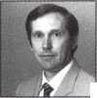

Back

Page



My father came up with this old lock when I told him and my mother that I was going to work as the editor for Keynotes. A public surveyor since the late ’40s, Dad has a long-standing affection for the historic, the singular, the dis­carded, the rusty, the more subtle treasures of the land. And so I have been given a bag of colorful streambed rocks, a maple table reconstructed from pieces found in an old barn, a massive stony butter churn (that I occasionally use for a doorstop), various aged bottles, and the world’s heaviest crocheted afghan that he fought for against a fierce farmwoman at a Hill Country estate sale. I don’t know absolutely where he got the old lock. I could swear I recall it mounted on a tall wooden gate toward the edge of our acreage in central Texas, the place where I grew until I was about 11. Yes, I can picture it quite clearly. Bolted tight, forbidding entry to a wind­ing path that led down, down deep into many trees, including one that grew like a leafy basketball to the ground and created the most secret playhouse—a rustle and flicker of light and scent. That lock, for sure, was on that gate and I used to climb over like the lawless intruder I was. And I would hide from the world while they all panicked and wondered where in God’s name I could possibly be. I’m sure that’s so. Mother says ‘no.’ That my father got the lock somewhere else and that the woods weren’t locked away and that she knew exactly where I was and that I wasn’t breaking the law by playing on our own proper­ty. That I’m being dreamy and that I just like to remember it that way.

I think somebody is messing with the truth here.

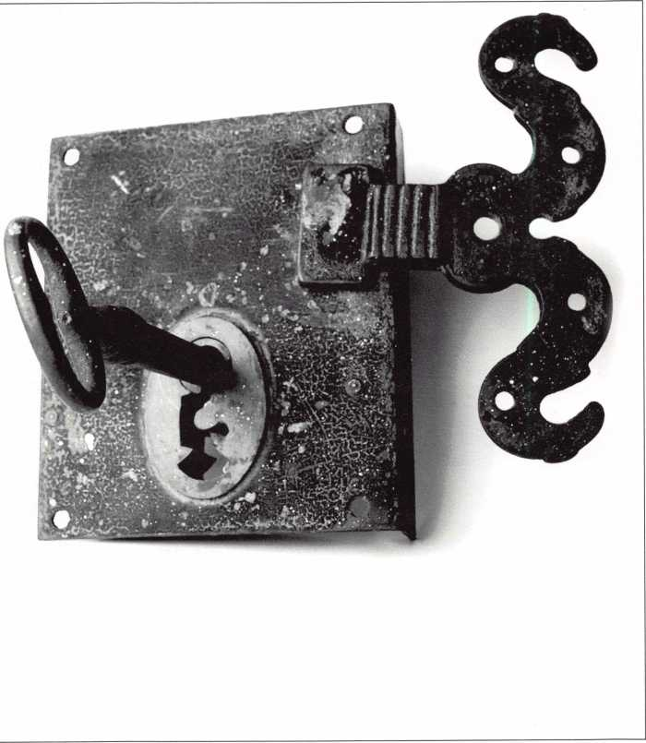

Anne McDonald Davis



Keynotes

January 1997

| Get the best master keying textbook

around, written by one of the most

keeping; basic mechanical and

write a system

*ntroduction to Split Pin Master Keying*

To order, write or FAX:

iciated Locksmiths of America, Inc.; 3003 Live

Oak Street Dallas TX 75204 FAX (214) 827-1810

Credit card orders: Phone (214) 827-1701

**Jerome V. Andrews, CML**

well- known locksmith instructors

in the profession. Just $44.00

[including shipping and handling],

Fundamentals of Master Keying

covers system structure and record

arithmetic concepts; and how to

^ V '’

**sOll^**

*mm*

If s '"■> . m• • i

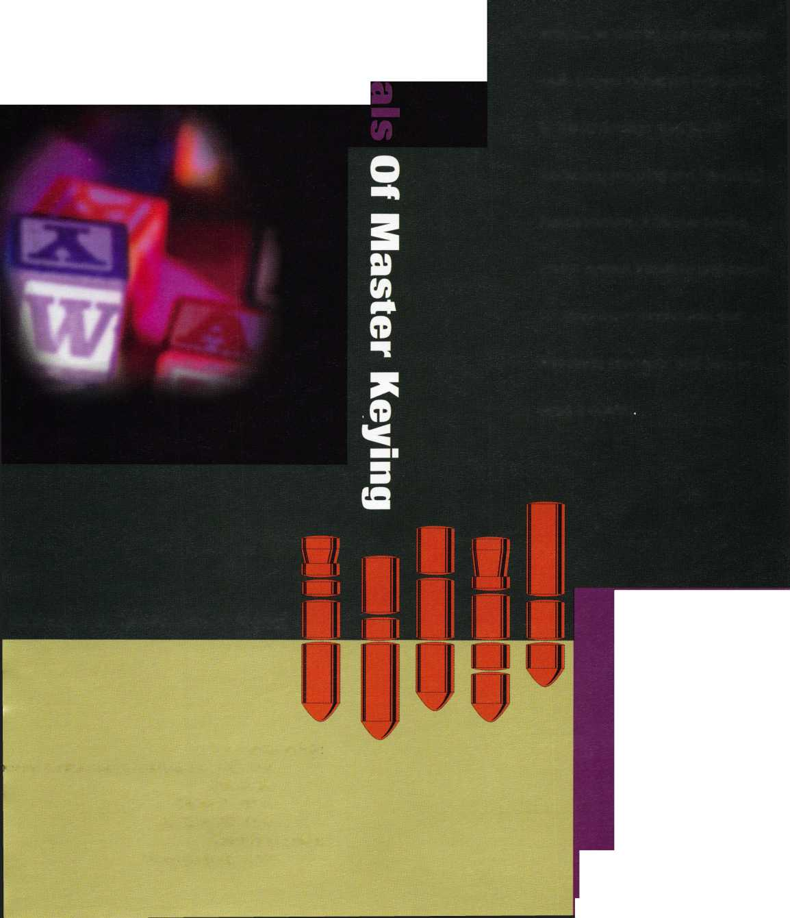

**in MBIllllillFBi1** dm **♦ I ■ ♦**

**jet** Silver **Line... Landmark of Precision**

PRECISION MANUFACTURED from the finest NICKEL SILVER and Polishec to a Magnificent Silver Finish! A landmark in key manufacturing.

Over 170 numbers, coined, embossed and designed to create the appearance of the originals!

Offering Regular and Sectional keys from...

ARROW BEST CORBIN RUSSWIN

DIEBOLD FALCON HHM

KWIKSET LeFEBURE MEDECO

MOSLER SARGENT SARGENT & GREENLEAF

SCHLAGE YALE YORK

jet hardware... where

QUALITY is OUR KEY!

JET HARDWARE MANUFACTURING CO

800 Hinsdale Street, Brooklyn NY 11207

Free Information - Reader Service Card

